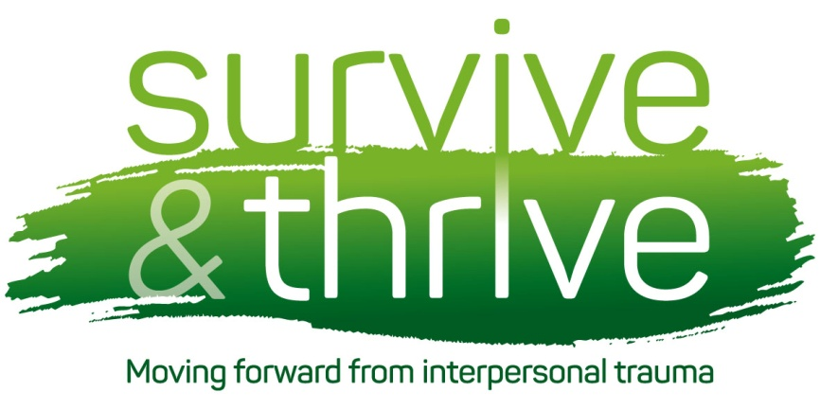

Weeks 6: Understanding Anger and ways of Managing Anger

Anger is a healthy emotion, designed to help to protect us. It can be a signal that we are under attack or threat. It can energise us to be able to deal with that.

However, anger is an emotion it is very common to have problems with. For some people anger can lead to aggression and violence with all the risks to your or others physical safety, your relationships and even your liberty. Anger can feel overwhelming and out of control. You may think of anger as the same as aggression, but anger is a feeling and aggression is when we act in a hostile, damaging or threatening way.

For other people the very idea of feeling anger can be a very frightening, we might bottle it up and avoid it. They might worry that if they showed their anger to someone else they would be rejected or lose the relationship.

At both ends of the scale anger can lead to problems

Too much anger risks

* Hurting others
* Damaging your relationships
* Getting into trouble with law
* Damaging your property
* Lowering your self esteem
* Using drugs or alcohol as a ways of managing these feelings

Too little anger risks

* Getting hurt by others taking advantage of you
* Using drugs or alcohol to block out your feelings
* Feeling overlooked/undervalued
* Feeling numb and shut down
* An ‘explosion’ at some point as you ‘let off steam’ further down the road.

In session 10 we will look at effective communication, which is a way of avoiding being both aggressive and passive or submissive in your relationships with others. However, today’s session is just focussing on how to allow yourself to acknowledge your angry feelings safely.

Why do some People feel Uncomfortable with Anger?

As we have seen throughout the weeks, the way we have learned to deal with things and think about things often has some basis in what we experienced earlier in our life. Some children are punished or criticised for displaying strong emotions:

*‘Good girls don’t get angry’*

*‘Big boys don’t make a fuss about things’.*

We don’t learn how to feel safe with feeling and any strong feelings can make us feel out of control and uncomfortable. This may be part of the general pattern of avoiding or numbing out feelings.

For others, the terrifying experience of seeing adults out of control and aggressive can make us feel that anger isn’t safe and may make us worry that if we allow ourselves to get angry we will also lose control and attack others. We may in fact be mixing up anger and aggression.

Why do some people feel unable to control their angry feelings or let anger become aggression?

Anger which becomes out of control, or lead to aggression, can be a very serious problem which can completely take over your life.

Take Bill for example:

*Bill had a very difficult childhood, his parents divorced when he was young and he was brought up by his mum. Unfortunately, Bills mum had a serious problem with alcohol and was very often unable to provide adequate care for him. Bill often came home from school not knowing what to expect, sometimes mum would be ok and other times he would be ‘in for it’. His mum would seem completely out of control and would beat him and berate him telling him that he was the source of her problems. Bill came to learn that if you were upset about something, it was ok to take it out on someone else. He also learned to be on edge, to expect the unexpected and be wired up for threats.*

*During school Bill would often be bullied for not looking cared for. Bill learned that one way to get the respect of his peers by being the most aggressive boy in the year. In his teens he started drinking and taking drugs and getting into more and more trouble with the law.*

For Bill

* He learned a way of dealing with other people was through violence and aggression.
* He became ‘wired’ to expect aggression, which meant there was times when people meant no harm to him but he misread the situation and overreacted, based on his past experiences rather than what was happening now.
* He learned that sometimes aggression was given some respect, which he was desperate for, making him much more likely to keep going with that.
* Drugs and alcohol made him more likely to get into trouble with his anger.

What are the Different parts of Anger?

As with the other emotions we have looked at, anger is made up of different parts. The example below is a common experience of an angry reaction to being cut up by another driver.

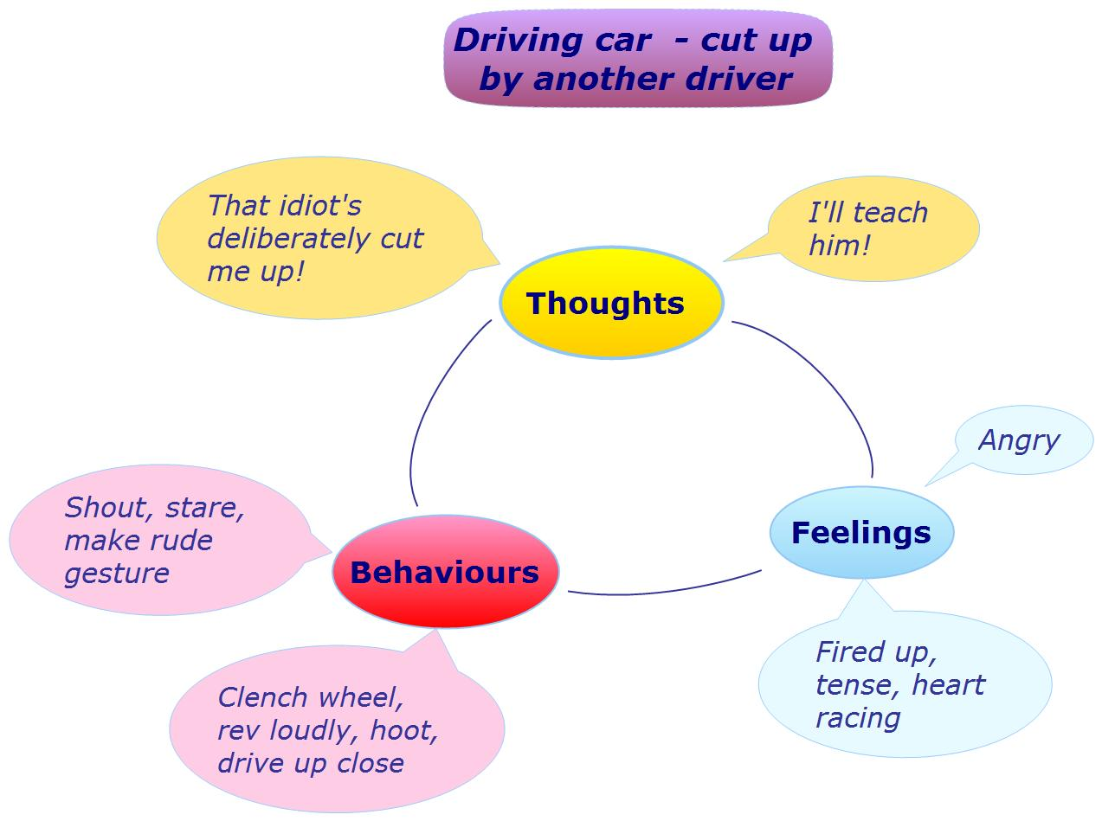

# (Example from get self-help (<http://www.get.gg/anger.htm>))

# Feelings: you might notice feeling angry, and your body changes to make you feel fired up, you might feel tense, your heart racing and your stomach knotted.

# Behaviours: I might behave in an aggressive or threatening way to communicate my annoyance but this also increases the chance that this is going to lead to aggression. I might shout, tower over people, clench my fists

**Thoughts:** if you are prone to anger you will probably see the world through the expectation that people are trying to harm you or make you look bad. You might think ‘they are doing that on purpose’ you might think you are being treated unfairly or disrespectfully.

**Coping with Too much Anger**

Coping with your angry feelings may take a while to get the hang of. But similarly to other difficult feelings, it is worth thinking of ways of dealing with all the parts of anger

**Feelings:** try breathing or anything else that helps you to keep a little calmer. Walk away for a moment, practice any of your safe coping skills. The old trick of counting to 10 can actually be really helpful. Manage your underlying stress

levels (you are much less likely to blow up if you haven’t got far too much on your plate in the first place). Notice that it is anger you are feeling and start to wonder what it is you are angry about. Try to avoid blocking out the feelings with drugs and alcohol. You are more likely to lose control if you are under the influence.

**Behaviours:** displaying lots of aggressive behaviours will escalate your own response to the situation but is also likely to ramp up the other person’s response to you.

Unclench your fists, drop your shoulders, and notice your tone of voice and volume. We will talk about this some more in session 10.

**Thoughts:** firstly you have to notice your thoughts. Is it a fact? Is it based on what is happening right now or is it coming from expectations from things in the past? Is it based on a belief that other people will always be a threat to you or trying to get ‘one over on you’.

Remember there may be more than one way of thinking about things and things might not be just as they immediately seem…

**Coping with Too Little Anger**

If you feel that getting angry would be dangerous for you or your relationships, so you keep feelings of anger pushed away at all times, it would be worth thinking about

* Anger is just a feeling, like all feelings, if you can learn to cope with it and tolerate it you will feel better generally.
* Anger is not the same as aggression. Aggression is generally destructive and damaging but anger can help you to achieve things and keep you safe.
* Try not to use drugs/alcohol/self-harm to push away angry feelings. Try to notice the angry feelings.
* Come for week 10 to learn about effective communication.

Please fill in the exercises in the key points handout

A final thought….

Do not teach your children never to be angry, teach them how to be angry

* Lyman Abbott