Sleep is a very important part of recovery; It’s a time when lots of our brain’s processing happens. Getting a good night’s sleep has many benefits to your physical and mental health. Here are some ways to practice good sleep hygiene...

**Good**

**sleep hygiene**

**Lifestyle factors**

**Bedroom factors**

Sleep is an essential part of recovery, so ensuring that you are able to get a good night’s sleep is an excellent way of helping your recovery process.

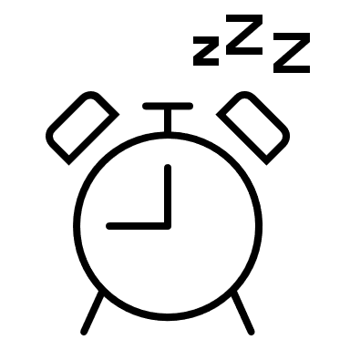

Waking up from nightmares can be extremely disruptive to our sleep patterns. Here are some techniques to use if you wake up from a nightmare...

* Bottle of spray water – grounding and cooling.
* Relaxing/grounding smells – keep next to your bed.
* Grounding statements.
* Move around, speak out loud, turn a light on or go to the window.
* Grounding object – e.g., stress ball.
* Controlled breathing.
* Imagine your safe place.
* Imagine and rehearse a different, positive ending to recurrent bad dreams.