Physical symptoms of anxiety

‘Fight-flight-freeze’ (Sympathetic system) and ‘Rest-digest’ (Parasympathetic system) are two branches of the same nervous system.
- Fight-flight-freeze is all about responding to threat, preparing the body for stressful or dangerous situations.
- Rest-digest is the opposite, it is all about calm and restoration, allowing the body to rest and look after itself by allowing areas like the immune and digestive systems to function properly.

Symptoms of fight-flight-freeze
Symptoms of fight-flight-freeze can be unpleasant but are not harmful, they are there to protect us, even if they can be a little misguided at times. Being more aware of these symptoms can make them feel less scary and help us know when to use our strategies. Below is a list of common physical symptoms of being in our threat system:

- Difficulty concentrating
- Changes to vision (blurred or tunnel vision)
- Dizzy/faint
- Breathing faster or feeling breathless
- Heart racing/heart palpitations
- Chest tight or painful
- Stomach churning
- Sweating
- Tense/sore muscles
- Trembling or tingling sensations

Because fight-flight-freeze and rest-digest are two branches of the same nervous system, we cannot be in both at the same time. So, if we want one to be less dominant, we have to activate the other.

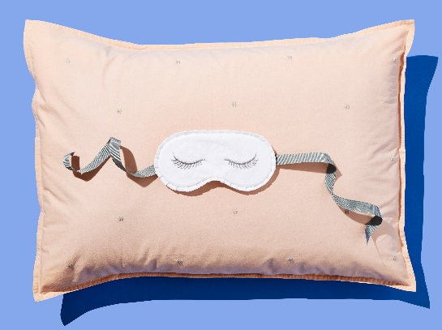
Rest-digest
Parasympathetic system
OR
Fight-flight-freeze
Sympathetic system
There are lots of different ways to help us switch between fight-flight-freeze and rest-digest. One way is by using our breath.

- When we are anxious or threatened our breathing speeds up in order to get our body ready for danger.
- Relaxed breathing (sometimes called abdominal or diaphragmatic breathing) signals to the body that it is safe to relax. Relaxed breathing is slower and deeper than normal breathing, and it happens lower in the body (the belly rather than the chest).

Preparing to breathe
Make yourself as comfortable as you can in your chair, standing up or lying down. If you’re sitting or standing, place your feet flat on the ground. If you’re lying down place your arms by your side. Bring your attention to any points of contact that your body is making with the ground or chair.
Breathing
Bring your attention to your breath for a few seconds.
Then take a slightly deeper breath down into your belly and count for:
1…2…3…4
Take a pause for
1 (some people find it useful to say ‘calm’ or ‘relax’ at this pause).

Then breathe out for slightly longer
1…2…3…4… 5
Take a pause for 1 and start again.

To access guided audio: https://www.youtube.com/watch?v=H-S1MtV5Pio
To access downloadable audios: https://services.nhslothian.scot/lcps/compassion-focused-therapy-audio-tracks/
Additional audios: https://services.nhslothian.scot/lcps/relaxation-visualisation-audios/

