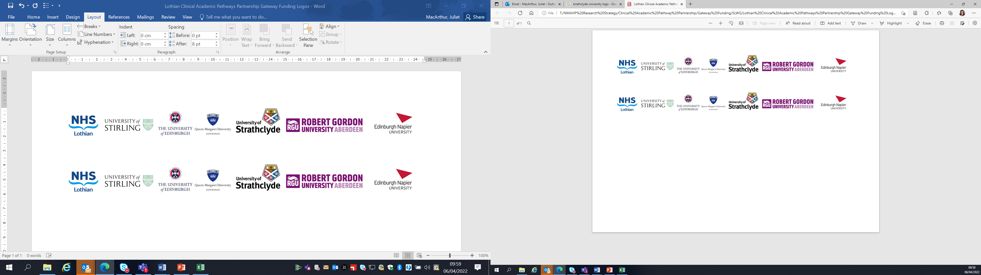Lothian Clinical Academic Pathways Partnership

Clinical Academic Research Gateway Funding

First Steps into Research Opportunities 2027

Institution & Department  Research Centre (if appropriate) | University of Edinburgh,  School of Health in Social Science  Centre for Homelessness and Inclusion Health
Contact – name, role & email | Dr Richard Lowrie,  Richard.lowrie@ed.ac.uk  Reader in the Centre for Homelessness and Inclusion Health.  Lead Pharmacist, R&D NHS GG&C.  Honorary clinical Pharmacist, The Access Place, NHS Lothian.
Research Project/Programme Title | INterVEntion by phaRmacy technicianS to improve prEscribing and CARE for people with multimorbidies living in areas of socioeconomic disadvantage. (INVERSE CARE)
Details of Research Project / Programme – including funder, team members, methodology, stage of implementation | Definitive Randomised Controlled Trial (RCT) with parallel process and economic evaluation looking to answer the research questions:  - Does Pharmacy Technician led medicine review outreach and home /temporary accommodation visits to people with multimorbidities improve health related quality of life and reduce polypharmacy?  - Is the INVERSE CARE intervention cost effective?  - What are the perceptions and experiences of people receiving the intervention, stakeholders and staff delivering?  Aiming for literature / systematic review March-May 2027 and drafting a grant proposal June-Oct 2027.  The First Steps opportunity creates the ideal environment for an NMAHP to work within an established research team. This will offer the successful candidate(s) the below opportunities including being involved in writing a grant application.
Opportunities for candidate  e.g. attending meetings; data collection; data management; analysis; ethics application; dissemination activities  (bullet points) | All under mentorship of Richard Lowrie:  Literature (possibly systematic) review;  - GCP course participation;  - Discussion of ethical issues and consent (particularly in people who present in extremis or who are under the influence) in research  - Attending steering and study management group meetings;  - Writing for grant application  - Opportunity to be costed into the application
Any other considerations or information for potential candidates? (e.g. potential links to other projects, networking opportunities, specific skills needed) | These objectives are designed to offer candidates a wide range of exposures needed to develop a broad understanding of the different stages of progression from research question to grant application. Candidates will be afforded multiple networking opportunities within University of Edinburgh and across the UK.  They will develop qualitative, quantitative and economic research skills in a supportive environment.  The mentor (R Lowrie) will remain closely involved throughout the duration and after the end of the 12 days of protected time.
Dates available (awards likely to be made Feb/Mar 2027 for start in Mar/Apr 2027) | April-Nov 2027
Mentor(s) | Dr Richard Lowrie

