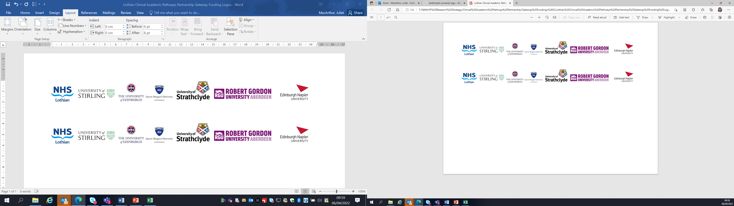Lothian Clinical Academic Pathways Partnership

Clinical Academic Research Gateway Funding

First Steps into Research Opportunities 2027
Full details of the Gateway awards scheme can be found at:
Lothian Clinical Academic Research Gateway Awards – Health and Care Professions Research

Institution & Department  Research Centre (if appropriate) | University of Edinburgh  Institute of Neuroscience and Cardiovascular Research
Research Project/Programme Title | ADOPT-UDMI
Contact – name, role & email | Amy Ferry, Senior Research Nurse  amy.ferry@ed.ac.uk
Details of Research Project / Programme – including funder, team members, methodology, stage of implementation | Adoption of the universal definition and classification of myocardial infarction (ADOPT UDMI) is a British Heart Foundation funded global initiative designed to promote, evaluate, and drive research into the adoption of the 5th universal definition of myocardial infarction. It is led by Prof Nick Mills and delivered by a team including a programme manager, clinical studies manager, research nurses and doctors and trial support staff.
Opportunities for candidate  e.g. attending meetings; data collection; data management; analysis; ethics application; dissemination activities  (bullet points) | The candidate will be able to get involved with the following for 3 studies in the programme:  · recruitment of participants  · data collection  · data management  · qualitative data collection and analysis  · trial team meetings  It is likely that we will also be setting up new related studies during the placement period that would provide exposure to preparation of trial protocols, Patient information leaflets, PPI, and preparation for ethical review board.
Any other considerations or information for potential candidates? (e.g. potential links to other projects, networking opportunities, specific skills needed) | An overview of the ADOPT-UDMI programme can be found here:  https://www.bmj.com/content/395/bmj-2026-100978
Dates available (awards likely to be made March 2027 for start in April 2027 onwards) | April 2027 onwards
Mentor(s) – name, role & email if additional to contact above | Amy Ferry

