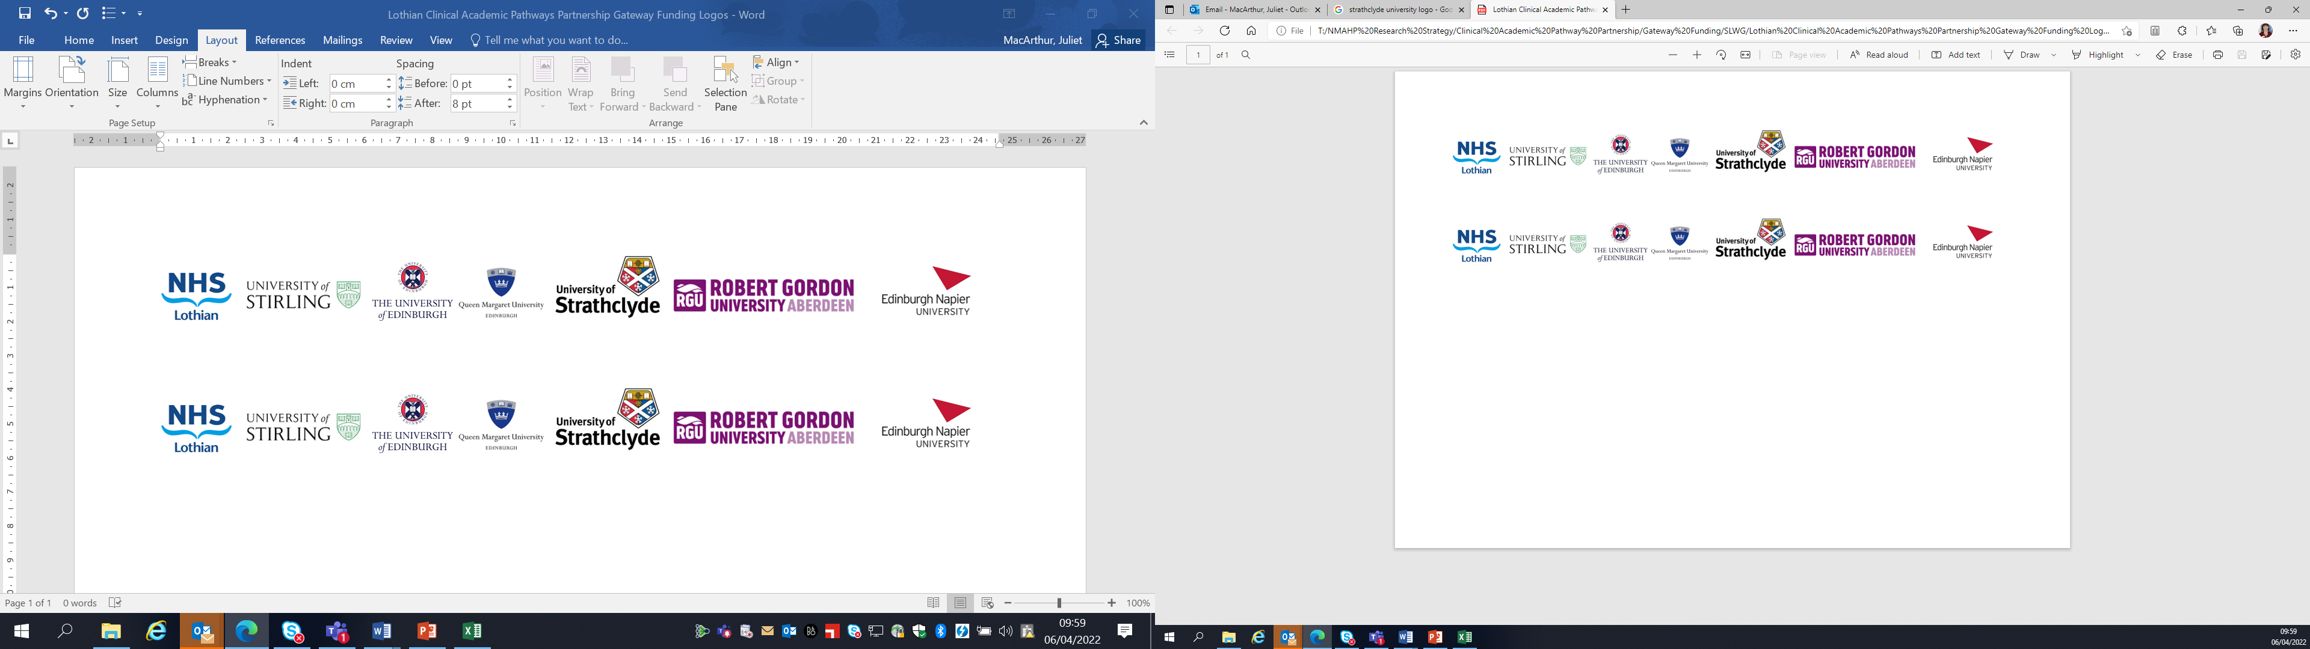Lothian Clinical Academic Pathways Partnership

Clinical Academic Research Gateway Funding

First Steps into Research Opportunities 2027
Full details of the Gateway awards scheme can be found at:
Lothian Clinical Academic Research Gateway Awards – Health and Care Professions Research

Institution & Department  Research Centre (if appropriate) | Institution: University of Strathclyde  Department: Strathclyde Institute of Pharmacy & Biomedical Sciences (SIPBS)  Research Group: Pharmacoepidemiology and Health Services
Research Project/Programme Title | Culture Change on the Curriculum (Triple C): Tackling Stigma in the Pharmaceutical Care of Substance Dependency to Support Recovery
Contact – name, role & email | Dr Natalie Weir  natalie.m.weir@strath.ac.uk  Lecturer  University of Strathclyde  Dr David Kernaghan  David.kernaghan@strath.ac.uk  Research Associate  University of Strathclyde
Details of Research Project / Programme – including funder, team members, methodology, stage of implementation | Funder: Academy of Medical Science  Team Members:  Dr Natalie Weir¹  Dr David Kernaghan^{1,2, 6}  Prof Andrew Radley³  Mr Adrian MacKenzie⁴  Dr Sarah Donaldson³  Mr Duncan Hill⁵  Dr Laura Roe³  1 University of Strathclyde, 2 University of Edinburgh, 3 University of Dundee, 4 NHS Healthcare Improvement Scotland, 5 Pharmacy Torrance House, 6 NHS Greater Glasgow and Clyde  Methodology  Mixed methods: qualitative (via workshops/focus groups and interviews) and quantitative (via questionnaires)  Phase 1 - Underpinning exploratory work:  - Scoping reviews investigating the international evidence base on stigma and harm reduction-based education interventions for pharmacy students and staff  - Undergraduate pharmacy student internships identifying online and multi-media representations of drug dependency and available resources for those seeking support.  Phase 2 - Co-design of the education  - Co-design and evaluation on the impact of two teaching interventions (podcast and expert panel) delivered to pharmacy students on the care of people who use drugs.  - A 2-stage longitudinal questionnaire (eDelphi) study inviting over 100 participants (healthcare providers and pharmacy students; people with lived experience of substance dependency; policy makers, third sector representatives; work representatives or other stakeholders) to review content, and delivery methods for education interventions based on our findings of the scoping reviews, student internship and evaluation session.  - Key informant interviews with published authors and experts in the field.  - An iterative co-design sessions inviting over 100 participants (healthcare providers and pharmacy students; people with lived experience of substance dependency; policy makers, third sector representatives; work representatives or other stakeholders) to design education  Phase 3 - Testing of the education  - The education will be piloted with pharmacy students (n=20) across Scotland and in 10 NHS Lanarkshire pharmacies.  - Evaluation will measure stigma (Opening Minds Scale (13, 14)) pre-, post-, and at 3, 6-, 12-months; beliefs (qualitative interviews); behaviour change (reflective diaries); and impact on patients (qualitative interviews).  Stage of Implementation  We are 6 months into the 24 months project, so far we have completed Phase 1, and are about to begin Phase 2.
Opportunities for candidate  e.g. attending meetings; data collection; data management; analysis; ethics application; dissemination activities  (bullet points) | Possible exposure to data handing and analysis  - Introduction to qualitive data analysis methods including thematic evaluation and software NVivo/QualCoder) for key informant interviews (with supervision from our research team)  - Introduction to quantitative data analysis methods using basic statistics (e.g. analysis and interpretation of questionnaire results)  Possible exposure to study design:  - Development of round 2 of an questionnaire (eDelphi) study (including development of possible visual vignettes)  Possible exposure to data collection:  - Participate in planning of hybrid co-design sessions for up to 100 participants (including ethics process, workshop design)  - Delivery/observation of the hybrid co-design sessions, including in person, online, on campus and off campus with specified partners  Other opportunities  - Mentorship from trained and experienced lecturers, pharmacists, researchers and more  - Opportunity to join our wider research group meetings, events and training sessions (e.g. seminars)  - Opportunity to learn about poster and presentation design, creation and dissemination  - Attendance to local/national conferences  - Continued inclusion in our Project advisory Group (PAG) helping shape the content and direction of the project  - Networking (e.g. invitation to weekly departmental lunches and seasonal social events)
Any other considerations or information for potential candidates? (e.g. potential links to other projects, networking opportunities, specific skills needed) | We believe this would be a great opportunity for any health care professional with a keen interest in academic research to get involved in this field. Many of our team members come from a pharmacy and non-research backgrounds and have proved invaluable in a research discipline. We also believe this would be a great opportunity to network as the core research team spans many different disciplines across universities, NHS organisations and pharmacy, as well as links to our research group that regularly invites guest lectures
Dates available (awards likely to be made March 2027 for start in April 2027 onwards) | April 2027 onwards, our project is due to run until mid-2028 so start times and dates can be flexible. For maximum benefit, it would be best to spread involvement over the 12-month period so candidates can see different stages of the project and progress.
Mentor(s) – name, role & email if additional to contact above | Dr Natalie Weir  natalie.m.weir@strath.ac.uk  Lecturer  University of Strathclyde  Dr David Kernaghan  David.kernaghan@strath.ac.uk  Research Associate  University of Strathclyde  If a suitable candidate is identified, we would be happy to discuss your own learning needs and ambitions to identify the most suitable mentor in our department.

