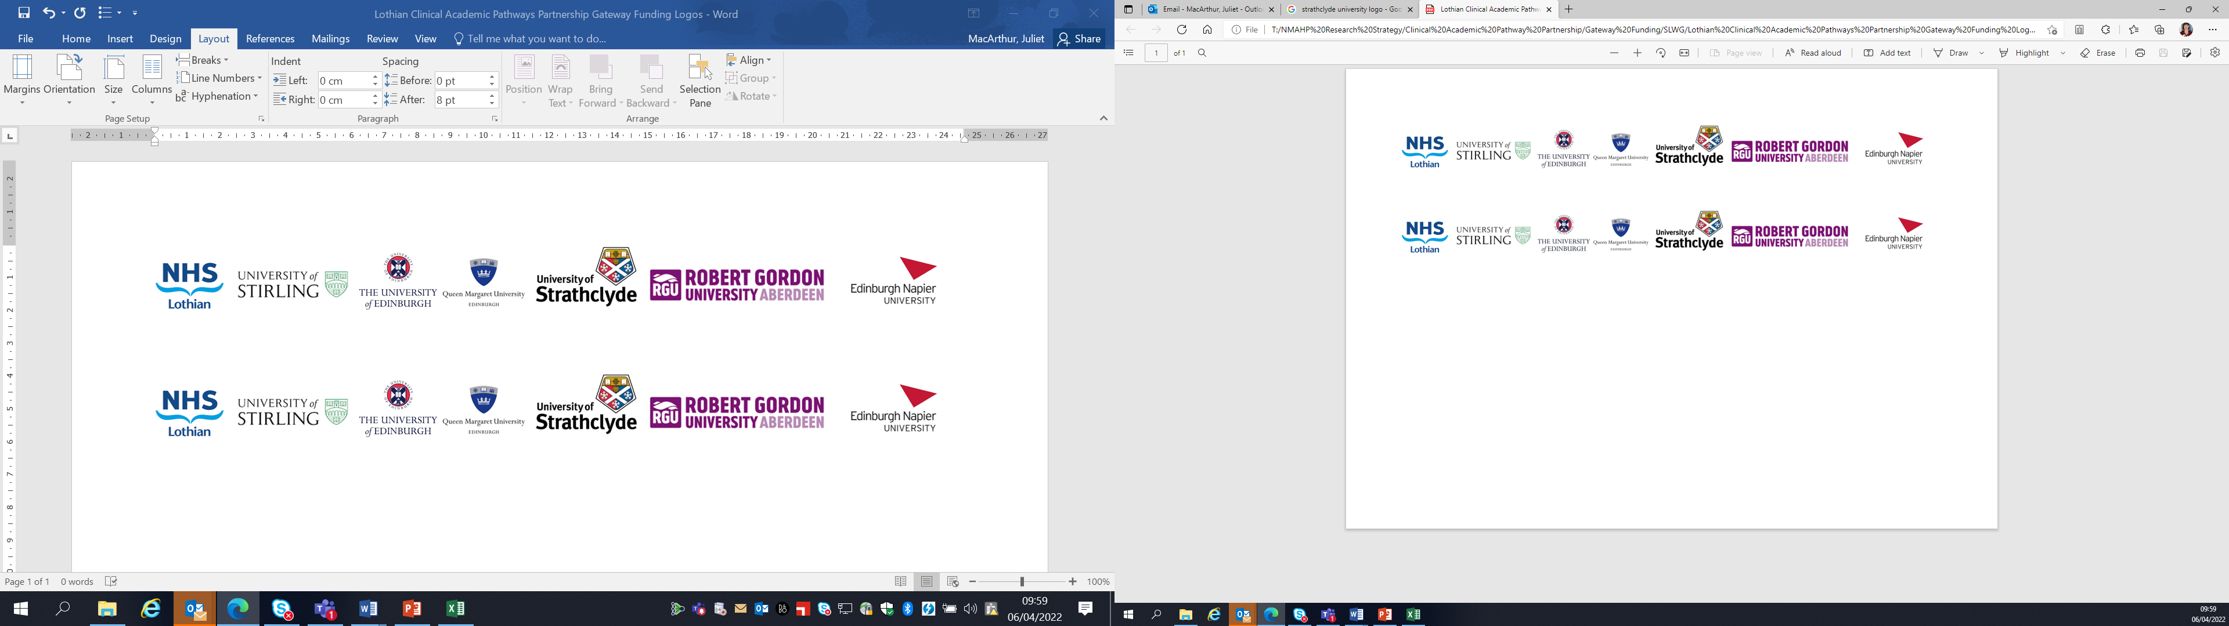Lothian Clinical Academic Pathways Partnership

Clinical Academic Research Gateway Funding

First Steps into Research Opportunities 2027
Institution & Department  Research Centre (if appropriate) | National Autism Implementation Team (NAIT), Queen Margaret University  Clinical Audiology, Speech and Language Research Centre
Contact – name, role & email | Marion Rutherford, Senior Research Fellow, mrutherford@qmu.ac.uk
Research Project/Programme Title | NAIT research programme 2025-2026 focussed on neuro-affirming practices in health, education, employment and justice contexts
Details of Research Project / Programme – including funder, team members, methodology, stage of implementation | NAIT are funded by Scottish Government (currently until end of March 2026)  Team include SLT, OT, Teachers, Psychiatrist and Researchers  A range of research is underway which includes  - Systematic review  - Evaluation of experiences of neurodivergent people with anxiety related absence from school  - Experiences of neurodivergent people in employment
Opportunities for candidate  e.g. attending meetings; data collection; data management; analysis; ethics application; dissemination activities  (bullet points) | - A range of current research team activities will be underway. We can agree with the staff member which would best suit their interests, for example  - Attending meetings  - Literature review and quality analysis following Prospero protocol  - Learning the process of systematic review  - Qualitative research – focus groups, interviews, surveys, thematic analysis
Any other considerations or information for potential candidates? (e.g. potential links to other projects, networking opportunities, specific skills needed) | This work is feeding in to the Neuro-affirming Community of Practice Scotland (also led by NAIT) and the team are involved in a range of work in developing professional learning resources or guidance and making links across research and practice.
Dates available (awards likely to be made March 2027 for start in April/May 2027) | From April 2027
Mentor(s) | Marion Rutherford

