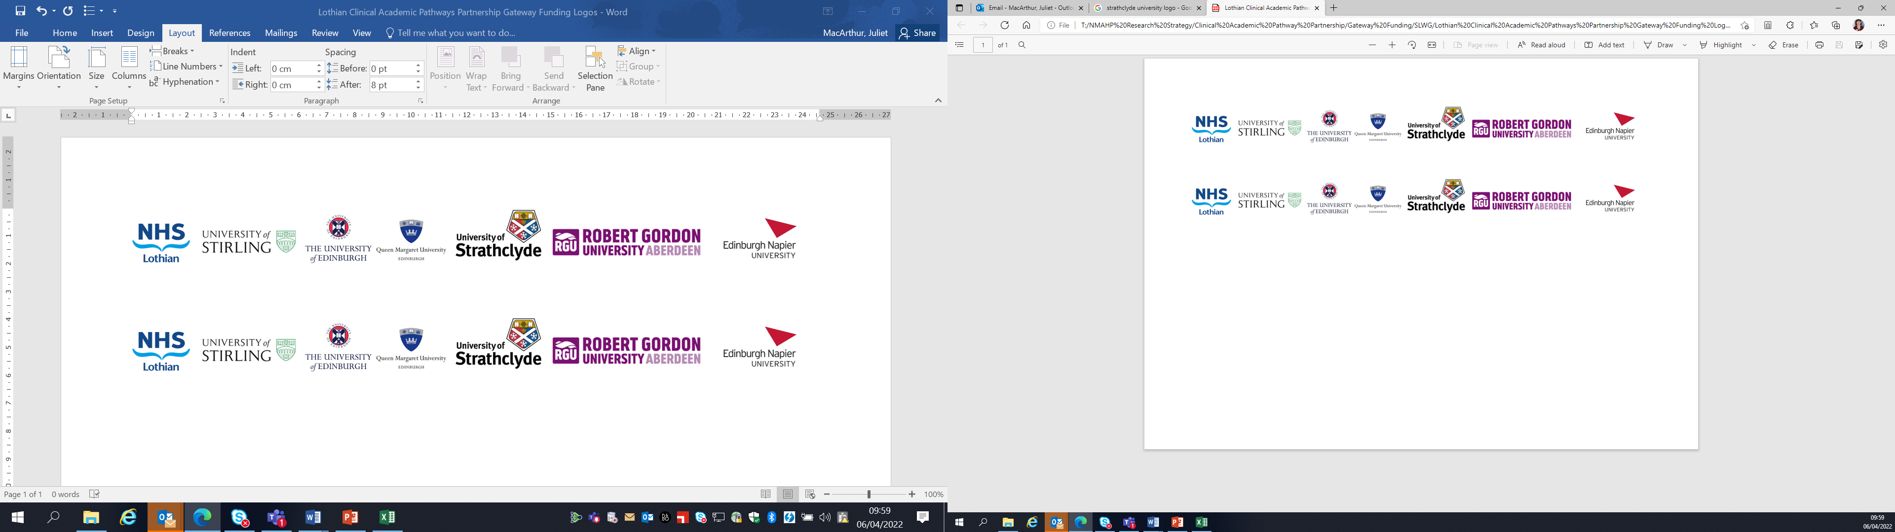Lothian Clinical Academic Pathways Partnership

Clinical Academic Research Gateway Funding

First Steps into Research Opportunities 2027
Full details of the Gateway awards scheme can be found at:
Lothian Clinical Academic Research Gateway Awards – Health and Care Professions Research

Institution & Department  Research Centre (if appropriate) | Queen Margaret University  Centre for Person-centred Practice Research
Contact – name, role & email | Gemma Stevenson, Project Lead  GStevenson@qmu.ac.uk  LydiaOsteoporosisProject@qmu.ac.uk  Vicki Waqa, Educational lead.
Research Project/Programme Title | Lydia X Osteoporosis project
Details of Research Project / Programme – including funder, team members, methodology, stage of implementation | The Lydia Osteoporosis Project is a pioneering programme based at Queen Margaret University that has been improving understanding, awareness and support for people affected by osteoporosis since 2011. The current phase of activity, Lydia X, brings together people living with osteoporosis, healthcare professionals, researchers, students and community partners with a shared goal: to raise awareness of bone health and osteoporosis prevention and management, supporting people to live well with the condition and shaping the future of care through research and collaboration.  This is achieved through focusing on three key areas, being education, engagement and research:  Education Aim: To enhance knowledge and understanding of bone health and osteoporosis among health and social care professionals, undergraduate and postgraduate healthcare students, and the public, supporting prevention, early identification and person-centred approaches to care.  Engagement Aims: To engage with people living with osteoporosis and their families/carers, facilitating education and peer support.  To build a community of people living with osteoporosis and health and social care professionals with a special interest in osteoporosis through meetings hosted at (QMU). These meetings will have educational input and space for informal networking and support.  Research Aim: To undertake person-centred research on the impact of osteoporosis and osteoporosis as a public health issue. This research will focus on improving healthcare services for people living with osteoporosis.
Opportunities for candidate  e.g. attending meetings; data collection; data management; analysis; ethics application; dissemination activities  (bullet points) | The successful candidate would become part of the Lydia project team with specific focus on working with the Research Assistant on the team who will be starting in March/April 2027. The Research Assistant will be working on the project for 3 years.  The Lydia Osteoporosis Project is currently undertaking research focused on evaluating the impact of a community café on people living with osteoporosis; as well as developing a research project using adapted experience-based co-design to explore the care needs and experiences of people living with osteoporosis and HCPs in Lothian, to identify care priorities to enable living well following a diagnosis.  Opportunities for successful candidate will be  - Become part of established research team, attending meetings whereby project progress and planning is being reviewed  - Support the research assistant in recruitment, data collection, data management. Work in relation to this may be carried out independently but always with support and supervision of research assistant and project lead/member of the project team  - Develop knowledge, understanding and application of ethical considerations in research practice  - Potentially involvement in knowledge exchange/education actives with staff/students within QMU and as part of the project within communities  - Develop understanding of how the research activities overlap with, complement and inform core educational and engagement activities.
Any other considerations or information for potential candidates? (e.g. potential links to other projects, networking opportunities, specific skills needed) | As part of the education, engagement and research activities undertaken by the project, opportunities may become available to develop links with other key partners such as in the Scottish Government, Public Health Scotland and community healthcare teams supporting the project.  The project lead, Gemma Stevenson, is also co-chair for the Nursing and Paramedic Science Divisional Research Committee, as well as Divisional representative on the University Research Ethics Committee. Opportunities may therefore become available to enhance knowledge and understanding of wider research ethics beyond the project.
Dates available (awards likely to be made Feb 2026 for start in April 2026 onwards) | April 2027
Mentor(s) | Gemma Stevenson and Vicki Waqa

