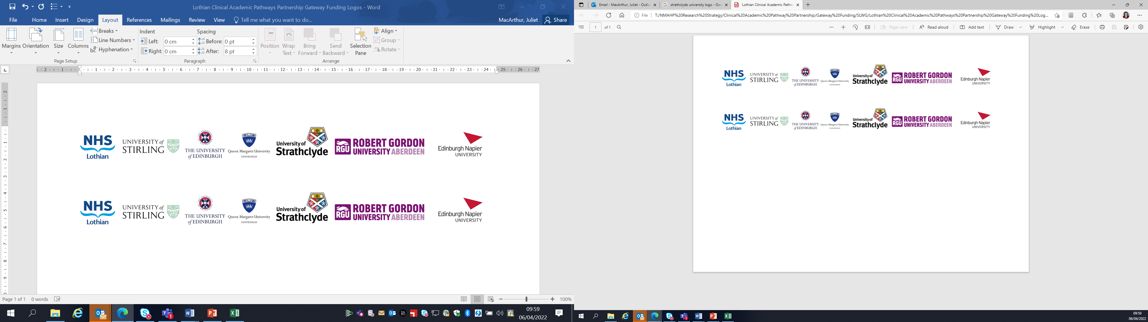Lothian Clinical Academic Pathways Partnership

Clinical Academic Research Gateway Funding

First Steps into Research Opportunities 2027
Full details of the Gateway awards scheme can be found at:
Lothian Clinical Academic Research Gateway Awards – Health and Care Professions Research

Institution & Department  Research Centre (if appropriate) | QMU- SCHOOL OF HEALTH SCIENCES-DIVISION OF PHYSIOTHERAPY, DIETETICS AND NUTRITION
Research Project/Programme Title | Young People Advisory Group for research in children living with long term conditions
Contact – name, role & email | Pelagia Koufaki, Professor of Exercise Physiology and Rehab Sciences  pkoufaki@qmu.ac.uk
Details of Research Project / Programme – including funder, team members, methodology, stage of implementation | To support an existing research project in renal paediatrics and help run a new Public and Patients Involvement initiative to support research activities and development for future studies.
Opportunities for candidate  e.g. attending meetings; data collection; data management; analysis; ethics application; dissemination activities  (bullet points) | Set up, ethics, recruitment, liaison with participants and families, establish links with local communities, develop educational participant facing materials in various formats for children with different needs, establish a PPIE network
Any other considerations or information for potential candidates? (e.g. potential links to other projects, networking opportunities, specific skills needed) | Ideally someone with experience working with children with long term conditions and families and someone with access to relevant networks and local communities
Dates available (awards likely to be made March 2027 for start in April 2027 onwards) | From April 2027
Mentor(s) – name, role & email if additional to contact above | Prof Pelagia Koufaki

