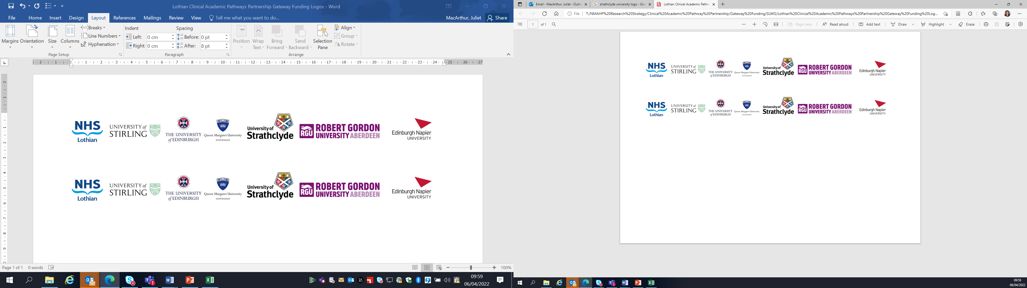Lothian Clinical Academic Pathways Partnership

Clinical Academic Research Gateway Funding

First Steps into Research Opportunities 2027

Institution & Department | NHS Lothian, Emergency Medicine Research Group of Edinburgh (EMERGE)
Contact – name, role & email | Rachel O’Brien  Research Nurse Manager  Rachel.o’brien@nhs.scot
Research Project/Programme Title | TERMINAC - Early termination of N-acetylcysteine following paracetamol overdose
Details of Research Project / Programme – including funder, team members, methodology, stage of implementation | The TERMINAC study, funded by the National Institute for Health Research, is a multicentre asking the research question - does the introduction of guidelines recommending early blood testing and stopping of N-acetylcysteine (NAC) in low-risk patients requiring treatment for a paracetamol overdose (POD) shorten their length of hospital stay and offer significant potential resource savings?  POD is a frequent reason for hospital admission and the most common cause of acute liver failure (ALF) in Western countries. The symptoms of early liver injury following POD are non-specific, so clinicians rely on blood tests to determine who requires NAC treatment using guidelines produced in the UK by the National Poisons Information Service (NPIS). All patients deemed to need treatment receive 12 hours of intravenous NAC with blood tests at the end to determine if the guideline-defined biochemical criteria for stopping NAC have been reached. UK guidelines advise treatment for patients at a lower risk of ALF than in other countries. These low-risk people with POD stand to benefit from shortening the duration of NAC treatment if it safely reduces their length of hospital stay and saves the NHS money.  Aims and objectives  To determine whether the introduction of guidelines recommending stopping NAC based on early blood testing (after 6 hours of treatment) is superior to standard care (blood testing at end of 12 hours NAC treatment) regarding the time from hospital presentation to discharge readiness.  Methods  Design: A parallel group, cluster randomised trial with waiver of consent.  Setting: 40 NHS Hospitals with Type 1 emergency departments.  Population: Adults and young people (age 12 years and above) presenting to hospital following a POD that requires NAC treatment (as per NPIS guidelines) and who have a high likelihood of a negative 6-hour paracetamol blood test and are at a low risk of liver injury (identified by routine pre-treatment blood tests).  Intervention (half of sites randomly assigned): Guideline for the early stopping of NAC informed by the results of blood testing at 6 hours after the start of treatment.  Comparator (half of sites randomly assigned): Standard clinical care (blood testing at end of 12-hour NAC treatment).  Outcome: Time from hospital presentation to completion of treatment for the overdose episode or hospital discharge, whichever is first.  The study is design is currently underway with the aim to start recruitment in Summer 2027.
Opportunities for candidate  e.g. attending meetings; data collection; data management; analysis; ethics application; dissemination activities  (bullet points) | The candidate will be able to get involved with the following:  - data collection  - data management  - Trial team meetings  - Interacting with other UK emergency medicine research groups.
Any other considerations or information for potential candidates? (e.g. potential links to other projects, networking opportunities, specific skills needed) | There will be the opportunity to network with colleagues in the University of Edinburgh as well as NHS colleagues working in emergency medicine research.  Having completed the National Institute of Health Research Good clinical Practice course before starting would be advantageous (Good Clinical Practice | NIHR) or attend an in person course at the Wellcome Trust Clinical Research Facility which is free of cost (Courses and events | Edinburgh Clinical Research Facility)  The team also have several toxicology projects ongoing that the candidate could get involved with. More information can be found here Current Research – Emerge Research  There may also be conferences that the candidate would be able to attend relevant to toxicology/emergency medicine.
Dates available (awards likely to be made March 2027 for start in April/May 2027) | Flexible with availability.
Mentor(s) | Caroline Blackstock, Lead Research Nurse  Rachel O’Brien, Clinical Research Nurse Manager

