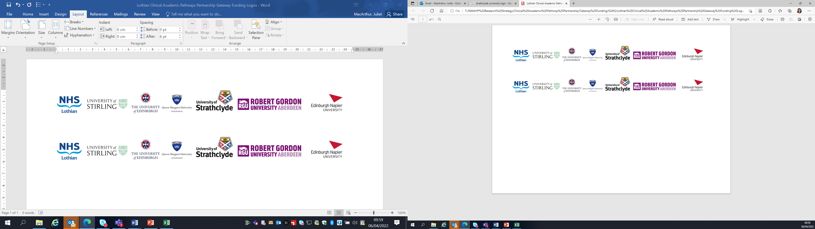Lothian Clinical Academic Pathways Partnership

Clinical Academic Research Gateway Funding

First Steps into Research Opportunities 2027
Full details of the Gateway awards scheme can be found at:
Lothian Clinical Academic Research Gateway Awards – Health and Care Professions Research

Institution & Department  Research Centre (if appropriate) | NRS South East Cancer Research Network, Edinburgh Cancer Centre, Western General Hospital, Edinburgh
Research Project/Programme Title | Cancer Clinical Trials
Contact – name, role & email | Heather McVicars (Oncology Clinical Research Nurse Manager)  heather.mcvicars@nhs.scot
Details of Research Project / Programme – including funder, team members, methodology, stage of implementation | This placement offers an exciting introduction to clinical research within one of Scotland's largest cancer research programmes. Working alongside experienced clinical research nurses, trial practitioners, data managers and research professionals, the applicant will gain insight into how cancer clinical trials are developed, delivered and translated into improvements in patient care. They will have the opportunity to explore the full patient journey within clinical trials and gain an understanding of the multidisciplinary teams that support cancer research.
Opportunities for candidate  e.g. attending meetings; data collection; data management; analysis; ethics application; dissemination activities  (bullet points) | What You Will Experience  - Shadow clinical research nurses delivering complex oncology clinical trials.  - Observe patient recruitment, consent discussions and trial follow-up visits.  - Gain an understanding of Good Clinical Practice (GCP) and research governance.  - Explore the role of research in improving cancer treatments and patient outcomes.  - Learn about trial coordination, study set-up and regulatory requirements.  - Spend time with the oncology data management team to understand how clinical trial data is collected, managed and analysed.  - Gain exposure to cancer informatics and the use of clinical data to support research and service improvement.  - Attend relevant research meetings and multidisciplinary discussions.  Potential Learning Activities  Depending on the participant's interests and experience, activities may include:  - Contributing to a literature review or evidence summary.  - Supporting data collection or data quality activities within a research project.  - Exploring patient experience or service improvement initiatives linked to research.  - Developing a small piece of work or presentation based on learning gained during the placement.  - Networking with clinical academics, research nurses and other research professionals across NHS Lothian.  What You Will Gain  By the end of the placement, participants will have:  - A greater understanding of clinical research processes.  - Experience of working within a multidisciplinary research environment.  - Enhanced knowledge of cancer trials, data management and research governance.  - Increased confidence in engaging with research within their own clinical area.  - Insight into potential future clinical academic and research career pathways.
Any other considerations or information for potential candidates? (e.g. potential links to other projects, networking opportunities, specific skills needed) | Depending on the learning ambition of the candidate – we can tailor the placement to an individual group of patients or one specific clinical trial rather than a broad overview of the department.
Dates available (awards likely to be made March 2027 for start in April 2027 onwards) | Flexible
Mentor(s) – name, role & email if additional to contact above | Dependent on the applicant/job family and placement within the team.

