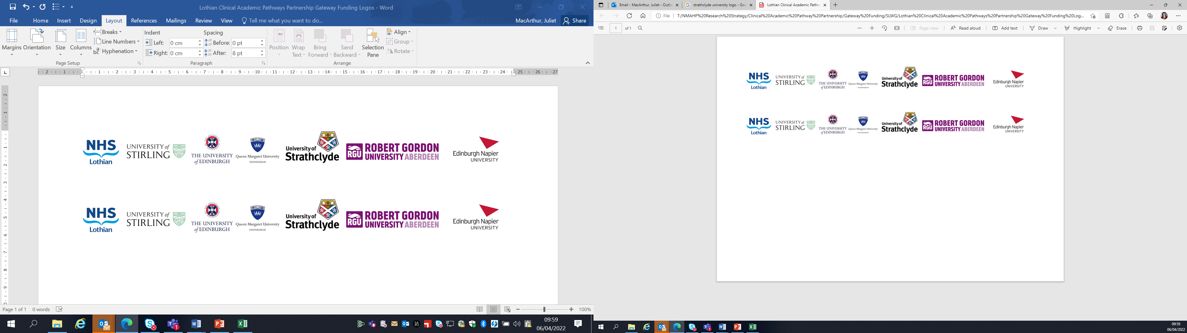Lothian Clinical Academic Pathways Partnership

Clinical Academic Research Gateway Funding

First Steps into Research Opportunities 2027
Institution & Department  Research Centre | Edinburgh Napier University (ENU): School of Health and Social Care and the School of Art and Creative Industries.  Linking to the ENU led interprofessional Working with Archives research group.
Contact – name, role & email | Nicola Ring, Professor of Nursing n.ring@napier.ac.uk
Research Project/  Programme Title | Researching Scotland’s forgotten 18th-century expert midwives: analysis of midwife Mrs Cowper’s birth book.
Details of Research Project / Programme – including funder, team members, methodology, stage of implementation | Background: Pre-20th-century Scottish women-midwives are frequently portrayed as incompetent, unsafe and inadequately trained. Highland midwife Mrs. Cowper is an important corrective to this narrative of incompetence as she was a highly regarded midwife. Research to-date suggests she was trained by an Edinburgh man-midwife professor and church sponsored.  Mrs. Cowper’s internationally rare original register records 3,948 babies from 1786 to 1843. The research team has conducted initial analysis for years 1786-18060 to e.g., identify her annual recorded births and baby deaths (no maternal deaths are recorded). Project data is in the public domain and held by the National Records of Scotland.  This research placement aim is to conduct further descriptive analysis of Mrs Cowper to learn more about her work. Specifically, this placement holder would:  - Extract register data for years 1807-1843.  - Descriptively analyse extracted data e.g., to quantify number of babies birthed each month per year including multiple births and baby deaths.  - Assist with writing a narrative data report with tables and figures.  - Share data findings in online project team meetings including with research parters in Caithness and Canada.  - Present research findings at an ENU Working with the Archives research meeting. This interdisciplinary group includes academics at other universities and archivists and curators in external organisations.
Opportunities for candidate  e.g. attending meetings; data collection; data management; analysis; ethics application; dissemination activities | Whilst this placement uses historical data, this project gives excellent opportunity to develop transferable research skills e.g., in extracting and analysing quantitative data, disseminating results, attending team meetings, networking. This placement gives opportunities to share research findings within a written report and via research presentations (with mentors and external partners).  There will be post-placement opportunities for the awardee to participate in dissemination activities, if they wish. In particular, collected data will contribute to a peer reviewed journal paper, the placement holder could be a co-author.
Any other considerations or information for potential candidates? (e.g. potential links to other projects, networking opportunities, specific skills needed) | Additional background information:  The mentors learned about Mrs. Cowper in 2024 when her 1843 John O’Groat newspaper death-notice was found when they worked with Scotland’s National Library and the Royal College of Nursing on a nursing and midwifery history public event. This death-notice indicated Mrs. Cowper was a highly regarded midwife. As little is known about women-midwives in the 1700s, mentors NR/NM have been working from this death-notice to research Mrs. Cowper. Their research has led to them working with Canada’s University of Guelph, Caithness Archives, Scotland’s National Records and Toronto’s Campbell House Museum and sharing Mrs. Cowper’s story at Edinburgh’s International Fringe Festival. Inter-disciplinary, international cross sector working will be part of this placement (in-person and online).  More placement details:  This research is about Scottish midwifery history but, the placement is open to anyone. No specific skills, experience or healthcare background is required – all that is needed is an interest in history!  Mentors NR/NM (see below) are based at ENU’s Sighthill Campus with mentor SB at ENU’s Merchiston Campus. Placement research meetings will likely be online.  Much of this placement takes place at Scotland’s National Records at General Register House on Edinburgh’s Prince’s St. where Mrs. Cowper’s book is kept. The placement holder will need to register with the National Records as a reader to access the book. (This is free but proof of identity and photo needed).  Placement days are flexible. This placement involves lots of independent working but, with regular mentor support (in-person, online and phone). Data will be extracted into an existing template in MS word or excel documents.
Dates available | 1st April 2027 (start date flexible)
Mentor(s) | Nicola Ring is a Professor of Nursing at ENU and RCN History of Nursing Forum Committee Member. She has extensive experience in conducting research into the history of nursing and midwifery including leading the highly impactful RCN Foundation funded project researching Scotland’s early nurses and midwives accused of witchcraft.  Ness McHugh is a midwifery lecturer at ENU. She has extensive knowledge of the history of midwifery and is experienced in nursing and midwifery history research including as a member of the accused witches project.  Sana Bilgrami is a film lecturer at ENU and an award-winning filmmaker. She leads ENU’s interprofessional Working with Archives research group. She has conducted nursing history research and produced a highly acclaimed film based on this output.

