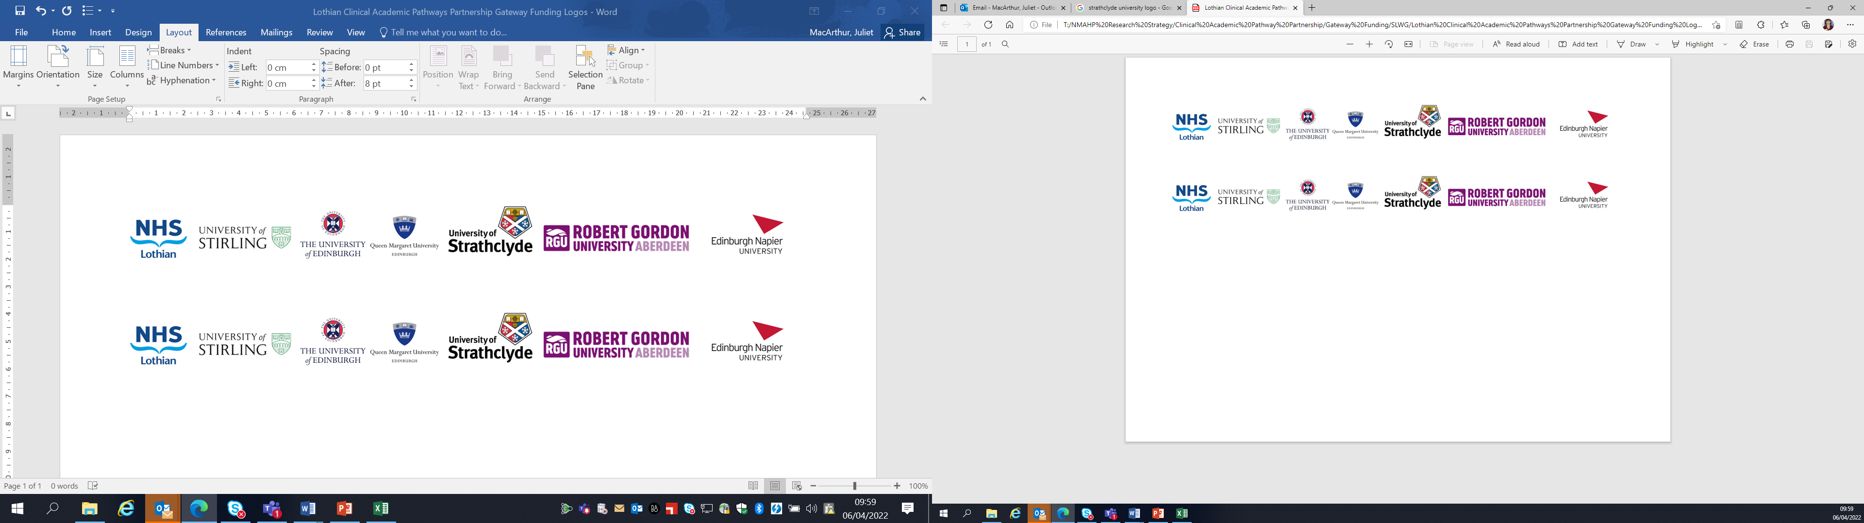Lothian Clinical Academic Pathways Partnership

Clinical Academic Research Gateway Funding

First Steps into Research Opportunities 2027

Institution & Department  Research Centre (if appropriate) | Edinburgh Napier University – School of Health and Social Care, Midwifery Subject Group
Contact – name, role & email | Professor Yvonne Kuipers y.kuipers@napier.ac.uk  Dr Alix Aitken-Arbuckle a.aitken-arbuckle@napier.ac.uk
Research Project/Programme Title | Continuity of Midwifery Care
Details of Research Project / Programme – including funder, team members, methodology, stage of implementation | This body of work is part of the Continuity of Midwifery Care research network which aims to unite academia and practice in Scotland and boost the evidence and conversations regarding CoC. As a group we aim to draw on knowledge and expertise within our network to establish leadership in CoC.  Current projects include:  Evaluation of Continuity of midwifery care in Scotland: A nested case-control study.  Aims: To evaluate the outcomes of midwife continuity of care by examining the differences in outcomes between those who received midwife-led continuity of care and those who did not (care-as –usual) in NHS Lothian.  Development of a research strategy for CoC from the perspective of all relevant Scottish stakeholders on macro-, meso- and microlevel.  Aim: To have a stakeholder-informed research mission, vision and agenda for continuity of care in the Scottish context.  The analysis of the Scottish research journey following the introduction of the Best Start, continuity of care in particular, through the lens of complexity theory.  Aim: To identify and structure the research that was conducted following the introduction of the Best Start framework in 2017 that evaluated, explored, interpreted and compared or described continuity of midwifery care in Scotland.  The Continuity of Carer newsletter.  Aim: To contribute to the current diverse and constrained utilisation of Coc despite its sound and vast evidence base; to communicate about Coc; To address the gap between CoC research, practice and education.  The midwife stories podcast.  Aim: To showcase the many faces of continuity of midwifery care by sharing midwives' experiences and perspectives and unique stories, uncovering how continuity is practiced, valued, and reimagined across different contexts, highlighting diverse perspectives on what continuity of care is and what it has the potential to become.
Opportunities for candidate  e.g. attending meetings; data collection; data management; analysis; ethics application; dissemination activities  (bullet points) | - Involvement in research design and ethics process,  - Attending meetings, networking and stakeholder events  - Helping with recruitment and data collection  - Data analysis  - Collaborating in publication and dissemination  - GCP training
Any other considerations or information for potential candidates? (e.g. potential links to other projects, networking opportunities, specific skills needed) | We encourage applications from midwives who have an interest in midwifery-led research and would like to develop their knowledge and skills in both quantitative and qualitative methods.
Dates available (awards likely to be made March 2027 for start in April/May 2027) | Anytime from April 2027 onwards
Mentor(s) | Dr Alix Aitken-Arbuckle  Professor Yvonne Kuipers

