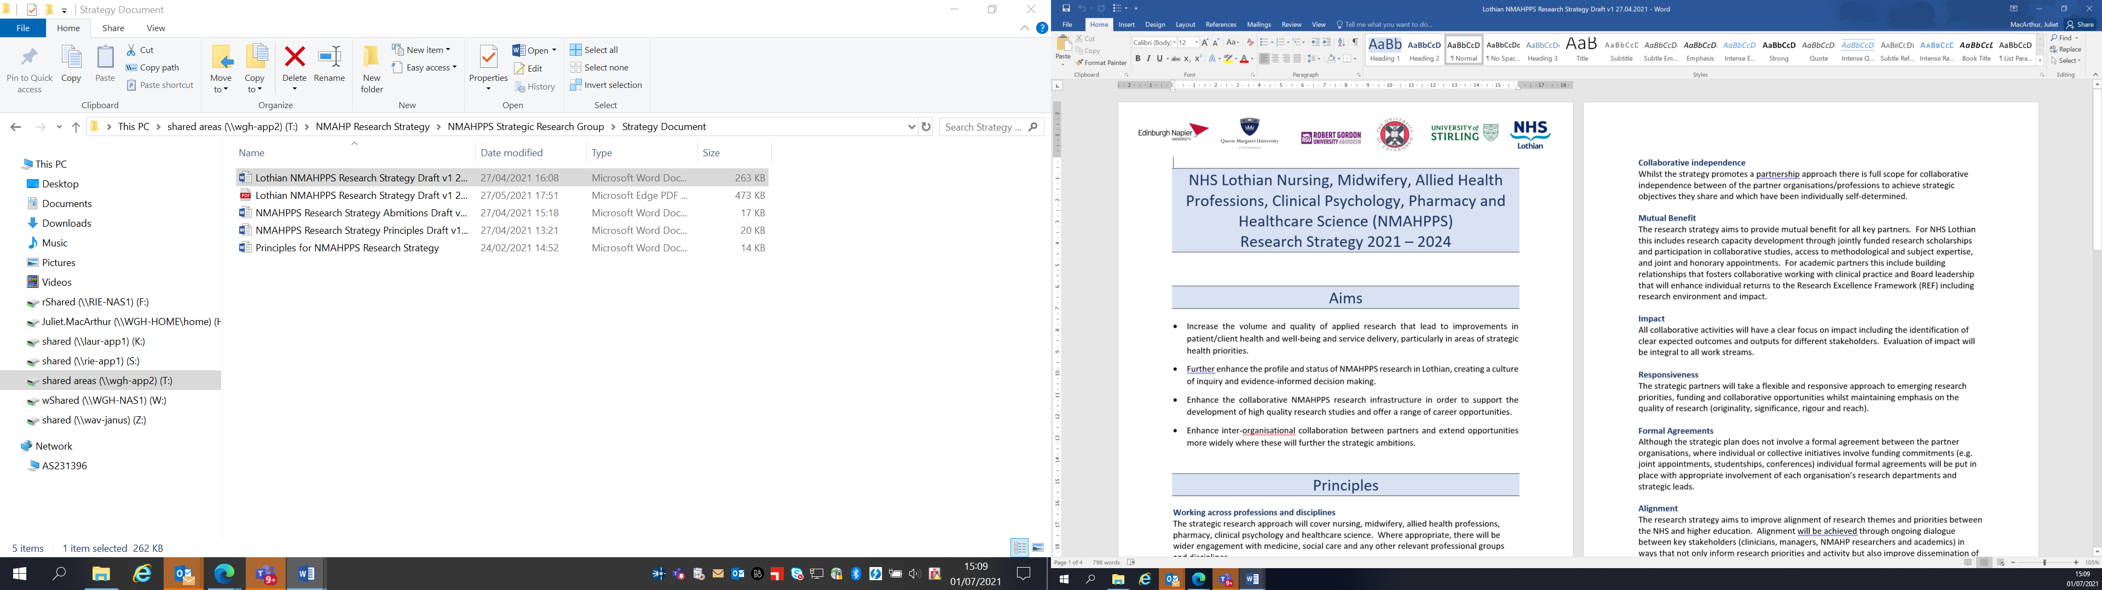Lothian Clinical Academic Pathways Partnership

Clinical Academic Research Gateway Funding

First Steps into Research Opportunities 2027
Institution & Department | Cardiovascular Research Centre, School of Health and Social Care, Edinburgh Napier University
Contact – name, role & email | Prof Lis Neubeck, Professor of Cardiovascular Health & Head of Cardiovascular Research Centre  l.neubeck@napier.ac.uk
Research Theme | Cardiovascular Research
Specific Research Project – including methodology, stage of implementation | We are offering the opportunity for a ‘First Steps’ opportunity across the entire portfolio of active research studies within the Cardiovascular Research Centre. These include studies on atrial fibrillation, stroke rehabilitation, mental health in women with chest pain, particularly spontaneous coronary artery dissection (SCAD), physical activity referral schemes, the role of AI in creating physical activity guidelines, digital and blood pressure management. The projects are all in various stages of implementation and as such will give the intern exposure to the different stages of research implementation as well as thematic aspects.
Opportunities for candidate  e.g. attending meetings; data collection; data management; analysis; ethics application; dissemination activities  (bullet points) | The candidate may have the opportunity to:  - Attend Cardiovascular Research Centre Team meetings;  - Attend individual trial meetings;  - Work alongside research staff and students analysing data sets;  - Work alongside research staff and students in making ethical applications for clinical research;  - Develop patient-facing information such as Participant Information Sheets and consent forms;  - Meet clinical groups of staff to discuss research activities;  - Support dissemination activities such as abstract writing and creating poster presentations.
Any other considerations for potential candidates? | The work undertaken by the Cardiovascular Research Centre is multi-disciplinary in nature and thus we welcome interns from medical, nursing or Allied Health Professions backgrounds.
Dates available (awards likely to be made March 2027 for start in April/May 2027) | Flexible
Mentor(s) | Prof Lis Neubeck  Dr Coral Hanson  Prof Alison Porter-Armstrong

