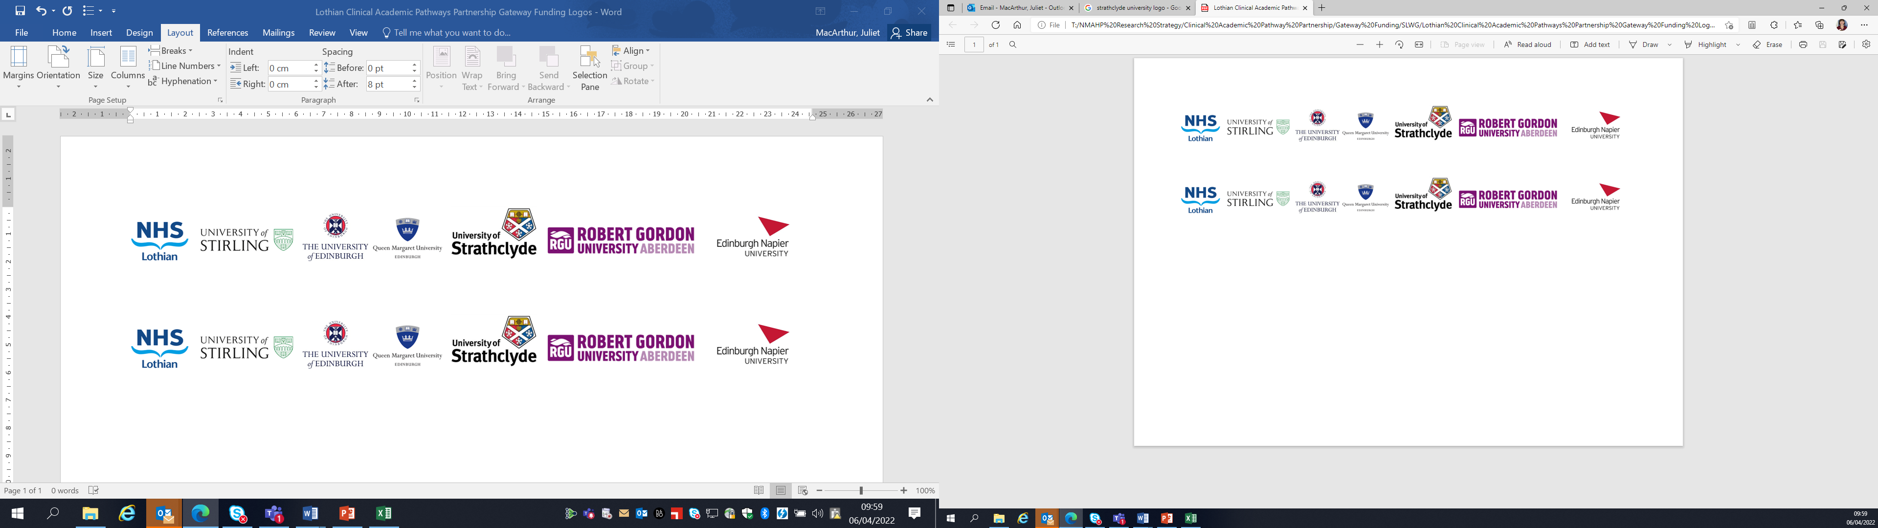Lothian Clinical Academic Pathways Partnership

Clinical Academic Research Gateway Funding

First Steps into Research Opportunities 2026
Institution & Department  Research Centre (if appropriate) | National Autism Implementation Team (NAIT), Queen Margaret University  Clinical Audiology, Speech and Language Research Centre
Contact – name, role & email | Marion Rutherford, Senior Research Fellow, mrutherford@qmu.ac.uk
Research Project/Programme Title | NAIT research programme 2025-2026 focussed on neuro-affirming practices in health, education, employment and justice contexts
Details of Research Project / Programme – including funder, team members, methodology, stage of implementation | NAIT are funded by Scottish Government (currently until end of March 2026)  Team include SLT, OT, Teachers, Psychiatrist and Researchers  A range of research is underway which includes  - Systematic review  - Evaluation of experiences of neurodivergent people with anxiety related absence from school  - Experiences of neurodivergent people in employment
Opportunities for candidate  e.g. attending meetings; data collection; data management; analysis; ethics application; dissemination activities  (bullet points) | - A range of current research team activities will be underway. We can agree with the staff member which would best suit their interests, for example  - Attending meetings  - Literature review and quality analysis following Prospero protocol  - Learning the process of systematic review  - Qualitative research – focus groups, interviews, surveys, thematic analysis
Any other considerations or information for potential candidates? (e.g. potential links to other projects, networking opportunities, specific skills needed) | This work is feeding in to the Neuro-affirming Community of Practice Scotland (also led by NAIT) and the team are involved in a range of work in developing professional learning resources or guidance and making links across research and practice.
Dates available (awards likely to be made February 2026 for start in April 2026) | Work underway now (October 2025-March 2026) with the hope but not guarantee of continued funding into 2026-27.
Mentor(s) | Marion Rutherford

