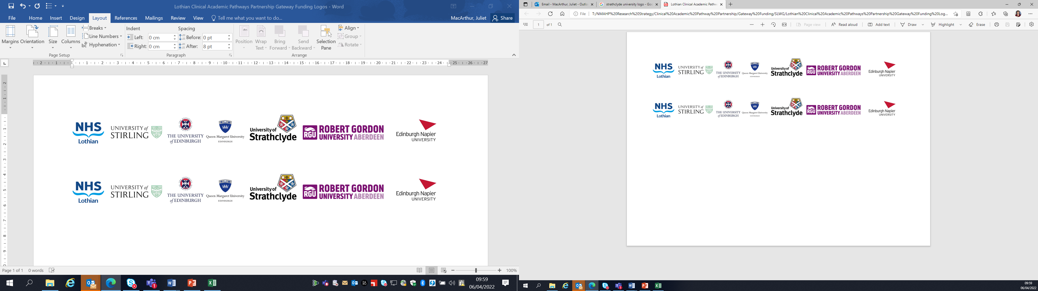Lothian Clinical Academic Pathways Partnership

Clinical Academic Research Gateway Funding

First Steps into Research Opportunities 2026
Full details of the Gateway awards scheme can be found at:
Lothian Clinical Academic Research Gateway Awards – Health and Care Professions Research

Institution & Department  Research Centre (if appropriate) | Queen Margaret University - School of Health Sciences - Division of Nursing and Paramedic Science
Contact – name, role & email | Dr Alison Wood, Senior Lecturer  awood1@qmu.ac.uk
Research Project/Programme Title | Qualitative Kidney Care Research Collaboration
Details of Research Project / Programme – including funder, team members, methodology, stage of implementation | Support the ongoing research contribution by QMU into work led by Queen’s University Belfast in relation to Kidney Care  Support ongoing research within a current Kidney research collaboration  Various projects are underway including:  - mindfulness within the kidney patient group  - sexual health, evaluating the preparedness of HCPs and patients to engage with sexual health discussions in dialysis care
Opportunities for candidate  e.g. attending meetings; data collection; data management; analysis; ethics application; dissemination activities  (bullet points) | - Involvement in research design and ethics process  - Attending research meetings  - Helping with recruitment and data collection  - Data analysis  - Collaborating in publication and dissemination
Any other considerations or information for potential candidates? (e.g. potential links to other projects, networking opportunities, specific skills needed) | Any professional background  The candidate should be interested in kidney care and in qualitative research.
Dates available (awards likely to be made Feb 2026 for start in April 2026 onwards) | April 2026
Mentor(s) | Dr Alison Wood awood1@qmu.ac.uk

