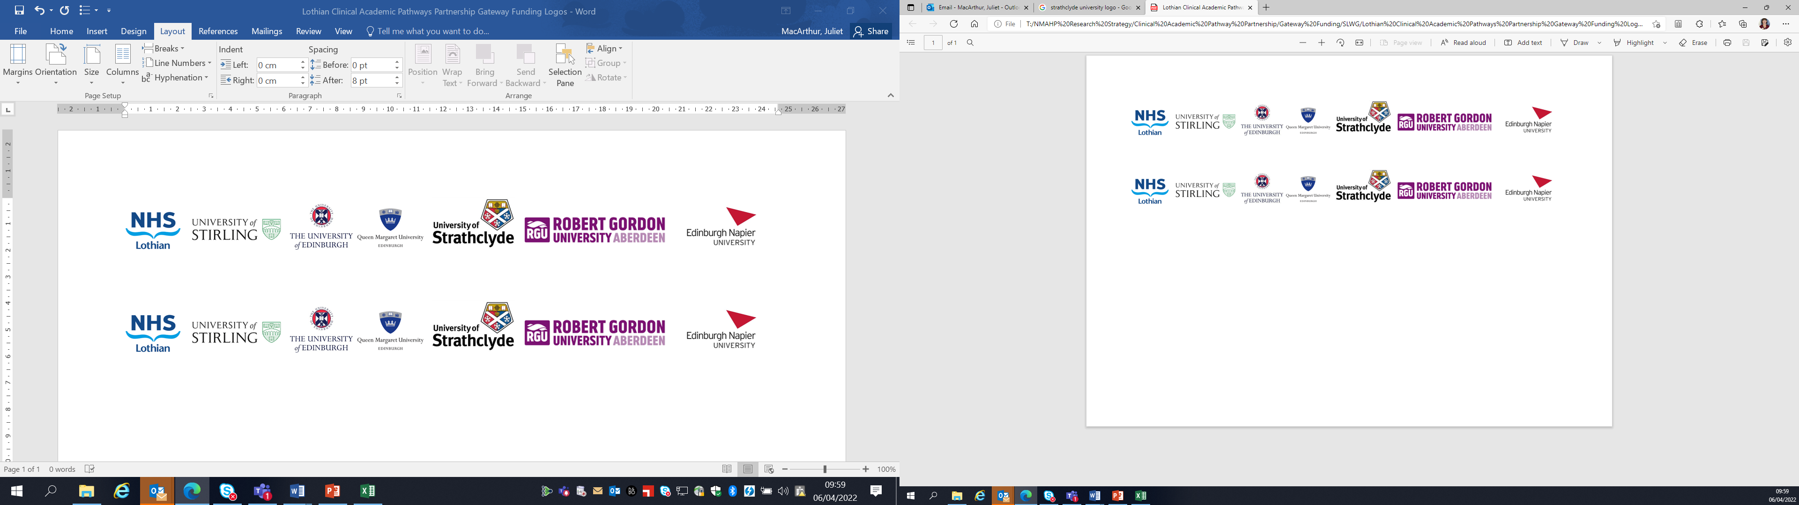Lothian Clinical Academic Pathways Partnership

Clinical Academic Research Gateway Funding

First Steps into Research Opportunities 2026

Institution & Department  Research Centre (if appropriate) | Queen Margaret University, Physiotherapy  Centre for Health, Activity and Rehabilitation Research  (CHEARR)
Contact – name, role & email | Kavi Jagadamma, senior lecturer Physiotherapy and PI of the study funded by the CSO described below.  Marietta van der Linden, co-director of CHEARR, co-applicant  Mvanderlinden@qmu.ac.uk
Research Project/Programme Title | Longitudinal profiles of lower limb range of motion in children with cerebral palsy using data from the Cerebral Palsy Integrated Pathway Scotland programme
Details of Research Project / Programme | Please see below the lay summary of the project funded by the CSO.  Cerebral Palsy (CP) is the most common physical disability in childhood and frequently affects mobility and posture. The Cerebral Palsy Integrated Pathway Scotland (CPIPS) programme was initiated by two of the applicants, providing a standardised musculoskeletal management programme for all children and young people (CYP) with CP in Scotland. Routinely recorded data include joint range of movement (‘flexibility’), mobility level, physical activity participation and a range of clinical and sociodemographic variables.  CPIPS thus provides a unique opportunity to generate a detailed profile of the change in musculoskeletal characteristics such as joint range of motion over time, as well as key factors influencing this change. Such information will not only support clinical decision making but will also address the needs of CYP with CP and their parents (‘know what to expect’).  The proposed project has therefore three stages. During stage 1 focus groups will be conducted with stakeholders such as health professionals, CYP with CP and their parents/carers to identify what information that can be extracted from the CPIPS data would be important to them. During stage 2 these data will be extracted and analysed using advanced statistical modelling methods. During stage 3 materials that are meaningful and appropriate to each of the stakeholder groups will be developed to disseminate the findings of the analyses of the CPIPS data.
Opportunities for candidate  e.g. attending meetings; data collection; data management; analysis; ethics application; dissemination activities  (bullet points) | - Attending steering group meetings  Depending on the background & experience of the applicant,  - data cleaning  - Assisting with the focus group sessions as observer/note taker  - data analysis (either quantitative or qualitative)  - literature searches  - Assist in the development of community-facing dissemination material
Any other considerations or information for potential candidates? (e.g. potential links to other projects, networking opportunities, specific skills needed) | The potential candidate will be encouraged to attend research and knowledge exchange centre seminars and meetings. Either those organised by CHEARR, but opportunities offered by relevant other research centres will also be highlighted, hence providing a wide range of networking opportunities.
Dates available (awards likely to be made Feb/Mar 2026 for start in Mar/Apr 2026) | March-June 2026
Mentor(s) | Kavi Jagadamma, Judith Lane, Marietta van der Linden  Mvanderlinden@qmu.ac.uk

