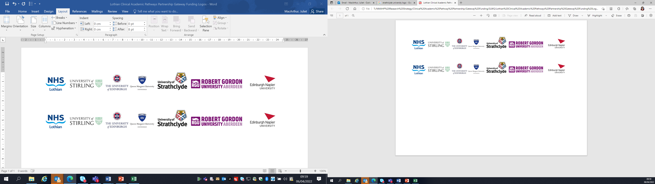Lothian Clinical Academic Pathways Partnership

Clinical Academic Research Gateway Funding

First Steps into Research Opportunities 2026

Institution & Department  Research Centre (if appropriate) | (i) University of Edinburgh, Usher Institute (ii) Royal Hospital for Children and Young People (NHS Lothian), Paediatric Critical Care Unit (PCCU)
Contact – name, role & email | Dr Milly Lo, Consultant Paediatric Intensivist, Milly.Lo@nhs.scot
Research Project/Programme Title | Data driven improvement research in paediatric critical and acute care / IMPACT-ACE programme
Details of Research Project / Programme – including funder, team members, methodology, stage of implementation | The candidate will be supervised to either work on existing projects or build their own nurse / AHP led data driven improvement pilot project within IMPACT-ACE programme. This allows the candidate to learn about data-driven projects’ study design, data analyses techniques with the following funded projects: KidsBrainIT (MRC; Ian Piper – Data analyist and Health Care Scientist; secondary analyses of prospective observational big data study); Windows in the Brains (WiB-2) (CSO; Javier Escuderdo – biomedical engineer, Vera Nenadovic – Nurse scientist, Laura Smith – Clinical Psychologist + research co-ordinator; multi-centre data collection + secondary analyses prospective observational big data EEG study; PPI activities); PPI and clinician engagements within the Intensive-Share PPIE group (Laura Smith, Clinical Psychologist and PPIE lead).
Opportunities for candidate  e.g. attending meetings; data collection; data management; analysis; ethics application; dissemination activities  (bullet points) | The successful candidate will be fully integrated into our research programme with opportunities to: (i) attend and participate in local (IMPACT-ACE) and international research consortium meetings (KidsBrainIT and WiB-2) led by Dr. Lo. (ii) participate in data collection and mixed methods analysis; (iii) learn data management and research co-ordination; (iv) actively involve in ethics application and amendment process; (v) to learn and actively participate in grant applications; (vi) dissemination activities including presentations at national and international scientific conferences, manuscripts drafting for peer review journal publications, PPI activities, and clinicians-researchers engagements.  The successful candidate will have the opportunity to engage with the well-established adult Critical Care team, shadowing recruitment and data collection activities and understanding research management and governance.  We will arrange for the successful candidate to spend time in the Paediatric Clinical Research Facility. This facilitates learning about research governance and management of a wide range of interventional and observational studies involving children.
Any other considerations or information for potential candidates? (e.g. potential links to other projects, networking opportunities, specific skills needed) | As Dr. Lo led international research consortia (KidsBrainIT and WiB-2), the successful candidate will have ample networking opportunities with international leading nurse scientists in both high income and lower middle income countries to facilitate future collaborations for the candidate’s research career. The successful candidate will have links with leading researchers in different disciplines (e.g. biomedical engineering, health care scientists, data scientists specialising in data visualisations, clinical psychologists) and the first Scottish PPI group for PCCU.
Dates available (awards likely to be made Feb/Mar 2026 for start in Mar/Apr 2026) | 1 April 2026
Mentor(s) | (i) Dr. Tsz-Yan Milly Lo; (ii) Dr. Laura Smith

