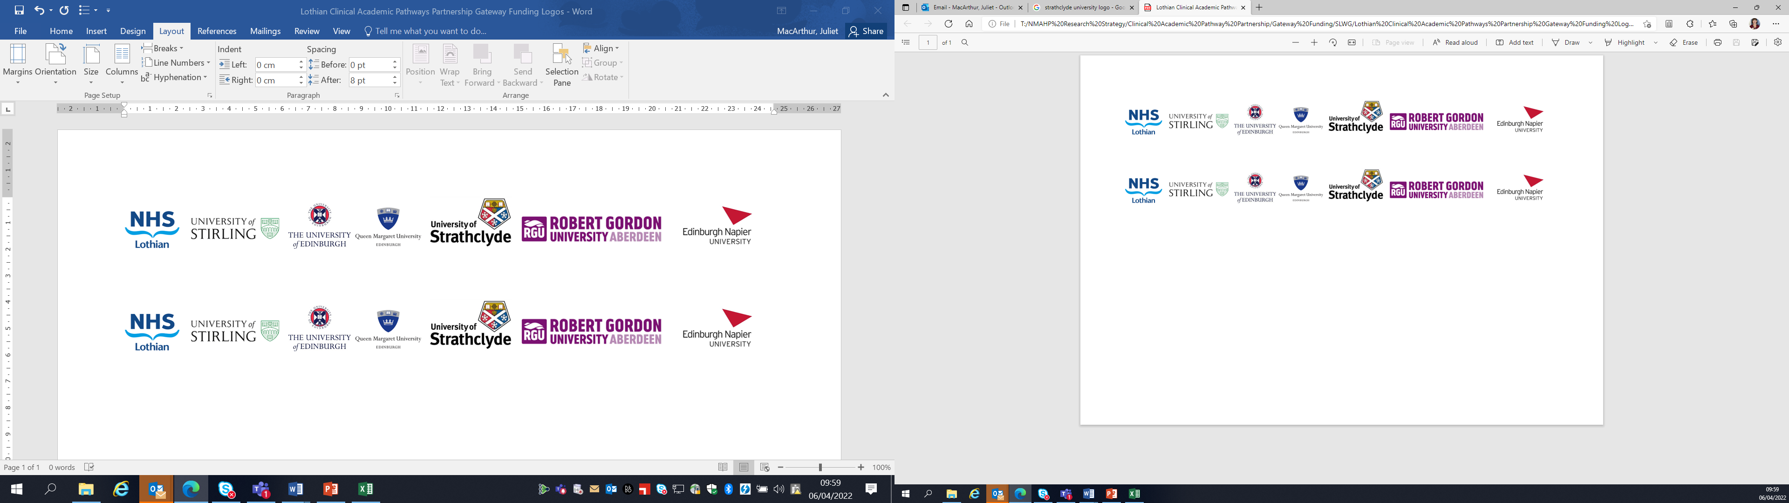Lothian Clinical Academic Pathways Partnership

Clinical Academic Research Gateway Funding

First Steps into Research Opportunities 2026
Full details of the Gateway awards scheme can be found at:
Lothian Clinical Academic Research Gateway Awards – Health and Care Professions Research

Institution & Department  Research Centre (if appropriate) | Paediatric Rheumatology  Royal Hospital for Children and Young People  Edinburgh
Contact – name, role & email | Dr Catriona Anderson, Consultant Paediatric Rheumatologist, Edinburgh  Dr Mary Brennan, Consultant Paediatric Rheumatologist, Edinburgh  Dr Eve Smith, University of Glasgow, Honorary Consultant Paediatric Rheumatologist, Edinburgh
Research Project/Programme Title | Developing CAIRN, the Child-to-adulthood Arthritis and Inflammation Research Network across Scotland.
Details of Research Project / Programme – including funder, team members, methodology, stage of implementation | The candidate will play a pivotal role in establishing the new Child-to-Adulthood Arthritis and Inflammation Research Network (CAIRN). CAIRN is designed to become a leading pan-Scotland research network focused on Juvenile Idiopathic Arthritis (JIA) and related Rheumatic and Musculoskeletal Diseases (RMDs). Building on the strong clinical foundations of the Scottish Paediatric and Adolescent Rheumatology Network (SPARN), CAIRN will drive collaborative, high-quality research across the life course. The candidate will contribute to the setup and delivery of new CAIRN studies and actively support ongoing research within the Department of Paediatric Rheumatology at the Royal Hospital for Children and Young People, Edinburgh.  Funder: Recent funding secured from NIHR Versus Arthritis Musculoskeletal Translational Research Collaboration (TRC) and also from the NIHR for the HTA supported FIRST trial. BCRD JIA registry receives per patient funding from the University of Manchester.  Team Members: Catriona Anderson (Consultant Paediatric Rheumatology, Edinburgh), Mary Brennan (Consultant Paediatric Rheumatology, Edinburgh), Eve Smith (Clinical Senior Lecturer, University of Glasgow), SPARN members, national paediatric rheumatology collaborators through the National Versus Arthritis Clinical Studies Group.  Methodology:  - Observational registry studies (JSLE, JIA, JDM)  - Imaging-based study (functional brain MRI in JIA)  - Randomised controlled trial (NIHR HTA FIRST trial: Rituximab vs placebo for SLE aged 5+)  - Remote national web-based studies (NIHR funded IMPACT, PeRFekT)  Stage of Implementation:  - Registries: Active and recruiting  - Functional MRI study: Funding obtained, set-up phase  - FIRST trial: Opening in 2026 for recruitment  - Remote national web-based studies: on-going, recruiting
Opportunities for candidate  e.g. attending meetings; data collection; data management; analysis; ethics application; dissemination activities  (bullet points) | - Attend local, national and international research team meetings (Edinburgh/Glasgow, SPARN, National Versus Arthritis Clinical Studies Group.  Scottish Society of Rheumatology (SSR), British Society of Rheumatology (BSR), Paediatric Rheumatology European Society (PReS). Candidate will be supported to submit abstracts and apply for bursaries to attend such meetings.  - Support data collection for registry studies, new imaging study, NIHR FIRST trial and established Clinical Audit System (CAS database)  - Assist with data entry and management  - Observe and contribute to ethics and governance applications  - Facilitate Lothian patients participating in wider UK wide research studies (e.g. VA supported BAR-JDM, CAR-T trial, remotely delivered studies (NIHR funded IMPACT, PeRFekT)  - Participate in trial set-up activities  - Contribute to dissemination of research (abstracts, posters, presentations, PPIE events)  - Gain exposure to multi-centre collaboration and clinical trial processes  - PPIE training - via Edinburgh CRF and the CSO NRS Paediatric network, with practical training opportunities linked to the NIHR FIRST trial and TRC fMRI study, YOUR RHEUM.  - Edinburgh CRF research training opportunities (introduction to research training, good clinical practice training, consent in children and young people course, Bitesize Introduction to Patient Public Involvement Course, Introduction to Public Speaking)  - Analysis of routinely collected data which can be made available through the Lothian Clinical Auditor team
Any other considerations or information for potential candidates? (e.g. potential links to other projects, networking opportunities, specific skills needed) | - The candidate will be an integral to the CAIRN network, involved in research delivery and set-up in Edinburgh. They will have close links to all other SPARN centres, in-particular those in the southeast of Scotland, Glasgow and Aberdeen.  Networking opportunities will be made available with UK and international paediatric rheumatology research groups (e.g. the UK Clinical Studies Group which has wide MDT representation).  - Skills that would be beneficial:  - Interest in research and evidence-based practice  - Basic IT/data handling skills  - Good organisational and communication skills  - Will be supported to develop towards independent research ideas over time.
Dates available (awards likely to be made Feb 2026 for start in April 2026 onwards) | April 2026
Mentor(s) | Dr Alison Wood, Lecturer of Nursing, Queen Margaret University (TBC, we have reached out to her about this application)  Dr Janine Hackett, Lecturer in OT with background in Paediatric Rheumatology, Queen Margaret University (TBC, we have reached out to her about this application)  Dr Eve Smith, Senior Lecturer in Paediatric Rheumatology, University of Glasgow

