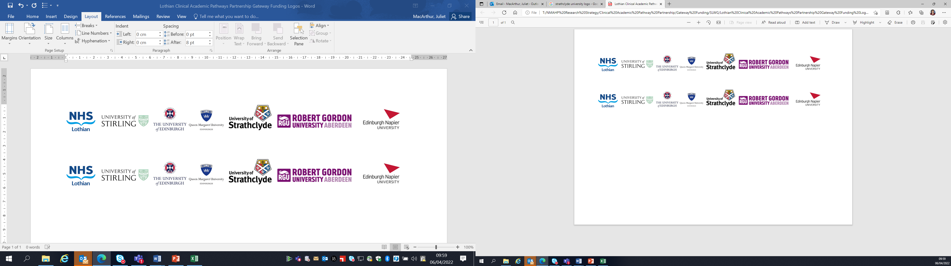Lothian Clinical Academic Pathways Partnership

Clinical Academic Research Gateway Funding

First Steps into Research Opportunities 2026

Institution & Department | NHS Lothian, Emergency Medicine Research Group of Edinburgh (EMERGE)
Contact – name, role & email | Rachel O’Brien  Research Nurse Manager  Rachel.o’brien@nhs.scot
Research Project/Programme Title | POC DILI  Point-of-care assessment of drug-induced liver injury
Details of Research Project / Programme – including funder, team members, methodology, stage of implementation | The POC-DILI study, funded by the Medical Research Council, is a multicentre diagnostic accuracy trial due to start in October 2024 and recruiting 620 participants who have attended the Emergency Department after taking an overdose of paracetamol.  Paracetamol overdose (POD) is common (UK/year: ~100,000 cases, ~50,000 treated, ~5,000 develop liver injury). The sooner treatment with acetylcysteine (NAC) is started post-POD the greater the likelihood that liver injury will be prevented.  ALT is the current standard-of-care biomarker for drug-induced liver injury, and it is a reliable clinical reference standard for established liver injury. However, ALT increases too slowly post-POD for the diagnosis of liver injury within the therapeutic time window of maximal NAC efficacy. There is a need for an assay capable of risk stratifying patients by their probability of developing liver injury post-POD to improve time-critical clinical decision making.  K18 is a diagnostically sensitive circulating protein-based biomarker for the early identification of liver injury.  To improve patient care we have created a Point of Care DILI Diagnostic capable of rapidly and reliably quantifying K18 levels in small amounts of capillary blood. The diagnostic consists of a K18 Lateral Flow Assay operating in tandem with a Handheld Reader.
Opportunities for candidate  e.g. attending meetings; data collection; data management; analysis; ethics application; dissemination activities  (bullet points) | The candidate will be able to get involved with the following:  - recruitment of participants  - data collection  - data management  - Trial team meetings  - Interacting with other UK emergency medicine research groups.  There is also the opportunity to be involved in the early set-up and design stages of a follow-up multicentre trial (POC-DILI 2) which already has funding secured.
Any other considerations or information for potential candidates? (e.g. potential links to other projects, networking opportunities, specific skills needed) | There will be the opportunity to network with colleagues in the University of Edinburgh as well as NHS colleagues working in emergency medicine research.  Having completed the National Institute of Health Research Good clinical Practice course before starting would be advantageous (Good Clinical Practice | NIHR) or attend an in person course at the Wellcome Trust Clinical Research Facility which is free of cost (Courses and events | Edinburgh Clinical Research Facility)  The team also have several toxicology projects ongoing that the candidate could get involved with. More information can be found here Current Research – Emerge Research  There may also be conferences that the candidate would be able to attend relevant to toxicology/emergency medicine.
Dates available (awards likely to be made Feb/Mar 2025 for start in Mar/Apr 2025) | Flexible with availability.
Mentor(s) | Anna Miell  Rachel O’Brien

