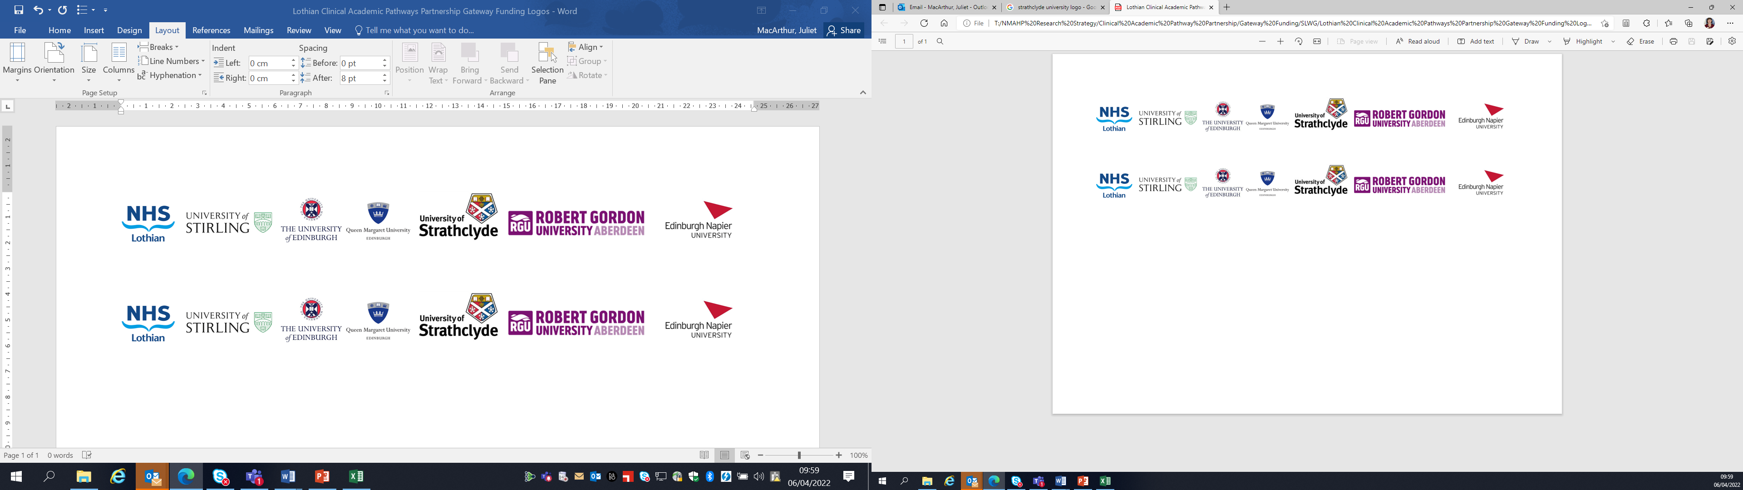Lothian Clinical Academic Pathways Partnership

Clinical Academic Research Gateway Funding

First Steps into Research Opportunities 2026
Full details of the Gateway awards scheme can be found at:
Lothian Clinical Academic Research Gateway Awards – Health and Care Professions Research

Institution & Department

Research Centre (if appropriate)

Contact – name, role & email

Research Project/Programme Title

Details of Research Project / Programme – including funder, team members, methodology, stage of implementation

Opportunities for candidate
e.g. attending meetings; data collection; data management; analysis; ethics application; dissemination activities
(bullet points)

Any other considerations or information for potential candidates? (e.g. potential links to other projects, networking opportunities, specific skills needed)

Dates available (awards likely to be made Feb 2026 for start in April 2026 onwards)

Mentor(s)

