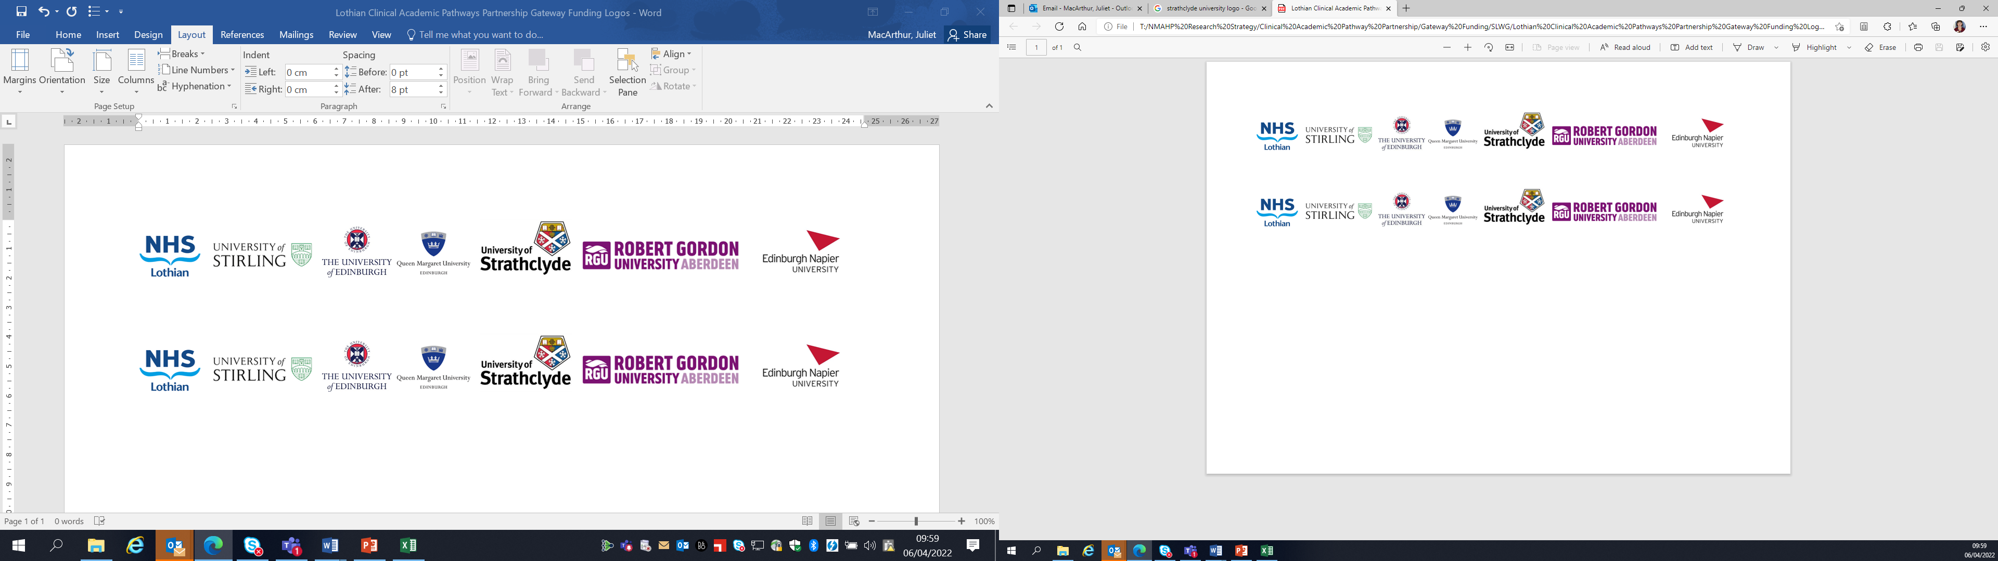Lothian Clinical Academic Pathways Partnership

Clinical Academic Research Gateway Funding

First Steps into Research Opportunities 2026
Institution & Department  Research Centre (if appropriate) | School of Health and Social Care, Edinburgh Napier University (ENU) and the Royal College of Nursing (RCN) Archives
Contact – name, role & email | Nicola Ring, Professor of Nursing n.ring@napier.ac.uk
Research Project/Programme Title | Migration and the History of Nursing in Scotland
Details of Research Project / Programme – including funder, team members, methodology, stage of implementation | This innovative joint placement with ENU and RCN Archives is inspired by the forthcoming RCN exhibition on Migration and Nursing which launches in March 2026. This 1-year exhibition starts in London, moves to Edinburgh (October 2026), and is supported by a range of events (in-person and online).  The placement research can focus on any aspect of migration and nursing pre-1970. The award recipient can choose a specific focus of interest to them. The history of migration and Scotland’s nurses is under-recognised, and this research will help fill a gap in Scotland’s history of nursing.
Opportunities for candidate  e.g. attending meetings; data collection; data management; analysis; ethics application; dissemination activities  (bullet points) | This placement aims is to raise awareness of diversity in Scotland’s nursing history and to recognise Scotland’s historically overlooked migrant nurses.  This placement offers excellent learning opportunities e.g.  -planning archival research  - conducting a small piece of historical research relating to migrant nurses in Scotland.  - disseminating findings including writing an RCN blog and a giving a presentation.  -participating in essential networking to plan and conduct this research including attending meetings.  A core part of this placement is learning how to trace nurses of the past. This will include meeting with archivists and researchers of nursing history as well as visiting collections.  Historical materials used in this research will be in the public domain. This novel historical placement will give someone the opportunity to develop transferable research skills e.g., project planning, finding/critiquing sources, disseminating results, networking. Depending on the nature of the research, the award recipient may be taught about oral history interviewing and conduct an oral history interview.  Dissemination: The recipient’s research will be shared during an end-of-placement ‘Show and Tell’. This will be tailored to the individual e.g., for a novice presenter this could be a small group presentation or for someone more experienced a lecture or webinar. Online outputs may include an RCN History of Nursing blog or a Wikipedia entry. There is also potential for a journal paper or conference presentation post-placement. Support will be available to help the award recipient disseminate their work.
Any other considerations or information for potential candidates? (e.g. potential links to other projects, networking opportunities, specific skills needed) | This is a novel placement being jointly offered by ENU and RCN. The award recipient will be able to shape the focus of this research e.g., if they have a particular type of migrant nurse they want to know more about. The focus could be on overseas nurse coming to Scotland or a nurse who left Scotland to work in another country. The research will be planned to be achievable in the time available and there is considerable flexibility regarding placement days.  The recipient will be supported during the research process to learn new skills and to disseminate their findings e.g., the mentors will be co-authors or co-presenters, if needed. There will also be opportunities to learn about different aspects of nursing history research e.g., the RCN oral history nursing project and Nurses in Red (a project to get more nurses listed on Wikipedia).  This research is about the history of nursing but, the placement is open to anyone with an interest in the topic perhaps someone with a family history of UK migrant nursing. The placement is also open to non-RCN members. No specific skills or experience required – all that is needed is a love of history!  The ENU mentors are based in ENU’s Sighthill Campus, but the award recipient will be visiting the RCN Scotland Information Hub (St Oswald Road) as well as attending online meetings. They may also visit other archive collections in Edinburgh.
Dates available | 1st April 2026
Mentor(s) | Lead mentors:  Nicola Ring is a Professor of Nursing at ENU and RCN History of Nursing Forum Committee Member. She has extensive experience in conducting research into the history of nursing and midwifery including leading the highly impactful RCN Foundation funded project researching Scotland’s early nurses and midwives accused of witchcraft.  Teresa Doherty Head of RCN Archive & Records Management and RCN Professional Lead for History of Nursing. She will provide an introductory session to help scope the research for a beginner or a seasoned researcher. Dependent on need she will be able to help with how to use archive catalogues; how to access archive offices; signpost to relevant sources; how to conduct/deposit oral histories etc.  Rebecca Brew is an Adult Nurse Lecturer at ENU. She is currently School Lead for a 1st year BN module and is actively involved in a School committee, working towards decolonising the nursing curriculum. She is a Doctoral Candidate, and her research focuses on the transitioning experiences of Internationally Educated Female West African Nurses from Former British Colonial Territories into the Nursing Workforce in Scotland.

