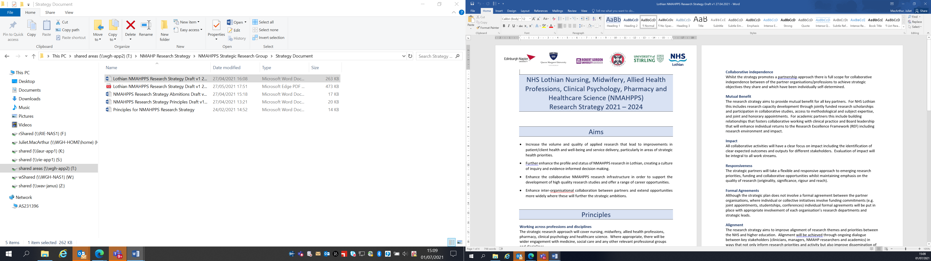Lothian Clinical Academic Pathways Partnership

Clinical Academic Research Gateway Funding

First Steps into Research Opportunities 2026

Institution & Department | Simulation and Clinical Skills Centre, School of Health and Social Care, Edinburgh Napier University
Contact – name, role & email | Prof Cathal Breen, Professor of Simulation and Clinical Skills  c.breen@napier.ac.uk
Research Theme | Acquisition of clinical skills expertise.
Specific Research Project – including methodology, stage of implementation | We are offering the opportunity for a ‘First Steps’ opportunity across the entire portfolio of active research studies within the Special Interest Group for Simulation Based Education (SIGSBE). These include trials on live streaming of SBE, augmented reality assisted clinical skills development and use of healthcare technologies to evaluate clinical skill proficiency. The projects are all in various stages of implementation and as such will give the intern exposure to the different stages of research implementation as well as thematic aspects.
Opportunities for candidate  e.g. attending meetings; data collection; data management; analysis; ethics application; dissemination activities  (bullet points) | The candidate may have the opportunity to:  - Attend SIGSBE Team meetings;  - Attend individual trial meetings;  - Work alongside research staff and university tutors designing SBE scenarios;  - Work alongside research staff in making ethical applications for clinical research;  - Develop patient-facing information such as information for Standardised patients;  - Meet clinical groups of staff to discuss research activities;  - Support dissemination activities such as abstract writing and creating poster presentations.
Any other considerations for potential candidates? | The work undertaken by the SIGSBE within the Simulation and Clinical Skill Centre is multi-disciplinary in nature and thus we welcome interns from medical, nursing or Allied Health Professions backgrounds.
Dates available | Flexible
Mentor(s) | Prof Cathal Breen  c.breen@napier.ac.uk

