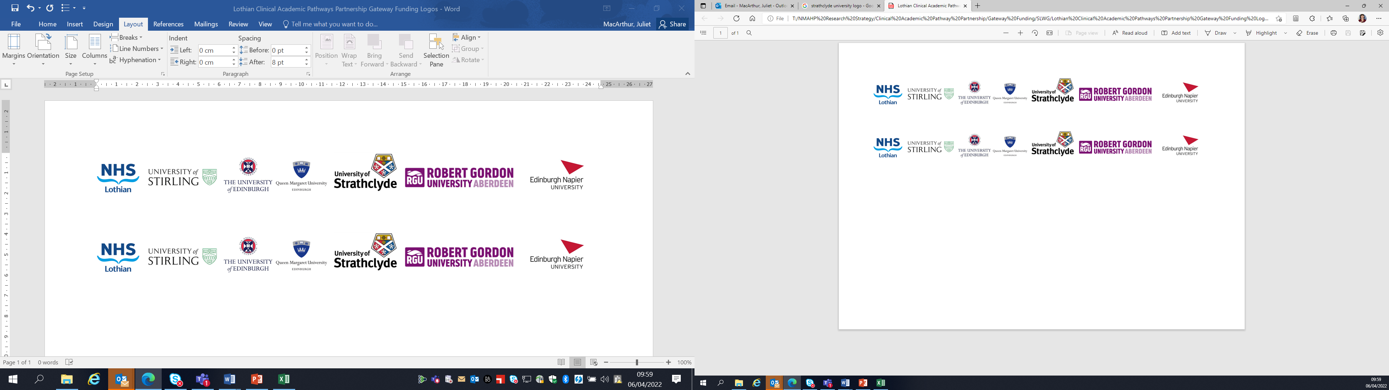Lothian Clinical Academic Pathways Partnership

Clinical Academic Research Gateway Funding

First Steps into Research Opportunities 2026

Institution & Department  Research Centre (if appropriate) | Edinburgh Napier University – School of Health and Social Care, Midwifery Subject Group
Contact – name, role & email | Professor Yvonne Kuipers y.kuipers@napier.ac.uk  Dr Alix Aitken-Arbuckle a.aitken-arbuckle@napier.ac.uk
Research Project/Programme Title | Continuity of Midwifery Care
Details of Research Project / Programme – including funder, team members, methodology, stage of implementation | This body of work is part of the Continuity of Midwifery Care research network which aims to unite academia and practice in Scotland and boost the evidence and conversations regarding CoC. As a group we aim to draw on knowledge and expertise within our network to establish leadership in CoC.  Current projects include:  Evaluation of Continuity of midwifery care in Scotland: A nested case-control study.  Aims: To evaluate the outcomes of midwife-led continuity of care by examining the differences in outcomes between those who received midwife-led continuity of care and those who did not (care-as –usual) in NHS Lothian.  Developing a research strategy for CoC from the perspective of all relevant Scottish stakeholders on macro-, meso- and microlevel.  Aim: To have a stakeholder-informed research mission, vision and agenda for continuity of care in the Scottish context.  Informing midwifery education why students with clinical placements in a continuity of care model meet the required NMC competencies as outlined in the Midwifery Practice Assessment Document (MPAD) within the required time of the midwifery programme.  Aim: To explore how midwifery students’ continuity of care placements enhance meeting the NMC required standards of proficiency for registered midwives as outlined in the Midwifery Practice Assessment Document (MPAD)  The Continuity of Carer newsletter.  Aim: To contribute to the current diverse and constrained utilisation of Coc despite its sound and vast evidence base; to communicate about Coc; To address the gap between CoC research, practice and education.
Opportunities for candidate  e.g. attending meetings; data collection; data management; analysis; ethics application; dissemination activities  (bullet points) | - Involvement in research design and ethics process,  - Attending meetings, networking and stakeholder events  - Helping with recruitment and data collection,  - Data analysis  - Collaborating in publication and dissemination  - GCP training
Any other considerations or information for potential candidates? (e.g. potential links to other projects, networking opportunities, specific skills needed) | We encourage applications from midwives who have an interest in midwifery led research and would like to develop their knowledge and skills in both quantitative and qualitative methods.
Dates available (awards likely to be made Feb/Mar 2024 for start in Mar/Apr 2023) | Anytime from April 2026 onwards
Mentor(s) | Dr Alix Aitken-Arbuckle  Professor Yvonne Kuipers

