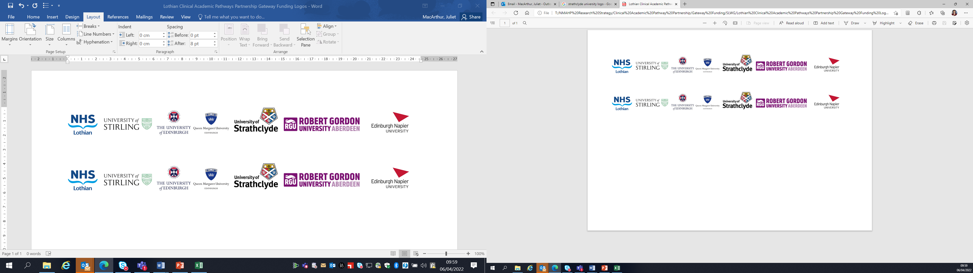Lothian Clinical Academic Pathways Partnership

Clinical Academic Research Gateway Funding

First Steps into Research Opportunities 2026
Institution & Department  Research Centre (if appropriate) | Learning Disabilities -Knowledge to Action Research Group (LD-KAR), School of Health and Social Care (SHSC), Edinburgh Napier University (ENU)
Contact – name, role & email | Dr Lisa O’Leary (l.oleary@napier.ac.uk) and Prof. Nicola Ring.  (N.Ring@napier.ac.uk)
Research Project/Programme Title | Learning Disabilities Knowledge to Action Research Group (LD-KAR– a 1st Steps taster research placement
Details of Research Project / Programme – including funder, team members, methodology, stage of implementation | The research project is focussed on adaptation of the swallowing oral health and nutrition knowledge and skills (SONKS) training programme for carers who support people with Learning Disabilities (LD). This is an 18-month project funded by the Bailey Thomas Charitable Fund.  This work is led by Dr Lisa O’Leary is supported by a network of clinicians (James Reid, Speech and Language Therapist NHS Forth Valley) and international/interdisciplinary team of academics (Professor Nicola Ring, Professor Nicola Roberts, Dr Susan Guthrie, Professor Laurence Taggart, Dr Maria Truesdale, Professor Bronwyn Hemsley and Dr Daniel Dicksit.  This study is being conducted using a 3-phase 18-month mixed method co-design approach. Phase 1 involves a consultation exercise with interviews and focus groups to: (1) explore carers’ experiences of delivering the SONKS training, (2) explore staff’s experiences of receiving the SONKS training, (3) explore people with LD’s experiences of being supported by carers who engaged in the SONKS training.  Phase 2 involves obtaining consensus on proposed adaptations of SONKS for use by a range of carers and participants with LD of all ages using a Delphi approach. Phase 3 involves co-adaptation and co-design of a finalised and refined SONKS intervention.  The successful candidate will have the opportunity to help with the Phases 2 and 3 of the study.
Opportunities for candidate  e.g. attending meetings; data collection; data management; analysis; ethics application; dissemination activities  (bullet points) | The placement will involve working with this research team to conduct and disseminate the project. The successful candidate will acquire experience of data collection, patient and public involvement, codesign, data analysis and dissemination. The successful candidate will have the opportunity to be a co-author on any publications.  This placement will also offer you the opportunity to network with our interdisciplinary LD-KAR research group in ENU’s SHSC. The group has members from LD nursing, disabilities studies, psychology and the allied health professionals working in various settings. The group also has international members. Membership of this group will also enable the candidate to see research in action across the research process e.g., project planning, funding application development, ethics applications, data collection and analysis on a wide range of projects and topics  All LD-KAR group members are engaged in research to improve the lives of those living with a learning disability and their carers whilst developing research capacity and capability in this field.  Working with those with a LD to actively involve them in the research process is central to this research group. Opportunities to be involved in such activity and research dissemination will also be included in this placement.
Any other considerations or information for potential candidates? (e.g. potential links to other projects, networking opportunities, specific skills needed) | This placement will enable the award recipient to develop their learning disability research network and international network. This will be a bespoke placement developed to suit the research learning needs of the award recipient. No specific skills or experience required We will develop a placement that best suits the awardee.
Dates available | From April 2026
Mentor(s) | Lead mentors: Dr Lisa O’Leary (ILM accredited coach and mentor) , Prof. Nicola Ring and Professor Nicola Roberts.

