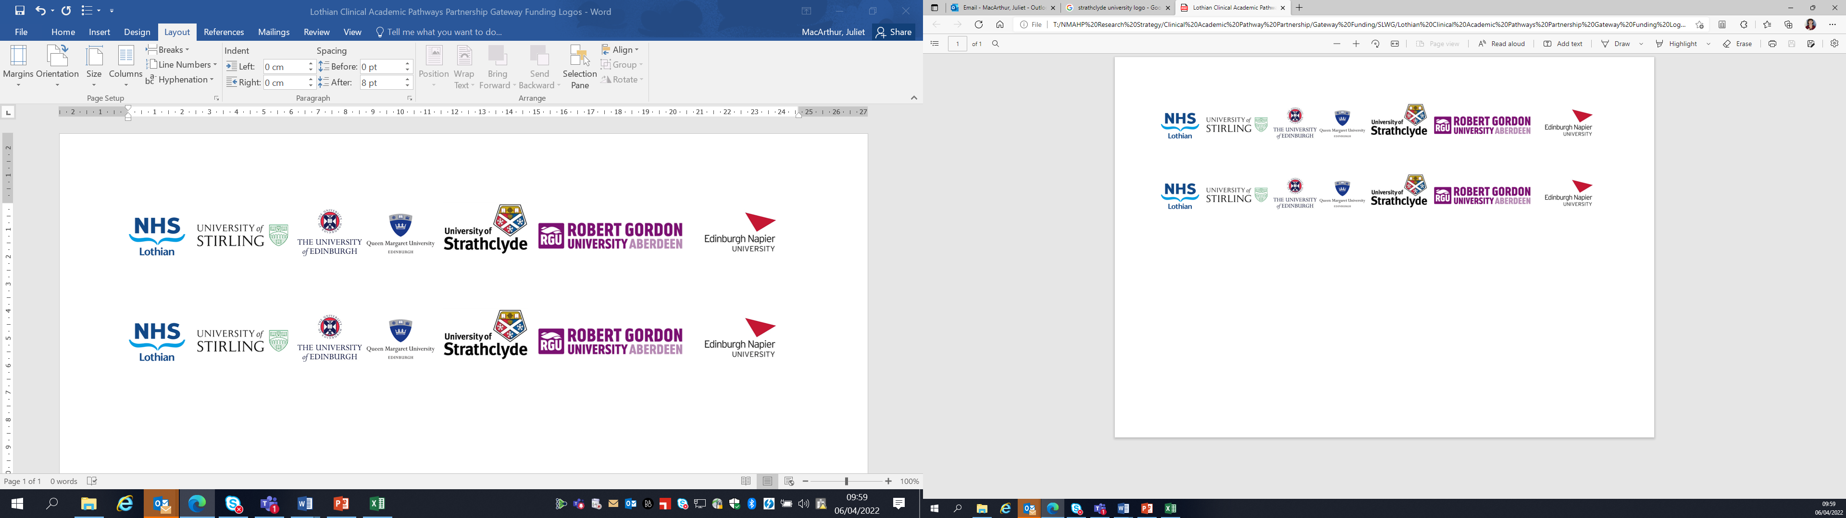Lothian Clinical Academic Pathways Partnership

Clinical Academic Research Gateway Funding

First Steps into Research Opportunities 2025

Institution & Department  Research Centre (if appropriate) | The Anne Rowling Regenerative Neurology Clinic, Centre for Clinical Brain Sciences, University of Edinburgh
Contact – name, role & email | Judy Newton  Deputy Director of the Anne Rowling Clinic and MND Nurse Consultant judith.newton@ed.ac.uk
Research Project/Programme Title | RowlingCARE/NeuroCARE
Details of Research Project / Programme | RowlingCARE (Clinical, Audit, Research and Evaluation) is a University of Edinburgh-funded Scotland-wide digital registry that is open to everyone diagnosed with a neurodegenerative disorder, as well as their carers. By signing up to RowlingCARE, participants are consenting to researchers accessing and using certain parts of their anonymised healthcare records for research and to audit their care. They can also optionally sign up to be notified about new research studies that they might be eligible for. By comparing relevant healthcare data from many people, our University and NHS researchers can study the variation in these brain conditions in great detail. We can determine patterns and clues as to how to improve care and ultimately develop personalised medicines and clinical trials.  Since the platform was launched several years ago, more than 1500+ people have signed up. People can sign up online through the RowlingCARE website (www.rowling-care.org.uk) or, more often, when they attend an NHS specialist clinic at the Anne Rowling Clinic facility.  It is an exciting time for the RowlingCARE research project as it is undergoing a digital transformation to automate sign-up and to link with the use of an App through which participants can record details about their condition at home.  The opportunity is for the candidate to join the 20+ multi-disciplinary Anne Rowling Clinic team comprising research nurses, research practitioners, clinical research fellows (doctors) and clinical trial teams. The candidate will assist with in-clinic recruitment to RowlingCARE, taking informed consent.  The candidate will also have the opportunity to get involved in our suite of clinical research studies, collecting data and recording it correctly, these include Bioresourcing, digital health, gait analysis, clinical drug trials and observational studies.
Opportunities for candidate  e.g. attending meetings; data collection; data management; analysis; ethics application; dissemination activities  (bullet points) | - Meetings with clinical research teams both patient-facing and clinical trial managers/administrators, including fortnightly whole-team ‘lab meeting’  - Opportunities to understand the procedures and regulations required to conduct clinical research, as well as assist with study documentation  - Data collection and entry for research projects including observational studies and clinical drug trials  - Tour of affiliated laboratories to learn about the linked discovery research programmes including using stem cells and high throughput drug discovery  - Opportunity to become involved with communication of research to participants and public audiences through, for example, websites, social media, focus group events and open evenings.
Any other considerations or information for potential candidates? (e.g. potential links to other projects, networking opportunities, specific skills needed) | The Anne Rowling Regenerative Neurology Clinic at Edinburgh BioQuarter is a charitable University of Edinburgh clinical research facility supported by philanthropic donations by the author J.K. Rowling as well as national and international research grants from government, charities and industry.  The Clinic delivers research and trials for people with neurodegenerative conditions including multiple sclerosis, motor neuron disease, cognitive disorders and Parkinson’s. By hosting NHS Lothian specialist clinics plus a Scotland-wide online research interest register, the Clinic encourages people living with these conditions to engage with and get involved with research.  For more information please visit www.annerowlingclinic.org. There is a listing of current research projects at www.annerowlingclinic.org/research-trials/find-research-proect
Dates available | From January 2025
Mentor(s) | Judy Newton, MND Nurse Consultant/Deputy Director  Dr Suvankar Pal, Consultant Neurologist  Professor Siddharthan Chandran, Director of the Centre for Clinical Brain Sciences

