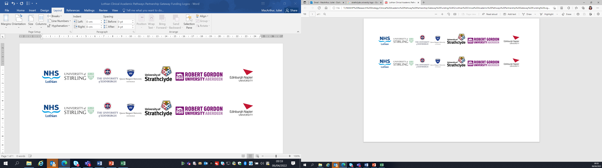Lothian Clinical Academic Pathways Partnership

Clinical Academic Research Gateway Funding

First Steps into Research Opportunities 2025

Institution & Department  Research Centre (if appropriate) | School of Health and Social Care  Edinburgh Napier University
Contact – name, role & email | Dr Gosha Wojcik (Lecturer & NHS Lothian Honorary Advanced Research Fellow) – g.wojcik@napier.ac.uk  Associate Prof Alpana Mair (Honorary Lecturer / Scottish Government Head of Effective Prescribing and Therapeutics) – a.mair@napier.ac.uk
Research Project/Programme Title | Short Duration Antibiotic Therapy for Critically Ill Patients with Sepsis (SHORTER Trial): A Mixed-Methods Process Evaluation of a Randomised Controlled Trial. A portfolio of research activities as part of the 1st Steps taster research placement.
Details of Research Project / Programme – including funder, team members, methodology, stage of implementation | This placement will be within the Medicine Optimisation theme at SHSC. The candidate will join an interdisciplinary research team working on the NIHR-funded SHORTER Trial, which focuses on reducing antibiotic duration in critically ill sepsis patients. The team includes experts from nursing, medicine, infectious diseases, microbiology, statistics, and health economics, employing diverse methodologies, such as a pragmatic open-label RCT and a mixed-methods Process Evaluation (PE). Under Gosha’s leadership, the Process Evaluation integrates a novel framework combining PE with behavioural change theory, which is particularly innovative within critical care research. The trial is currently in the Internal Pilot phase and being rolled out across 50 UK ICU sites. The successful candidate will work closely with this dynamic group, gaining exposure to cutting-edge research methodologies and interdisciplinary collaboration.
Opportunities for candidate  e.g. attending meetings; data collection; data management; analysis; ethics application; dissemination activities  (bullet points) | The candidate will gain comprehensive research experience through various stages of the research process. This will include project planning, developing funding applications (such as Gosha's current work on establishing an AMR Advisory Board in collaboration with an external partner), and ethics applications. Additionally, the candidate will engage in data collection activities like online interviews and data analysis related to antimicrobial resistance (AMR) as part of the SHORTER Trial.  Further opportunities include:  - Participation in a school-funded Campus Writing for Academic Funding & Knowledge Translation (CRAFT) writing day.  - Attendance at quarterly meetings of the Scottish Critical Care Interdisciplinary Research Liaison Group.  - A visit to the clinical research centre.  - The candidate will be invited to join an interdisciplinary research team led by Gosha, currently working on a systematic review that employs a behavioural science approach for analysis. This will offer the opportunity to conduct database searches and perform quality appraisals of studies, providing hands-on experience in systematic review methodology.  - Networking with researchers at different career stages.  - Mentorship from Alpana on effective strategies for translating research into policy and practice  These activities, along with opportunities for involvement in research dissemination, will be part of the placement. Building research capacity and mentorship are key priorities within SHSC.
Any other considerations or information for potential candidates? (e.g. potential links to other projects, networking opportunities, specific skills needed) | This placement will offer a unique opportunity for the award recipient to build a robust research network by engaging with researchers from various disciplines. It will be tailored to meet the specific research learning needs of the recipient, ensuring a bespoke experience. No prior skills or experience are required, as we will design the placement to align with the awardee's interests and goals. However, this opportunity would be particularly advantageous for pharmacists or healthcare professionals with a keen interest in antibiotic resistance, infectious diseases, clinical trial methodology, and behavioural science approaches.
Dates available (awards likely to be made Feb/Mar 2025 for start in Mar/Apr 2025) | 1st of Feb 2025
Mentor(s) | Lead mentors: Dr Gosha Wojcik, Associate Prof Alpana Mair and Dr Lydia Emerson (Senior Research Fellow on the SHORTER Trial). Other SHORTER Trial members will act as mentors, where appropriate.

