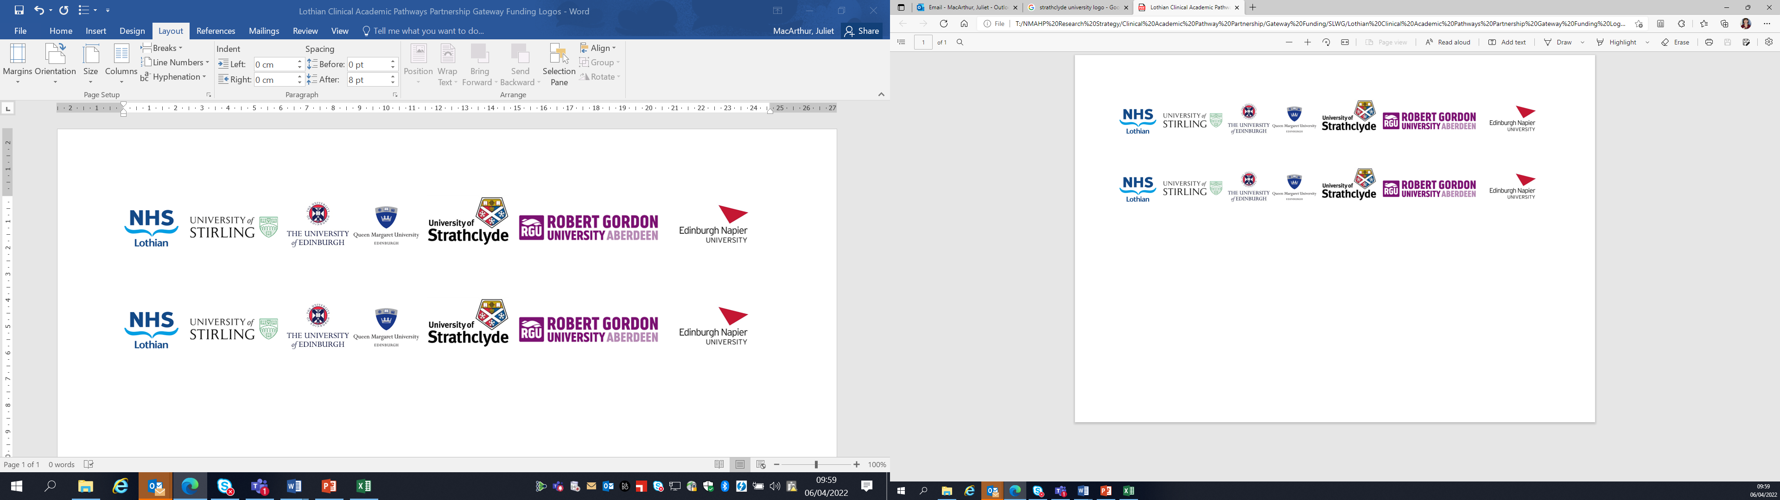Lothian Clinical Academic Pathways Partnership

Clinical Academic Research Gateway Funding

First Steps into Research Opportunities 2025
Institution & Department  Research Centre (if appropriate) | Queen Margaret University  Centre for Person-centred Research
Contact – name, role & email | Erna Haraldsdottir, Director Centre for Person-centred Research  Eharaldsdottir@qmu.ac.uk
Research Project/Programme Title | Expert Components of Person-Centred Nursing Intervention for older People with Cognitive Impairment in Hospital Experiencing Distress. (EPIC)
Details of Research Project / Programme – including funder, team members, methodology, stage of implementation | This study is now getting close to starting. Ethical approval granted and research assistant expected to start 1 December 2024  The project is funded by NHS Lothian  This will be an observational study involving direct observation of the work of an expert dementia nurse and interviews with patients and family members.
Opportunities for candidate  e.g. attending meetings; data collection; data management; analysis; ethics application; dissemination activities  (bullet points) | Candidate will have opportunities to  - Attend project meetings and gain insight into project management and teamwork within a research project  - Gain insight into research design of a mixed method observational study  - Gain understanding of the research process such as data collection and analysis  - Possible visit the research site for some shadowing but not during direct observation
Any other considerations or information for potential candidates? (e.g. potential links to other projects, networking opportunities, specific skills needed) | Attending Research Centre meetings.
Dates available (awards likely to be made Feb/Mar 2025 for start in Mar/Apr 2025) | Successful candidate would join the project group and time and commitment to be agreed.
Mentor(s) | Prof Erna Haraldsdottir and Dr. Karen Rennie

