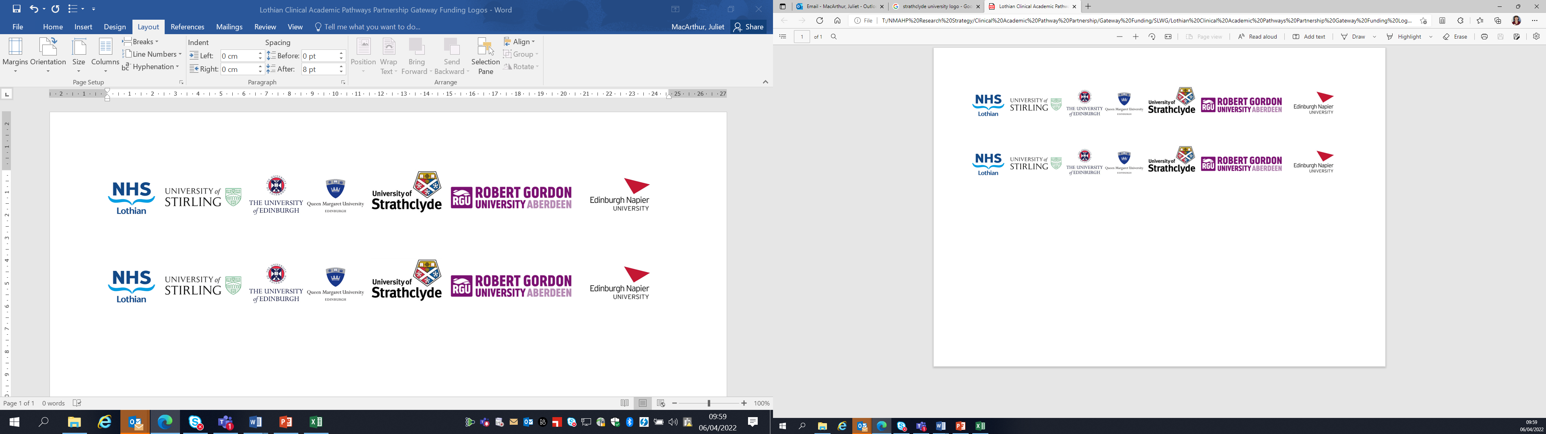Lothian Clinical Academic Pathways Partnership

Clinical Academic Research Gateway Funding

First Steps into Research Opportunities 2025
Institution & Department  Research Centre (if appropriate) | Learning Disabilities - Knowledge to Action Research Group (KAR- LD)  School of Health and Social Care, Edinburgh Napier University
Contact – name, role & email | Dr Natasha Spassiani (Lecturer) and Prof. Nicola Ring.  N.Spassiani@napier.ac.uk. N.Ring@napier.ac.uk
Research Project/Programme Title | Learning Disabilities Knowledge to Action Research Group – a 1st Steps taster research placement
Details of Research Project / Programme – including funder, team members, methodology, stage of implementation | This placement is with the interdisciplinary KAR-LD research group at SHSC. The group has members from LD nursing, disabilities studies, psychology and the allied health professionals working in various settings. All KAR-LD members are engaged in research to improve the lives of those living with LD and their carers whilst developing research capacity and capability in this field.
Opportunities for candidate  e.g. attending meetings; data collection; data management; analysis; ethics application; dissemination activities  (bullet points) | KAR-LD can offer a wide range of research learning opportunities to a 1st steps award participant that would enable them to see research in action across the research process e.g., project planning, funding application development, ethics applications, data collection and analysis on a wide range of projects and topics. Working with those with LD to actively involve them in the research process is central to the KAR-LD. Opportunities to be involved in such activity and research dissemination will also be included in this placement.
Any other considerations or information for potential candidates? (e.g. potential links to other projects, networking opportunities, specific skills needed) | This collective placement to the KAR-LD will involve the award recipient also developing their LD research network. This will be a bespoke placement developed to suit the research learning needs of the award recipient. No specific skills or experience required - we will develop a placement that best suits the awardee.
Dates available (awards likely to be made Feb/Mar 2024 for start in Mar/Apr 2024) | 1st Feb. 2024
Mentor(s) | Lead mentors: Dr Natasha Spassiani, Prof. Nicola Ring and Sam Abdullah. Other KAR-LD members will act as mentors where appropriate.

Please return to Andy Peters, AHP Research & Development Facilitator, NHS Lothian andy.peters@nhslothian.scot.nhs.uk

