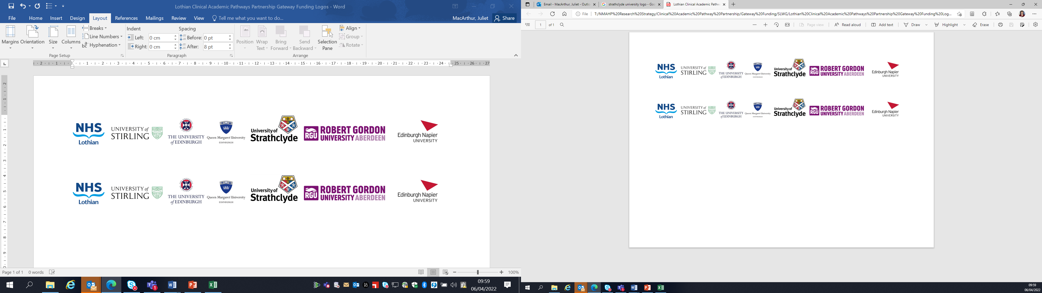Lothian Clinical Academic Pathways Partnership

Clinical Academic Research Gateway Funding

First Steps into Research Opportunities 2026
Full details of the Gateway awards scheme can be found at:
Lothian Clinical Academic Research Gateway Awards – Health and Care Professions Research

Institution & Department  Research Centre (if appropriate) | Queen Margaret University  Centre for Person-centred Practice Research
Contact – name, role & email | Erna Haraldsdottir/Gemma Stevenson/Vicki Waga (project team)  Eharaldsdottir@QMU.ac.uk
Research Project/Programme Title | Lydia X Osteoporosis project
Details of Research Project / Programme – including funder, team members, methodology, stage of implementation | Lydia X is the 4th phase of a funded project focusing on osteoporosis; prevention, living with and knowledge and skills of health care practitioners.  LOPX will continue to focus on three key areas:  - Education  Knowledge exchange with health care professionals and students.  - Research  Undertaking person-centred research on the impact of osteoporosis, and osteoporosis as a public health issue. Focusing on improving health care service for people living with osteoporosis through experience based codesign study.  - Engagement  Engaging with those living with osteoporosis, offering advice and community support. On top of this, raising awareness among the general public, and health care practitioners working with at risk groups, with the impact of osteoporosis, prevention messages and our research findings.  We aim to build a community of people living with osteoporosis and health care professionals with a special interest in osteoporosis in meetings hosted at QMU. These will have educational input and space for informal networking and support.
Opportunities for candidate  e.g. attending meetings; data collection; data management; analysis; ethics application; dissemination activities  (bullet points) | Successful candidate would become part of the Lydia project team with specific focus on working with the Research Assistant on the team who will be starting in January 2026. The Research Assistant will be working on the project for 2 years.  The focus the research project will be to carry out research into the experience of living with osteoporosis. The aim is to inform another strand of the project- Education for health care professionals as well as potentially being written up as paper based on its findings independently.  Opportunities for successful candidate will be  - Become part of established research team, attending meetings whereby project progress and planning is being reviewed  - Support the research assistant in ethical application, data collection, data management. Work in relation to this may be carried out independently but always with support and supervision of research assistant and project lead/member of the project team  - Develop knowledge, understanding and application of ethical considerations in research practice  - Potentially involvement in knowledge exchange/education actives with staff/students within QMU and as part of the project within communities
Any other considerations or information for potential candidates? (e.g. potential links to other projects, networking opportunities, specific skills needed) | Being part of QMU research community may potentially offer other opportunities such as link with other projects within the research centre and undergraduate nursing programmes
Dates available (awards likely to be made Feb 2026 for start in April 2026 onwards) | April 2026
Mentor(s) | Gemma Stevenson, Vicki Waga, Erna Haraldsdottir

