NHS Lothian AHP Innovation Research and Improvement Strategy
2022 -2027
Microsoft Word - NHS Lothian AHP Innovation Research & Improvement Strategy 2022-27 Final 21 6 22
Progress Report March 2024
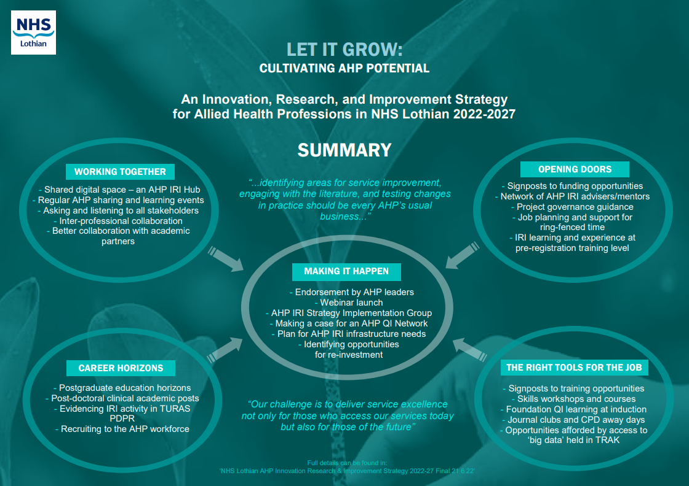

The purpose of our AHP Innovation Research and Improvement strategy:
As a reminder, the work of our Steering Group and all its Action Groups is intended to progress our stated strategic principles:
‘... the mindset and behaviours needed for innovation, research, and improvement should be part of usual business, for us all ... ‘Evidence, Research and Development’ is one of the four pillars of practice. It is not an optional add-on.’
‘The strategy aims to encourage, nurture, and give permission for a culture of curiosity, robust testing of new ideas, learning, and continuous improvement.’
Another principle in development and implementation of the strategy is inclusivity; in terms of responsibility, leadership and engagement so that there is something for every AHP in the actions.

What have we done so far?
We established an Implementation Steering Group and working sub-groups for specific actions. These groups direct, support and prioritise the actions articulated in the strategy.
See below for the original action groups’ leads and timelines.

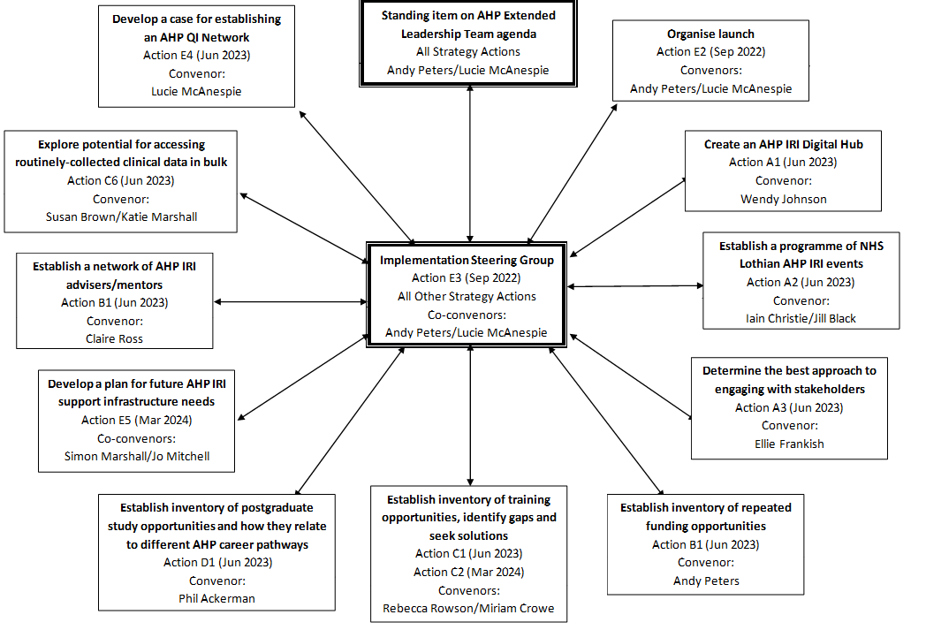
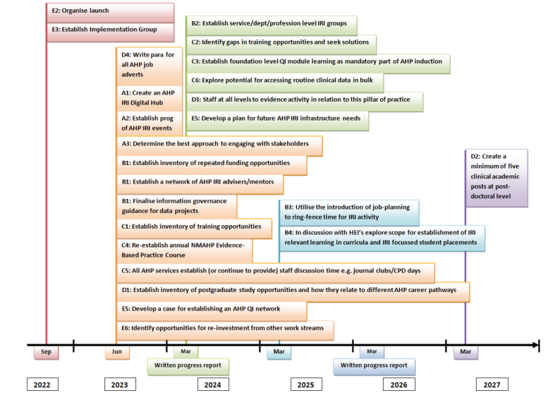

Achievements:
- Intranet-based IRI digital hub, and work towards a more permanent, interactive, internet-based solution
- Standard paragraph for all AHP job adverts which highlights our IRI Strategy
- Guidance on approaches to patient and public engagement/involvement
- Searchable up-to-date list of IRI funding opportunities e.g. grants, fellowships etc.
- Scottish Improvement Foundation Skills course accessible now for all Lothian AHPs
- Commencement of promotion events for the Strategy such as Lunch & Learn sessions and AHPpreciate and Progress
In Progress:
- Searchable up-to-date list of IRI training opportunities
- Establishing a network of AHP IRI mentors/advisors and create the infrastructure to support project work into the future
- Developing Project Governance Guidance for AHP staff e.g. whether a project is defined as research, approvals, ethics, consent, data protection, Caldicott etc.
- Ensure alignment with the parallel development of the AHP Learning and Development Strategic Framework particularly around learning related to the Evidence, Research & Development pillar of practice.
- Considering the best advice for AHP staff re: accessing routine clinical data (e.g. held in TRAK) for project question purposes
- Discussions to refresh and re-establish the AHP Evidence Based Practice course in late 2024
- Early discussions on the best approaches to AHP IRI Practice-based Learning

Challenges
- Time to devote to the work
- Ability to engage a wide range of AHPs, within a complex system, in taking the Actions forward and shaping the outputs
- Developing relevant outputs for the range of AHP professions and career development levels
- Financial pressures e.g. clinical academic posts
- Temporary posts e.g. AHP Digital Lead post, so lack staff time to do dedicated work

Current situation and next steps?
We have confirmed that our current Actions are the right ones to focus on.
We are mindful of the current climate and developments e.g. introduction of protected learning time and AHP learning and development strategic framework, which add weight to the need to continue to take forward our strategy.
However, we are aware we need to reshape how we achieve some of them because there have been some challenges around timelines and workload. We are suggesting clustering some groups to share leadership, maximize resources, spread awareness, reduce load and widen involvement. For example;
- joining ‘funding’ and ‘training opportunities’ sub-groups
- joining ‘mentoring’ and ‘support infrastructure’ sub-groups
- joining ‘training gaps’ (yet to be formed) and ‘establishing a programme of events’ sub-groups
We need to develop a communication plan to optimise our reach for the whole AHP workforce e.g. how to include and involve other AHPs via the Extended Leadership Team, use of Lunch and Learn, use of Practice Education newsletter, web pages, and the intranet.
To extend the strategy’s reach we invite any AHP to become involved in the work of the strategy by joining any of following action groups:
- Establish a plan for future AHP support infrastructure including developing a network of improvement and research mentors – contact email addresses: Claire.ross4@nhs.scot, Joanne.mitchell@nhs.scot and Simon.marshall@nhs.scot
- To further develop an interactive one stop digital hub for improvement, research and innovation information and resources – contact wendy.johnson@nhs.scot
- Creating a comprehensive index of training opportunities and awareness raising and promotion of these- contact Miriam.crowe@nhs.scot rebecca.rowson@nhs.scot lorna.sinclair2@nhs.scot
- Producing guidance around accessing routinely held clinical data for project purposes – contact susan.brown13@nhs.scot iain.christie@nhs.scot
- Create a generic map of AHP career pathway learning at different levels of practice based on physiotherapy MSK framework contact – phillip.ackerman@nhs.scot, claire.matheson2@nhs.scot
- Share and use ‘approaches to engaging with patient and public stakeholders’ resource - contact Ellie.frankish@nhs.scot iain.christie@nhs.scot

- To become involved in the overall Strategy Implementation Steering Group – contact andy.peters@nhs.scot lucie.mcanespie@nhs.scot

