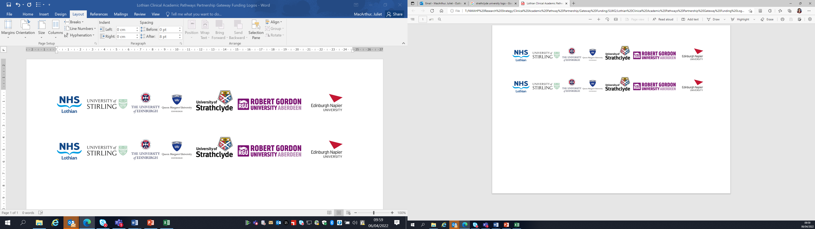Lothian Clinical Academic Pathways Partnership

Clinical Academic Research Gateway Funding

First Steps into Research Opportunities 2024

Institution & Department  Research Centre (if appropriate) | Queen Margaret University  Centre for Person-centred Research
Contact – name, role & email | Erna Haraldsdottir, Director Centre for Person-centred Research  Eharaldsdottir@qmu.ac.uk
Research Project/Programme Title | Expert Components of Person-Centred Nursing Intervention for older People with Cognitive Impairment in a Hospital Experiencing Distress. (EPIC)
Details of Research Project / Programme – including funder, team members, methodology, stage of implementation | This project is now getting close to starting. Currently ethical approval underway.  The project is funded by NHS Lothian  This will be an observation study
Opportunities for candidate  e.g. attending meetings; data collection; data management; analysis; ethics application; dissemination activities  (bullet points) | Candidate will have opportunities to  - Attend project meetings and gain insight into project management and teamwork within a research project  - Gain into research design of a mixed method observational study  - Gain insight into the process of applying for ethical approval  - Gain understanding of the research process such as data collection and analysis  - Possible visit the research site for some shadowing but not during direct observation
Any other considerations or information for potential candidates? (e.g. potential links to other projects, networking opportunities, specific skills needed) | Attending Centre meetings.
Dates available (awards likely to be made Feb/Mar 2024 for start in Mar/Apr 2023) | The candidate could join the project group for meetings that are likely to be held monthly over the next 6-9 months.
Mentor(s) | Prof Erna Haraldsdottir and Dr. Karen Rennie

Please return to Andy Peters, AHP Research & Development Facilitator, NHS Lothian andy.peters@nhslothian.scot.nhs.uk

