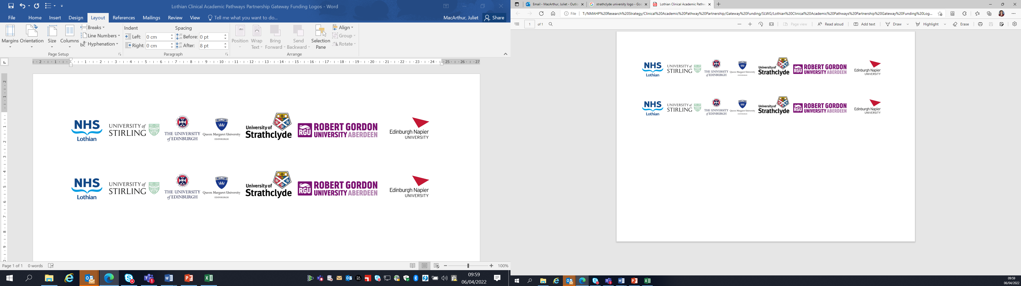Lothian Clinical Academic Pathways Partnership

Clinical Academic Research Gateway Funding

First Steps into Research Opportunities 2024

Institution & Department  Research Centre (if appropriate) | University of Edinburgh,  School of Health in Social Science  Centre for Homelessness and Inclusion Health
Contact – name, role & email | Dr Richard Lowrie,  Richard.lowrie@ed.ac.uk  Reader in the Centre for Homelessness and Inclusion Health.  Lead Pharmacist, R&D NHS GG&C  Dr Ishbel Miller  ishbel.miller@nhslothian.scot.nhs.uk  GP, The Access Place  NHS Lothian Health and Social Care Partnership  6 South Gray’s Close  Edinburgh  EH1 1NA
Research Project/Programme Title | Edinburgh exercise prescription: a feasibility study of the acceptability and impact of an individualised, 10 week physical exercise programme for people experiencing homelessness
Details of Research Project / Programme – including funder, team members, methodology, stage of implementation | The idea for this feasibility study originated with participants in two ongoing pilot RCTs (with parallel process and economic evaluations) funded by Scottish Government Drug Deaths Task Force and NIHR (RfPB). Both studies recruited over 200 people experiencing homelessness, most of whom had problem drug use and recent non fatal overdose. Both studies end in June 2024. The window of opportunity between Feb 2024 and June 2024 will be used to integrate one or preferably two successful applicants into the existing research teams and launch this feasibility study (which does not require ethical approval as it is a service development).  Existing research team members include experts by experience, leading homelessness clinicians and leading inclusion health researchers from Universities of Glasgow, Edinburgh, and Birmingham.  The First Steps opportunity creates the ideal environment for an Occupational Therapist or other AHP to work within a strong, established supervisory team. After June 2024, Richard Lowrie and wider team at University of Edinburgh Centre for Homelessness and Inclusion Health will offer successful candidate(s) the opportunity to continue working on the planned next steps: publishing the findings and starting a funding proposal for a multicentre pilot RCT of the intervention, with parallel process and economic evaluation.
Opportunities for candidate  e.g. attending meetings; data collection; data management; analysis; ethics application; dissemination activities  (bullet points) | All under mentorship of Richard Lowrie, Ishbel Miller:  Literature review;  GCP course participation;  Discussion of ethical issues and consent (particularly in people who present in extremis or who are under the influence) in research  Recruiting participants into the service development , as a ‘warm up’ to recruitment and written informed consent in the planned subsequent funded pilot RCT;  Attending steering and trial management group meetings;  Offering patients opportunity to join the service development testing the feasibility of weekly exercise;  Securing buy in or experts by experience who can contribute to the design and application for the subsequent pilot RCT funding bid;  Administration of semi structured interviews with service users; Under supervision, support for appropriate clinician from the Access Place to collect demographic data, drug use, non fatal overdoses, mental health assessments, quality of life, BP, pulse, Peak flow, BMI, before, during and after the 10 week exercise programme;  Ex Scotland International professional footballer will coach weekly small sided football games in a nearby park (The Meadows) for those opting to play football. Others will have the option of boxing, gym work, or other sports, under supervision from trained coaches. Relationships and networks created during this study will outlast the period of the First Steps programme.  Data summary and analysis for final report of this feasibility work;  The candidates will work with Richard Lowrie and The Access Place to deliver these objectives. Both will manage the service development project.  If feasibility signals are achieved (recruitment, participation in exercise, participation in baseline mini health check, positive feedback from participants) then we plan to progress to apply for funding from CSO for a pilot RCT.  The successful candidate(s) will lead on producing posters/presenting findings at relevant conferences.
Any other considerations or information for potential candidates? (e.g. potential links to other projects, networking opportunities, specific skills needed) | These objectives are designed to offer candidates a wide range of exposures needed to develop a broad understanding of the different stages of progression from health and social care service evaluation to research. Candidates will be afforded multiple networking and undergraduate teaching opportunities within University of Edinburgh.  They will develop generic evaluation skills and understand the need to move to ethical approval for a subsequent (randomised) trial.  The mentor (R Lowrie) will remain closely involved throughout the duration and after the end of the 12 days of protected time.  R Lowrie will also have a clinical (outreach) session in Edinburgh (attached to the Access Place) during the period of the planned feasibility study.
Dates available (awards likely to be made Feb/Mar 2024 for start in Mar/Apr 2024) | Feb-June 2024
Mentor(s) | Dr Richard Lowrie, Dr Ishbel Miller

Please return to Andy Peters, AHP Research & Development Facilitator, NHS Lothian andy.peters@nhslothian.scot.nhs.uk

