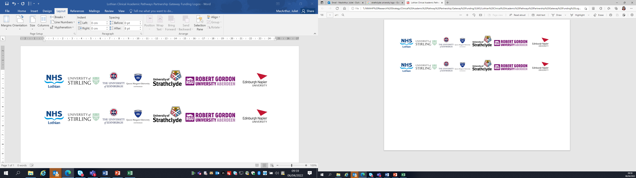Lothian Clinical Academic Pathways Partnership

Clinical Academic Research Gateway Funding

First Steps into Research Opportunities 2024

Institution & Department  Research Centre (if appropriate) | Robert Gordon University, Sch. Of Pharmacy & Life Sciences
Contact – name, role & email | Prof. Scott Cunningham, Prof. of Pharmacy Education & Practice, s.cunningham@rgu.ac.uk
Research Project/Programme Title | Integration of Pharmacist Independent Prescribing (PIP) into models of practice.
Details of Research Project / Programme – including funder, team members, methodology, stage of implementation | This project is linked to work being done in community pharmacy by one of the current Scottish Clinical Academic Fellows Cohort. The focus has been on exploring the integration of PIP into community pharmacy practice in the context of Pharmacy First Plus.  This work has been underpinned using theory - namely the Normalization Process Theory to act as a ‘lens’ for consideration of how IP has been integrated within this context.  There is scope to explore facets of this further within community pharmacy and also to consider how this approach can be extended to other sectors of practice within PIP in general practice and the managed sector where there is also a need to investigate its integration to determine optimal models of practice along with barriers and facilitators for implementation.  The FSiR candidate could work with the team on the ongoing community pharmacy work where the next step is to take a case study based approach to explore integration within a number of community pharmacies in detail. Alternatively, there would be scope to work up projects linked to other sectors that may be of greater interest to the applicants.
Opportunities for candidate  e.g. attending meetings; data collection; data management; analysis; ethics application; dissemination activities  (bullet points) | There would be opportunities for the applicant to  - Attend team meetings  - Do literature searches and initial steps of literature reviews and learn to use the software package ‘Covidence’  - Participate in the work up a protocol development  - Involvement in the process of ethics applications  - Involvement in the process of data collection (within the context of the community pharmacy case study work) and analysis  - Opportunities to attend research seminars within RGU PALS and present work at these also  - To engage with the ‘Vitae researcher development’ programme used within RGU for consideration and planning for development of research skills  - Get ‘hands on’ experience of the use of qualitative (Nvivo) and quantitative (SPSS) software packages.
Any other considerations or information for potential candidates? (e.g. potential links to other projects, networking opportunities, specific skills needed) | RGU has many opportunities for participation and networking of researcher face-to-face and indeed online through seminars and research presentations / workshops.  Much of the work we do is interdisciplinary – with around 12 healthcare professions and course at RGU such opportunities are limitless and a key part of the RGU research strategy is around interdisciplinary research.  This programme of work involves medical practitioners and advanced nurse practitioners along with a significant planned element of patient / public involvement.
Dates available | Start in Sept / Oct 2024
Mentor(s) | Prof. Scott Cunningham / Dr Trudi McIntosh

