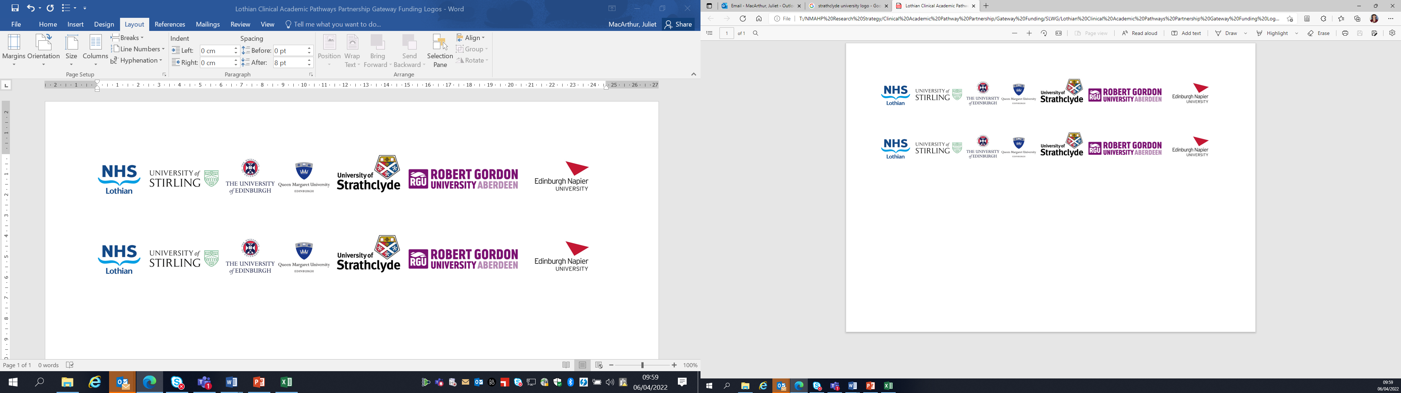Lothian Clinical Academic Pathways Partnership

Clinical Academic Research Gateway Funding

First Steps into Research Opportunities 2024

Institution & Department  Research Centre (if appropriate) | Robert Gordon University  SNMPP – School of Nursing, Midwifery and Paramedic Practice.
Contact – name, role & email | Dr Nick Adams – Research Fellow  n.adams5@rgu.ac.uk
Research Project/Programme Title | Exploring men’s mental health and help-seeking practices in Scotland
Details of Research Project / Programme – including funder, team members, methodology, stage of implementation | I am a Research Psychologist with an interdisciplinary background in Psychology and Sociology.  My interests are human psychology, mental health and men and masculinities. My research work examines how constructs of masculinities are developed and changed by specific environments, society and other influencers. I examine linkages between masculinities and men’s mental health and help-seeking practices and men’s safety and risk-taking practices in a variety of contexts. My work on identity and masculinities is informed by post-structuralist intersectional feminist theories.  I have a funding application submitted to explore men’s mental health and help-seeking practices in Scotland (decision pending January 2024).  Please get in touch if you would like to discuss possible collaboration, or possible ideas for new collaborative projects in the above areas.
Opportunities for candidate  e.g. attending meetings; data collection; data management; analysis; ethics application; dissemination activities  (bullet points) | - Project design and brainstorming.  - Grant applications.  - Data collection (interviewing) and structured thematic analysis and associated mentoring in these areas.  - Ethical applications experience and mentoring.  - Publication writing, journal identification and submission.  - Possible MRes / PhD proposal and application  - Journal Club and Seminar Series attendance/involvement.
Any other considerations or information for potential candidates? (e.g. potential links to other projects, networking opportunities, specific skills needed) | Please see my institutional profile for an overview of some of my past research work (publications):  https://rgu-repository.worktribe.com/person/859808/nick-adams  My publications are also indexed on Google Scholar:  https://scholar.google.com/citations?user=Bd0yAlcAAAAJ&hl=en
Dates available (awards likely to be made Feb/Mar 2024 for start in Mar/Apr 2024) | March 2024.
Mentor(s) | Dr Nick Adams

Please return to Andy Peters, AHP Research & Development Facilitator, NHS Lothian andy.peters@nhslothian.scot.nhs.uk

