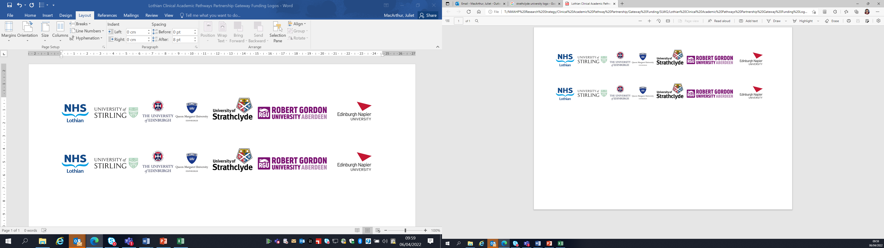Lothian Clinical Academic Pathways Partnership

Clinical Academic Research Gateway Funding

First Steps into Research Opportunities 2024

Institution & Department  Research Centre (if appropriate) | Edinburgh Clinical Research Facility  NHS Lothian  Sites at WGH, RIE and RHCYP
Contact – name, role & email | Corrienne McCulloch (Deputy Director) corrienne.mcculloch@nhslothian.scot.nhs.uk  Lesley Briody (Research Nurse Manager)  lesley.briody@nhslothian.scot.nhs.uk
Research Project/Programme Title | The Edinburgh Clinical Research Facilities (CRF) supports about 100-150 active clinical trials, so this placement opportunity would give very broad insight into the delivery of clinical trials rather than working on a specific research study.
Details of Research Project / Programme – including funder, team members, methodology, stage of implementation | Various academic and commercial funders  We support a wide portfolio of interventional clinical trials from Phase 1/First in Human though to phase IV. We also have a large number of experimental medicine, observational population based research being conducted at any given time.
Opportunities for candidate  e.g. attending meetings; data collection; data management; analysis; ethics application; dissemination activities  (bullet points) | - Placement with Research Governance Officer and Admin team  - Attendance at Phase 1 Study Review Committee  - Observing Clinical Research Nurses setting up and delivering clinical trials - consent, data collection, sample processing, clinical investigations, data entry  - Placement with Quality Assurance team  - Placement with Project Support team  - Placement with Patient and Public Involvement Manager  - Attendance at University Early Projects Meetings (with Deputy Director)  - Attendance at R&D forums (with Deputy Director)  - Placement with Education team - both clinical and wider research support  - Placement with Lead Nurses for Phase 1 trials  - Access to our clinical trials statisticians  - Observing outreach and community delivered research  - Placement with a paediatrician – Clinical Research Fellow  The above is a list of examples and opportunities we can provide for applicants, we will discuss specific needs and objectives of each individual at the start.
Any other considerations or information for potential candidates? (e.g. potential links to other projects, networking opportunities, specific skills needed) | The CRF supports a wide range of clinical specialities so there is an opportunity to dovetail into areas where the candidate may already have relevant clinical experience or interest.  This placement would be suitable for all disciplines.  We support multi-disciplinary researchers in the acute hospitals, the community and in REH, St Johns and Lauriston Place.  A number of senior staff have had Principal Investigator and academic roles, leading on our own research portfolios and developed careers in clinical research so would be happy to guide candidates as required.
Dates available (awards likely to be made Feb/Mar 2024 for start in Mar/Apr 2023) | We can be flexible with dates and work with the successful candidate to agree on dates.
Mentor(s) | Dr Corrienne McCulloch (Deputy Director)  Lesley Briody (Research Nurse Manager)  Gerry Cummings (Research Nurse Manager)  Ailsa Geddes (Lead Clinical Research Nurse Educator)  A number of Lead Nurses will volunteer dependent on candidate preference on site they wish to be based at.  Depending on the type of experiences sought we can identify suitable mentors to include at least one of the above named people.

Please return to Andy Peters, AHP Research & Development Facilitator, NHS Lothian andy.peters@nhslothian.scot.nhs.uk

