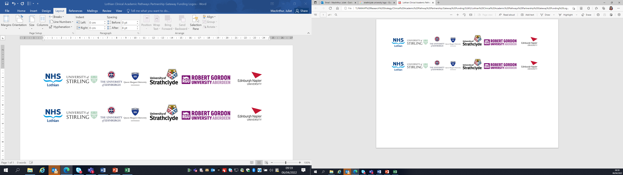Lothian Clinical Academic Pathways Partnership

Clinical Academic Research Gateway Funding

First Steps into Research Opportunities 2024

Institution & Department  Research Centre (if appropriate) | Edinburgh Napier University, School of Health and Social Care
Contact – name, role & email | Dr Nicola Roberts, Associate Professor, n.roberts@napier.ac.uk
Research Project/Programme Title | Respiratory care
Details of Research Project / Programme – including funder, team members, methodology, stage of implementation | There is an opportunity to get involved in a range of respiratory research projects that currently underway for example exploring nurses exposure to second hand smoke, determining the smoking prevalence of nurses or investigating how to support adolescents or individuals with intellectual disabilities to self manage their respiratory condition
Opportunities for candidate  e.g. attending meetings; data collection; data management; analysis; ethics application; dissemination activities  (bullet points) | The candidate may have the opportunity to:  1. Attend team research meetings  2. Work with project teams and students getting hands on supervised experience working with data sets  3. Work with researchers and students in preparing and making ethical applications  4. Help prepare disseminations for conference events, i.e. abstracts, posters, flyers etc  5. Potentially attend a respiratory conference and attend with one of the team  6. Meet with healthcare professionals and clinicians to discuss research issues and potential studies
Any other considerations or information for potential candidates? (e.g. potential links to other projects, networking opportunities, specific skills needed) | All professions can be accommodated for a placement.
Dates available (awards likely to be made Feb/Mar 2024 for start in Mar/Apr 2023) | Flexible
Mentor(s) | Dr Nicola Roberts N.Roberts@napier.ac.uk

Please return to Andy Peters, AHP Research & Development Facilitator, NHS Lothian andy.peters@nhslothian.scot.nhs.uk

