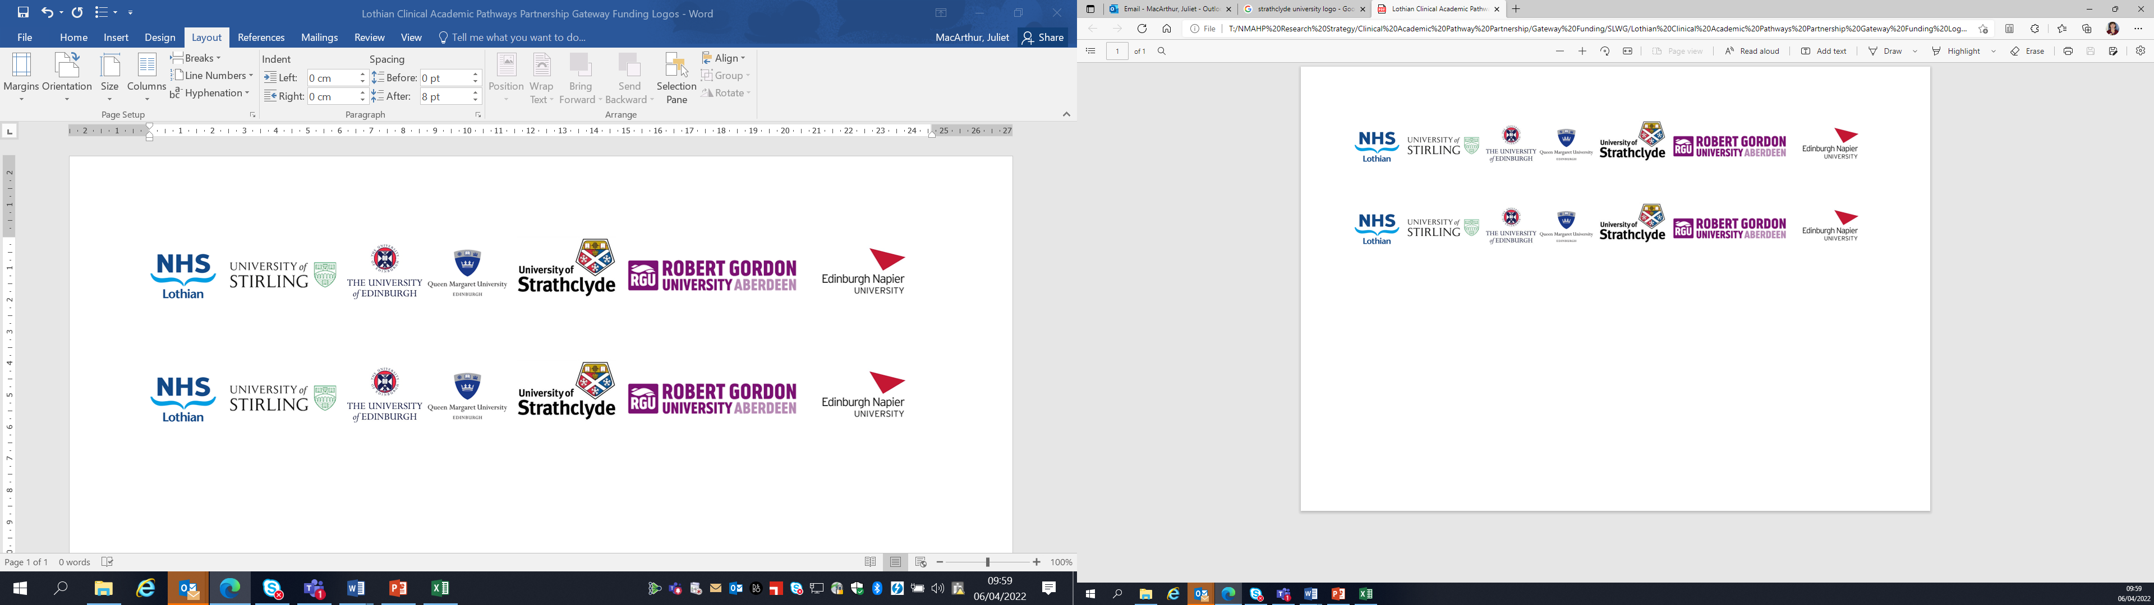Lothian Clinical Academic Pathways Partnership

Clinical Academic Research Gateway Funding

First Steps into Research Opportunities 2024

Institution & Department  Research Centre (if appropriate) | Edinburgh Napier University – School of Health and Social Care, Midwifery Subject Group
Contact – name, role & email | Dr Alix Aitken-Arbuckle a.aitken-arbuckle@napier.ac.uk  Professor Yvonne Kuipers y.kuipers@napier.ac.uk
Research Project/Programme Title | Continuity of Midwifery Care
Details of Research Project / Programme – including funder, team members, methodology, stage of implementation | This body of work is part of the Continuity of Midwifery Care research network which aims to unite academia and practice in Scotland and boost the evidence and conversations regarding CoC. As a group we aim to draw on knowledge and expertise within our network to establish leadership in CoC.  Current projects include:  Evaluation of Continuity of midwifery care in Scotland: A nested case-control study.  Aims: To evaluate the outcomes of midwife-led continuity of care by examining the differences in outcomes between those who received midwife-led continuity of care and those who did not (care-as –usual) in NHS Lothian.  Midwife-led continuity models versus other models of care for childbearing women: Updated systematic review and meta-analysis.  Aims: To compare the effects of midwife-led continuity models of care with other models of care for childbearing women and their infants adding to the existent body of knowledge in the Cochrane review (Sandal et al., 2016).  Development and evaluation of a Continuity of Midwifery Care model for pregnant people with Complex Social Factors.  Aims: To develop and evaluate a new service within NHS Lothian to provide continuity of midwifery care in order to improve maternal and neonatal outcomes.
Opportunities for candidate  e.g. attending meetings; data collection; data management; analysis; ethics application; dissemination activities  (bullet points) | - Involvement in research design and ethics process,  - Attending meetings, networking and stakeholder events  - Helping with recruitment and data collection,  - Data analysis  - Collaborating in publication and dissemination  - GCP training
Any other considerations or information for potential candidates? (e.g. potential links to other projects, networking opportunities, specific skills needed) | We encourage applications from midwives who have an interest in midwifery led research and would like to develop their knowledge and skills in both quantitative and qualitative methods.
Dates available (awards likely to be made Feb/Mar 2024 for start in Mar/Apr 2023) | Anytime from April 2024 onwards
Mentor(s) | Dr Alix Aitken-Arbuckle  Professor Yvonne Kuipers

Please return to Andy Peters, AHP Research & Development Facilitator, NHS Lothian andy.peters@nhslothian.scot.nhs.uk

