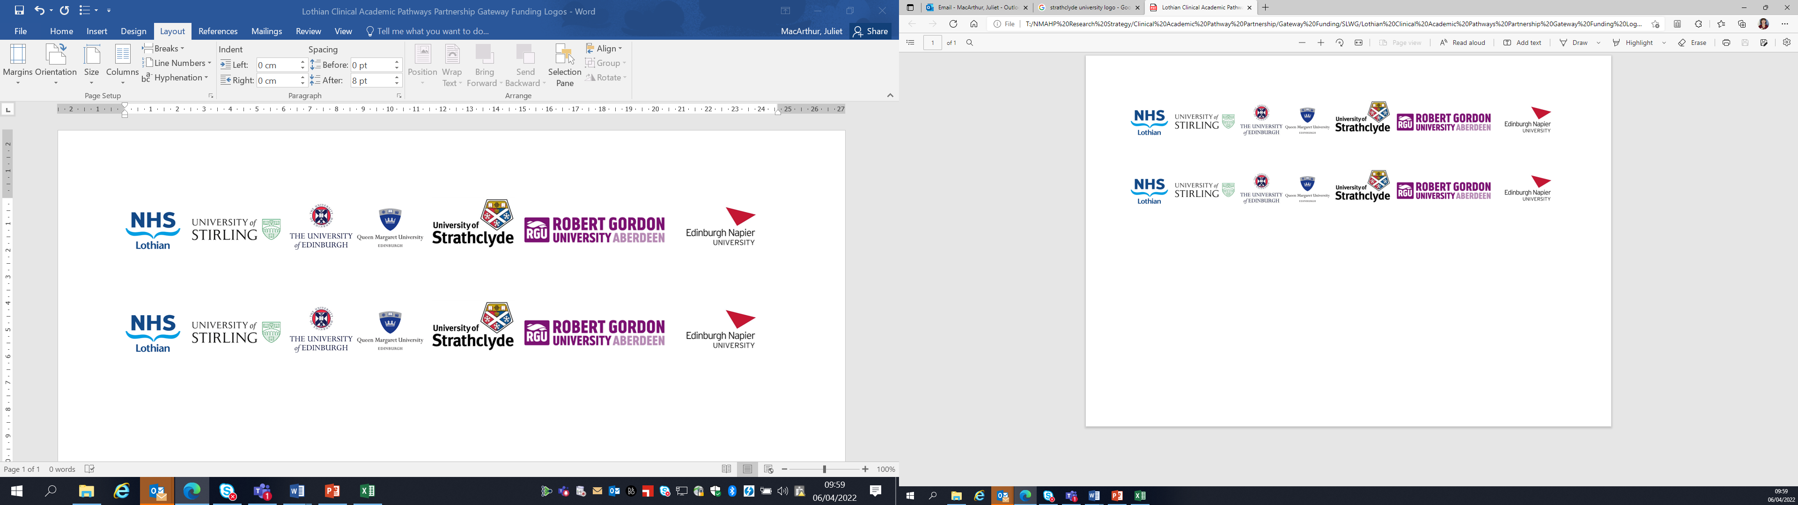Lothian Clinical Academic Pathways Partnership

Clinical Academic Research Gateway Funding

First Steps into Research Opportunities 2023

Institution & Department  Research Centre | Chalmers Sexual Health Centre  Centre for Reproductive Health, University of Edinburgh
Contact – name, role & email | Dr Michelle Cooper, Consultant & Senior Clinical Lecturer (Hon)  michelle.cooper@ed.ac.uk
Research Project/Programme Title | Clinical trial of a new 6-monthly injectable contraceptive (DMPA-XT study)
Details of Research Project / Programme | - New international multi-centre contraceptive trial funded by FHI 360 (US-based NGO)  - Chalmers Centre is one of 4 study sites and currently only UK site  - Aim is to evaluate efficacy, safety and satisfaction with a 6-monthly subcutaneous injection of depot medroxyprogesterone acetate (injectable progestogen hormone) as a contraceptive  - Plan is to recruit 100 healthy female volunteers to receive 2 injections subcutaneously into either abdomen or thigh over 12 months  - Follow-up visits with be conducted at 3-montly intervals at the study site  - Local study team members include: Anne Johnstone & Karen McCabe (experienced research nurses); Dr John Reynolds-Wright (junior sub-investigator); Dr Michelle Cooper (senior sub-investigator); Prof Sharon Cameron (principal investigator & research dept lead)  - The study will commence recruitment in Feb 2023 with an expected duration of 24 months to completion
Opportunities for candidate  e.g. attending meetings; data collection; data management; analysis; ethics application; dissemination activities  (bullet points) | - Practical application of Good Clinical Practice (GCP) e.g. processes for consent, adverse event reporting, monitoring, information governance  - Training requirements and study documentation for clinical trials  - Attending meetings (local research team, monthly progress updates with FHI360, wider research network)  - Screening & recruitment activities  - Data collection and management (including source data review, e-CRF completion, response to data queries)
Any other considerations or information for potential candidates? (e.g. potential links to other projects, networking opportunities, specific skills needed) | This one of several projects being undertaken within the department around contraception and abortion. The research team are part of a wider inter-disciplinary network offering the candidate opportunities to learn about other research methodologies within this area e.g. qualitative research, health services evaluation.
Dates available (awards likely to be made summer 2023 for start in September 2023) | Start date between Sept-Dec 2023 for 12 months
Mentor(s) | Anne Johnstone, Research Nurse  Karen McCabe, Research Nurse  Dr Michelle Cooper, Consultant

