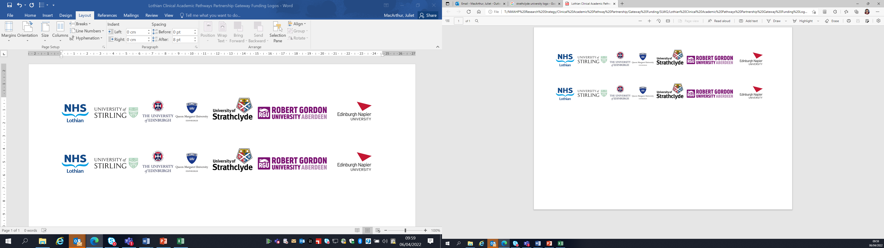Lothian Clinical Academic Pathways Partnership

Clinical Academic Research Gateway Funding

First Steps into Research Opportunities 2023

Institution & Department | Robert Gordon University, School of Health Sciences
Contact – name, role & email | Professor Kay Cooper  Clinical Professor Allied Health Professions  k.cooper@rgu.ac.uk
Research Project/Programme Title | Rehabilitation for people with Long COVID
Details of Research Project / Programme | Professor Kay Cooper is co-leading a CSO-funded study on Community rehabilitation for Long COVID. This is a mixed method realist evaluation of community rehabilitation in four Scottish health Boards, involving a multidisciplinary team from RGU, Stirling (Prof Edward Duncan co-leading), and Dundee Universities.  She also has funding to conduct PPI work to explore priorities for long COVID research beyond this study.  Therefore, this programme of work provides opportunity for the candidate to experience the dissemination phase of a study (including stakeholder workshops, writing, strategies to influence policy & practice) and also the early stages of developing research ideas (including literature reviewing, grant writing, ethics and R&D approvals)
Opportunities for candidate | There would be opportunities for:  - Attending project meetings (team & oversight committee)  - Literature searching, gathering & reviewing  - Manuscript preparation  - PPI activities  - Proposal development  - Grant writing  - Ethics & R&D applications
Any other considerations or information for potential candidates? (e.g. potential links to other projects, networking opportunities, specific skills needed) | Long COVID is likely to remain an important topic of research for some time to come. This programme of work will be suited to a candidate with an interest in Long COVID/long-term condition management/health service delivery who is looking to experience a range of research activities.  The candidate will be welcome to join relevant development activities at RGU including research seminars, meetings, and training events. They will also be encouraged to engage with activities of the Nort east Scotland Centre for Nursing, Midwifery and Allied Health Professions Research (a joint venture between RGU and NHS Grampian)
Dates available (awards likely to be made summer 2023 for start in September 2023) | Flexible start date around September 2023
Mentor(s) | Professor Kay Cooper

