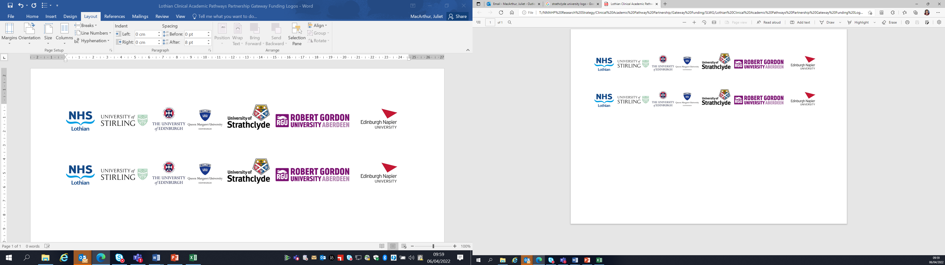Lothian Clinical Academic Pathways Partnership

Clinical Academic Research Gateway Funding

First Steps into Research Opportunities 2023

Institution & Department | Robert Gordon University, School of Health Sciences
Contact – name, role & email | Professor Kay Cooper  Clinical Professor Allied Health Professions  k.cooper@rgu.ac.uk
Research Project/Programme Title | Resistance exercise prescription for tendinopathy: a qualitative exploratory study of patients’ and physiotherapists’ experiences  Lay Summary of project  Tendons are cords of strong, flexible tissue that attach muscles to bones, allowing joints to move. Tendinopathy is a common condition that can affect any tendon in the body, causing pain and limiting function. Common tendinopathies include the Achilles (calf), knee (patellar), elbow (e.g., tennis elbow) and shoulder (formerly called impingement). People with tendinopathy are often seen by physiotherapists, with exercise being the mainstay of treatment.  We know that exercise is safe and beneficial for tendinopathy, and that strengthening exercise is most often prescribed for people with tendinopathy. However, we also know that strengthening exercise is not always prescribed at the best dosage, and that sticking to an exercise programme for tendinopathy can be challenging.  In this project we will interview people with tendinopathy about their experiences of physiotherapist-prescribed strengthening exercises, to understand the difficulties experienced by people with tendinopathy and potential solutions for overcoming these difficulties. We will also interview physiotherapists to understand how they prescribe strengthening exercise for tendinopathy, and why their prescription may not always be at the best dosage for recovery.  The findings will address a gap in the evidence on exercise for tendinopathy and will support the development of patient-centred exercise interventions.
Details of Research Project / Programme – including funder, team members, methodology, stage of implementation | Funder – NHS Grampian Endowment Research Fund  Team – Prof Kay Cooper (PI), Dr Lyndsay Alexander (Associate Prof RGU), Ms Lynn Murray (MSK Physiotherapists NHS Grampian), MS Shaelyn Pepper (Research Assistant RGU)  Stage – this project is due to commence in April 2023 for a 1-year duration
Opportunities for candidate  e.g. attending meetings; data collection; data management; analysis; ethics application; dissemination activities  (bullet points) | There would be opportunities for:  - Attending project meetings (team & oversight committee)  - Literature searching, gathering & reviewing  - Data collection – qualitative interviews  - Data processing & analysis – Framework analysis  - Facilitating/participating in stakeholder workshops  - Contributing to manuscript preparation  - PPI activities
Any other considerations or information for potential candidates? (e.g. potential links to other projects, networking opportunities, specific skills needed) | The project follows-on from a large NIHR HTA-funded evidence synthesis on exercise for tendinopathy, and PPI work to prioritise future tendinopathy and wider musculoskeletal research topics in underway by the project team. Therefore, there may be opportunity to experience other related workstreams.  The project is on physiotherapist-prescribed exercise. Although some knowledge/experience of physiotherapy and/or exercise may be an advantage it is not essential. Candidates with any professional background are welcome to apply, as long as they have some enthusiasm for the topic and for gaining experience in qualitative research.  The candidate will be welcome to join relevant development activities at RGU including research seminars, meetings, and training events. They will also be encouraged to engage with activities of the Nort east Scotland Centre for Nursing, Midwifery and Allied Health Professions Research (a joint venture between RGU and NHS Grampian)
Dates available (awards likely to be made summer 2023 for start in September 2023) | Flexible start date around September 2023
Mentor(s) | Professor Kay Cooper

