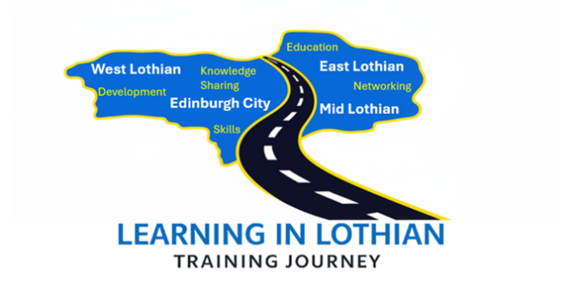
TEAM DYNAMICS

Thursday 5th November
Training Room 4 The Comely Bank Centre 10.00 – 15.00

This course is aimed at Managers / Supervisors
Understanding your team’s dynamics enables you to support staff more effectively and maximise each individual’s potential’
High performance teams have clear, defined goals and this comes from good leadership
The course will help you:
- Identify what makes an effective team. Understand the importance of clear goals and defined roles, psychological safety, mutual trust, respect and open and clear communication
- Understand Team relationships: Being aware of strong collaborations or potential conflicts that may influence performance
- Understand Motivation and engagement levels: Identifying what drives individuals, whether that’s recognition, autonomy, or development opportunities
- Uncover the relationship between team dynamics and performance
- Identify strategies to improve team dynamics
This awareness helps you create a more cohesive, effective team where individuals can perform at their best.
The course is a face-to-face event maximising the opportunity to share experiences and network with colleagues from across Lothian.
To book please send a completed application form to: loth.gptrainingapps@nhs.scot

Or for further information contact pauline.hutton@nhs.scot
Cost per learner- £45
DNA/Late cancellation cost-£70

