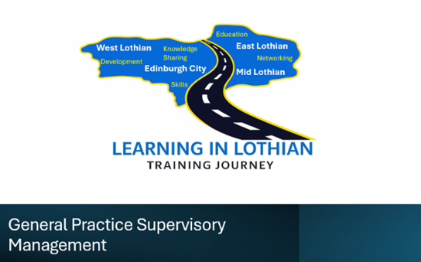
📍 Location: Board Room, Wester Hailes Healthy Living Centre, 30 Harvesters Way Edinburgh EH14 3JF

🎯 Who is this programme for?
The General Practice Supervisory Management Vocational Training Scheme is designed for:
- New or aspiring supervisors
- Staff stepping into management roles
This programme provides essential skills and knowledge to support those responsible for supervising or managing teams in a General Practice setting.

📚 What will you learn?
The course is structured across three key modules:
Module | Topic | Dates | Time
Module 1 | Managing Yourself | 8 & 29 September | 09:30 – 16:30
Module 2 | Managing Your Team | 6 & 27 October | 09:30 – 16:30
Module 3 | Managing the Organisation | 3 & 17 November | 09:30 – 16:30

🌐 Programme Benefits
Participants will:
- Develop confidence in supervisory and management responsibilities
- Gain insight into the “bigger picture” of their organisation and the wider NHS
- Understand key stakeholders influencing General Practice
- Learn how to build cohesive, effective teams
- Benefit from face-to-face learning, networking, and shared experience across Lothian#

🤝 Learning Approach

This is a face-to-face programme, designed to maximise collaboration, discussion, and peer learning with colleagues from across Lothian
📝 How to Apply send a completed application form to: loth.gptrainingapps@nhs.scot
Or for further information contact pauline.hutton@nhs.scot or derek.geddes@nhs.scot
Cost per learner- £100 DNA/Late cancellation cost-£125

