CHILDREN & YOUNG PEOPLE’S
OCCUPATIONAL THERAPY SERVICE

- CHILD’S DETAILS
Full Name | Date of Birth | CHI number
Address (include postcode) | Phone Numbers
Mobile (Preferred):
Home:

 | Parent/Carer’s Name
Main Language Spoken at Home: | Interpreter required:
 | YES/ NO

- SCHOOL/ NURSERY/ FAMILY CENTRE
Name | Class and Teacher’s Name

- PROFESSIONALS INVOLVED (include GP, AHP’s, Social Work, Learning Support, Education Inclusion Support Service, Educational Psychologist, CAMHS etc)
Name | Profession | Contact details

- RELEVANT MEDICAL HISTORY
Pre/Post natal, developmental milestones, relevant investigations, diagnosis and prognosis, medication.

- ANY RELEVANT BACKGROUND INFORMATION
Social circumstances, Previous request for assistance to Occupational Therapy
Mmmmmmmmmmmmmmmmmmmmmmmmmmmmmmmmmmmmmmmmmmmmmmmmmmmmmmmmmmmmm

- REASON FOR REQUEST FOR ASSISTANCE AND HOW THIS IMPACTS ON THE CHILD
In School / Nursery / Family Centre / Home

- WHAT STRATEGIES/APPROACHES HAVE ALREADY BEEN TRIED? HOW EFFECTIVE WERE THEY?

- WHAT DO YOU HOPE THE CHILD/YOUNG PERSON WILL GAIN FROM THIS REQUEST?

Have you accessed our website to look at the advice and strategies available here in the first instance?
Yes |  | No

Have you accessed the Children’s Occupational Therapy telephone advice line if applicable?
Yes |  | No

10. REQUESTOR’S DETAILS
Name | Position | Address
Phone no.

I agree to my child’s request for assistance to Occupational Therapy and to my child’s school being asked for further information if required.
Yes |  | No

I give permission for his/her GP and/or Community Paediatrician to be advised of this request for assistance.
Yes |  | No

Signature of Requestor: Date:

(Note: this referral cannot be processed without the signed or verbal consent of the child’s parent/carer)
Return completed forms to: Children’s Occupational Therapy Service, St. John’s Hospital,
Howden Road West, Livingston EH54 6PP Tel: 01506 524134 (Advice Line first Thursday of the month)
For Education Staff/ Health Care Professionals please email LOTH.ChildrensOTservice@nhs.scot

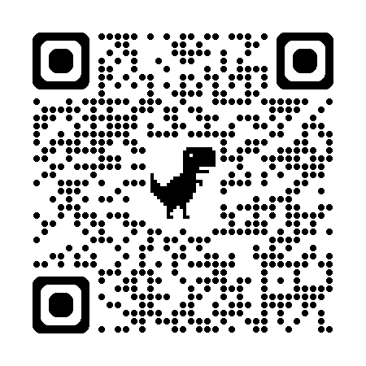
Link to website: https://services.nhslothian.scot/cypot/

