Helpful Strategies for Children with Joint Hypermobility and/or Juvenile Arthritis

Information for parents, carers and educational staff

For children with juvenile arthritis or hypermobile joints, activities of daily living and aspects of school life can be difficult to complete due to the pain and fatigue.

The main symptoms of juvenile arthritis include pain, swelling and stiffness in the joints. Young people can often experience fatigue alongside the pain. The hands, knees, elbows, back and feet are most commonly affected.

Hypermobility is when someone has very flexible joints. Hypermobile joints can cause pain, discomfort, and tiredness. It can affect balance, co-ordination, and strength.

Within this pack there are a range of everyday advice and strategies to improve comfort and independence for children who experience pain and fatigue. We have broken these down into different daily activities (both at home and school) for you to consider.

# Positioning

* Good posture during tabletop tasks is very important and should be the first step to consider.
* When the child is at their desk ensure that feet are flat on the floor, thighs and forearms are horizontal and the desk is just below elbow height.

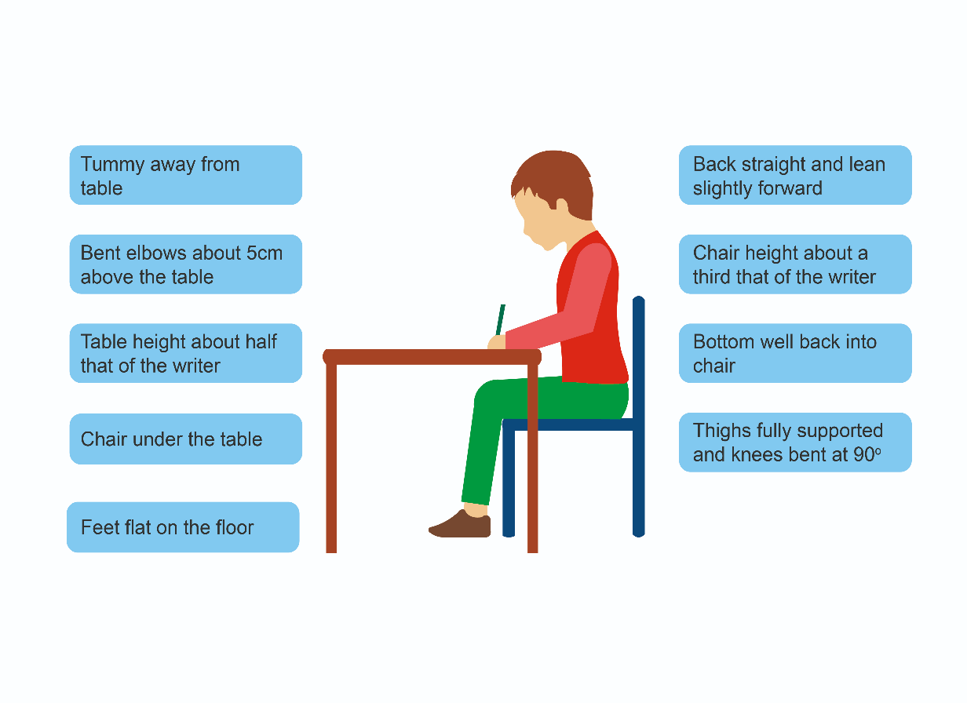

* Some school chairs might be uncomfortable for a young person who suffers from pain, particularly if the chair is small and hard or if a stool has no back support, such as those in science. Sitting on the floor can also be painful and difficult. If seating is uncomfortable and causing pain the use of a **height adjustable swivel computer chair** may alleviate pain symptoms for older students. These chairs can improve posture as the height adjustable function will ensure the young person’s feet are always planted on the floor. A computer chair will offer additional lower back support compared to a standard chair. There are also options to adjust the angle of the backrest to a comfortable position for the young person. As this is not a specialist piece of equipment it would not be supplied by Occupational Therapy and should be sourced by parents for use at home or education for use in school.
* Adding a pillow or cushion can also provide some pain relief/ help with discomfort. A cushion can also be easily transported around the school between classes. There are lumbar support cushions available online.
* It is possible to purchase high stools that have a back rest and footrest. If the young person benefits from any of the strategies listed above, please consider a stool like this to support their participation in certain subjects e.g., science, craft and design, art, home economics. Height adjustable options are also available online.
* A foot block can help if the chair is slightly high and the young person’s feet are not planted on the floor.
* Sitting on the floor/carpet or with crossed legs can be hard work for some children, consider allowing the child to sit on a chair or bench. Discourage sitting in a ‘w sit’ position on with knees and bottom on the floor.
* It can help if the young person faces the front of the class, so they don’t have to twist their body around to see the teacher or board.

# Handwriting

If hand and/or wrist pain is a frequent problem and impacting on handwriting, please consider the following:

* An angled surface such as an angle board or lever arch file will provide support at the wrist and will encourage best posture for writing; it also aids visibility by bringing the paper closer. A foam wedge cushion may encourage children/young people to sit up straighter as although this is hard work, slumping will cause pain.
* Explore different types of pens/pencils. It can be easier to use a roller ball or gel pen as this does not require as much pressure to be applied when writing, therefore, reducing pain. Alternative pencils can also be used to reduce stress on the hand including thicker, triangular pencils or the Twist n Write Pencil:

[www.thedyslexiashop.co.uk/collections/pens-pencils-and-writing-aids](http://www.thedyslexiashop.co.uk/collections/pens-pencils-and-writing-aids)

*  Adding grips that make the pencil thicker can also make it easier for children to hold the pencil. Widening the webspace between fingers hand will help to reduce joint hypermobility when grasping the pencil. Therefore pencil grips such as the Egg-Oh work well:

[www.thedyslexiashop.co.uk/products/egg-ohs-pencil-grips](http://www.thedyslexiashop.co.uk/products/egg-ohs-pencil-grips)



<https://sensoryneeds.co.uk/products/ark-s-butter-grip-combo>

* Also consider the size and weight of the pen/pencil, if it’s very light and thin the child/young person will have to work harder to grip it.
* When completing handwriting tasks ensure regular rest breaks are given.
* Consider giving additional handouts/notes at the start of a lesson, so the child does not have to write everything down. You could allow the young person to take photos of notes on the board to minimise copying.
* ICT support should be used to ensure that learning is fully evidenced. If handwriting is effortful, painful, or slow, offering a laptop, tablet or similar device will support the young person.
* Some young people may need special consideration for exams, such as extra time or the use of a computer or scribe, this can be discussed with the young person and their carer.
* Completing hand warm-ups before handwriting can be helpful, see below for some examples:
* Pull at fingers
* Monkey grip - pull hands apart
* Praying position - push hands together, holding hands close to chest
* Finger taps - tap fingers on a tabletop. Can imitate sequences
* Finger separation - spread fingers as far apart as possible
* Shake hands to relax
* Pencil walks - holding the pencil with a tripod grip then walking fingers up the pencil shaft and back down again using writing hand only.

For children with hypermobile joints it would be beneficial to try and strengthen up the hands by:

* Dynagel balls/ hand strengthening balls are available in variable resistances and can be used every day.
* Using spray bottles around the house e.g., to water plants, in the bath or to help with cleaning.
* Opening packets and boxes.
* Encourage squeezing bottles such as shampoo, sauces, paint and in water play etc.
* Theraputty is tougher than playdough therefore can be used in play to strengthen hands. There are lots of theraputty exercises available online to work through.

[www.nhsggc.org.uk/kids/healthcare-professionals/paediatric-occupational-therapy/theraputty-hand-strength-exercises/](https://www.nhsggc.org.uk/kids/healthcare-professionals/paediatric-occupational-therapy/theraputty-hand-strength-exercises/)

* There are various scissor alternatives to trial if standard scissors are causing any strain or pain: mounted tabletop scissors, easygrip loop scissors, mini easy grip scissors, spring assisted scissors, nimble one finger safety cutter.

# Participating in education

If a young person has arthritis or hypermobility taking part in the school day can be challenging and may cause increased pain or fatigue. Here are a few suggestions that can make things easier for the young person.

* Carrying heavy school bags can cause inflammation on the joints and lead to increased pain. Therefore, access to a locker to reduce the amount carried during the day is recommended. School should also consider offering digital resources or 2 copies of textbooks/resources so they don’t have to be transferred between home and school.
* Rest breaks are important, however gentle movement throughout the day is recommended to stop joints becoming stiff and painful. Children with joint pain will require more frequent movement breaks and these should be regularly incorporated into the school day. It can be helpful to have a subtle and agreed way for the child to indicate they require a movement break. Getting the whole class to do this can make it more discreet and avoid the child being singled out.
* The school day can be long and tiring. Therefore, it is recommended that the school work with the young person to pace their day and offer rest breaks if required to conserve energy and reduce pain and fatigue. It can be helpful for the young person to keep a diary of times they are feeling more tired or pain and see if there is a pattern to this. This can help with knowing when to schedule rest breaks or reducing their timetable in conjunction with the school.
* Pupils should be given a pass to leave class early to allow more travel time or a lift pass to ease strain of using the stairs if this is appropriate.
* Managing finer fastenings can be challenging therefore having flexibility with uniform is recommended i.e. t-shirts, joggers or comfortable shoes.

# Activities of daily living

If the young person has arthritis in their finger/hand joints, then we would advise adapting/avoiding tasks that involve using a tight grasp as this can increase inflammation in the joints. Below are some adaptations to consider building in regularly to their everyday routine.

**Holding tools**

Foam tubing or larger handles can be applied to everyday essentials such as toothbrushes, hairbrushes, and makeup brushes to provide additional comfort while reducing stress and pain on joints.

[www.essentialaids.com/household/gripping-turning/thick-plastazote-foam-tubing.html](http://www.essentialaids.com/household/gripping-turning/thick-plastazote-foam-tubing.html)

<https://livingmadeeasy.org.uk/category/health-and-personal-care/bathing-and-toileting/personal-care-equipment/product/foam-tubing>

**Showering/hair washing and styling:**

* Consider using a shower stool or chair to sit in the shower to conserve energy.
* Consider the use of a non-slip mat and a grab rail if this helps when standing within the shower.
* Try to spread out the time between hair washes by using dry shampoo.
* Use a combined shampoo/conditioner to reduce the time spent holding arms up to wash and condition hair.
* For joint arthritis an automatic dispenser for shampoo and conditioner may be an additional method to reducing the pressure on the hand muscles and joints.
* Hair washing brushes assist in spreading the shampoo around your hair when in the shower.

*The Etac Long Handled Beauty Hair Washer*

* Consider letting hair air dry rather than use a hair dryer as this will place less strain on joints or think about using a stand to hold the hair dryer, there are a variety of these available online.
* Experiment with different hairstyles, for example styles which are formed lower down on head. For long hair, consider using a hair claw or ‘one up hair tie’ for ponytails or to help keep hair back. These are easier to use than ordinary hair bobbles.
* A thicker handled hairbrush may be more comfortable to use or consider a long handled or lightweight hairbrush.
* Sitting down on a chair or bench when completing hair styles.

**Beauty and self-care:**

* Applying your makeup using beauty sponges as opposed to brushes can be easier as you don’t need to grip these as hard.
* Placing foam tubing around the makeup brushes provides additional comfort.
* Buying larger brushes or those with a rubber texture allow for easier grip. There are brands available online that provide alternative make up applicators that are easier to grasp.
* Sitting down to complete your makeup is advised.

**Mealtimes/food preparation:**

* Try using thicker handled cutlery such as ‘caring cutlery’ (junior/adult) or ‘foam handled’ cutlery if pain is experienced when using standard cutlery.
* Non**-**slip material/dycem can help stop items such as plates and, bowls moving about and can be used to help grip lids to ease opening.

All available from:

[www.essentialaids.com/](http://www.essentialaids.com/) [www.completecareshop.co.uk/](http://www.completecareshop.co.uk/)

<https://livingmadeeasy.org.uk/> [www.healthcarepro.co.uk/](http://www.healthcarepro.co.uk/)

[www.amazon.co.uk](http://www.amazon.co.uk)

* Try using a travel kettle for hot drinks as these are much lighter to lift.
* Use a steak knife instead of a regular knife when cutting up to minimise amount of strength and energy used.
* Other aids and equipment available include easy grip bread knives, electric can opener, can key, vegetable choppers to promote independence during meal preparation.

**Dressing:**

* If fine fastenings e.g., zips are difficult to grasp and pull up then attach a key ring or a piece of string/ribbon to the zip to make this easier to grasp and pull.
* It is important for a child/young person to try and master things such as tying shoelaces, buttons and tying a tie however, if hypermobility/arthritis is preventing them from being able to do this then it is important to trial different alternatives to support independence and to ensure positive self-esteem and confidence for the young person.

Alternatives include:

- Clothing with minimal fastenings

- Using a button hook to assist

- Velcro fastenings as an alternative to buttons (M&S have an adaptive clothing line)

- Trial slip on shoes to avoid laces altogether. You also get elastic shoelaces and bits to add to laces, so you don’t have to tie them e.g., Hickies laces, Xtenex laces, Greeper laces, Zubits laces, No tie elastic shoelaces, Atlas laces.