CARE HOME TESTING: ORDER FORM

**PLEASE COMPLETE AND SEND WITH PCR SAMPLE**

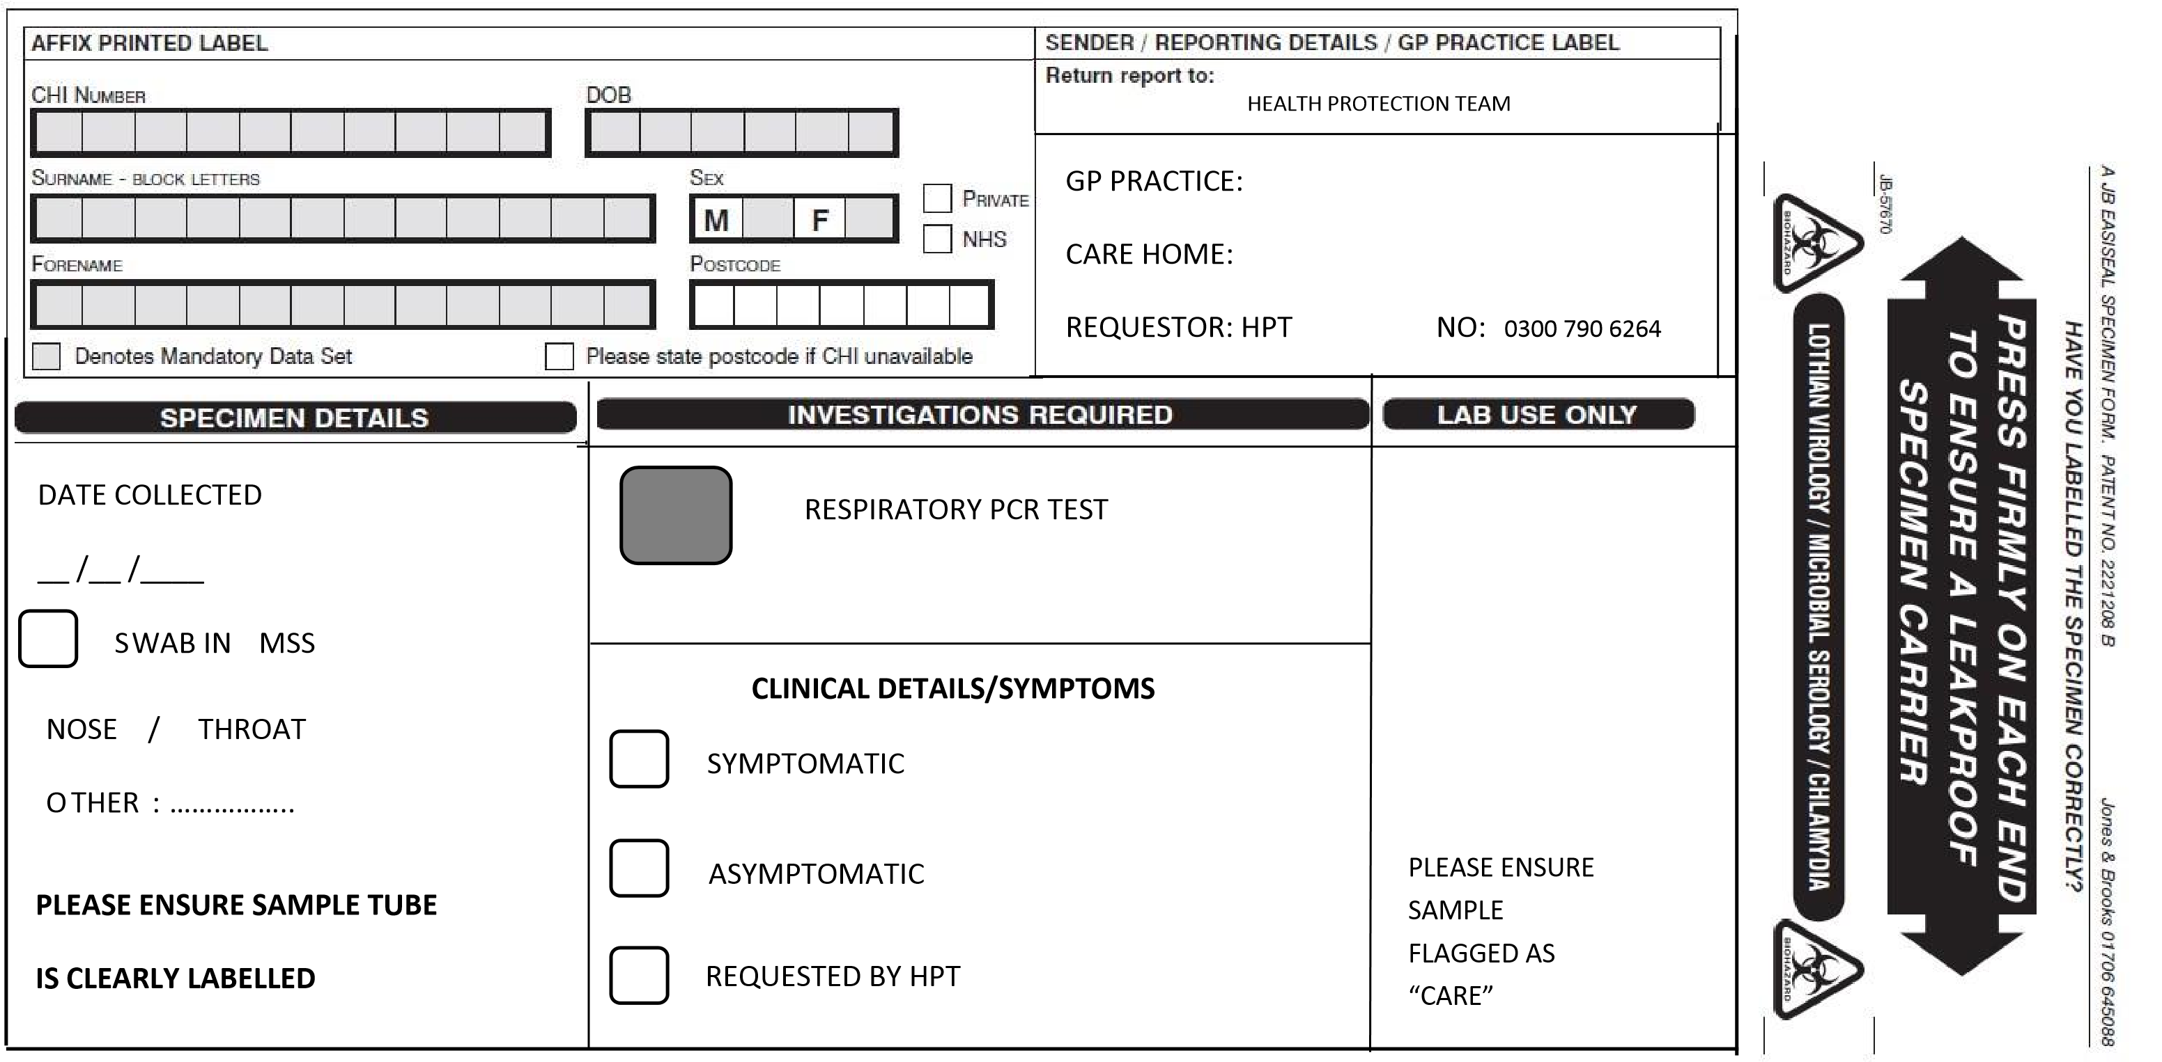

Version 1

Revision date: December 2023



**CLINICAL DETAILS/SYMPTOMS**



SYMPTOMATIC



ASYMPTOMATIC



REQUESTED BY HPT



PLEASE ENSURE



SAMPLE



FLAGGED AS



“CARE”

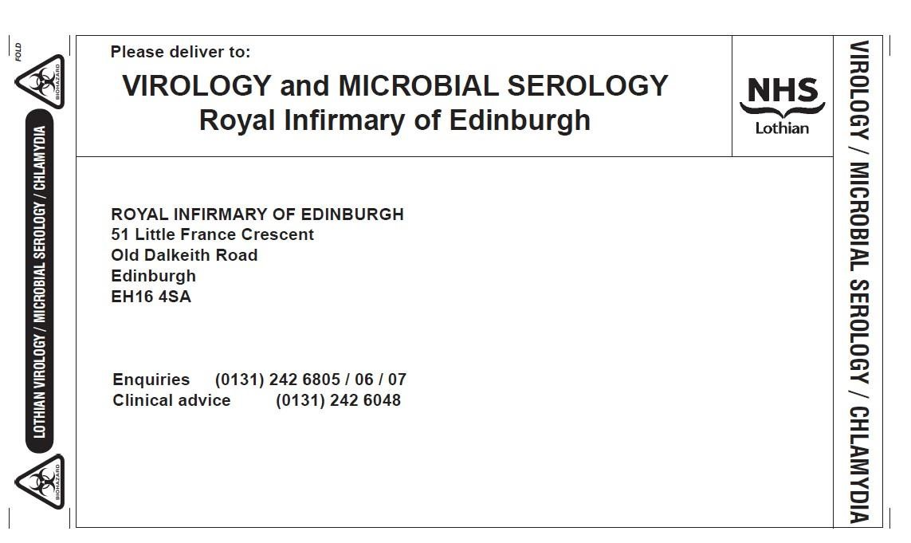

**V**



**IROLOGY**



**CARE HOME OUTBREAK TESTING**



Version 1

Revision date: December 2023