**Tool 17b: Post fall/incident report form**

Resident’s name:

Date of birth:

Room number:

Date of fall/incident:

Time of fall:

**Fall Location**

Outdoors Bedroom En-suite Bathroom

Corridor Sitting Room Dining room Exact location

**Surface type**

Carpet Linoleum Other (specify)

**Surface condition**

Wet Damaged Slipper Other

**Bed Position**

High Low Tilted N/A

**Call bell in reach**

Yes No N/A

**Light**

On Off N/A

**Mobility**

Ambulant Non-ambulant Independent Assistance of 1 Assistance of 2

**Aids**

None Stick Walking Frame Crutches Wheelchair

**Was aid used at the time of fall?**

Used correctly Used incorrectly Not used

Unknown Condition of aid

**Type of fall**

Slip Trip Collapse

Legs gave away Loss of balance Unknown

**Falls direction**

Drop Forwards Backwards

Sideways Unknown

**Any warning prior to fall**

Dizziness Faintness Confusion Fit

Loss of Consciousness Palpitations Aggression Breathlessness

Altered mental state None of above/other (specify)

**Toileting**

Resident attempting to got to toilet Incontinence

Frequency Urgency

**Footwear**

Shoes Slippers Socks

Bare feet Condition

**Glasses**

None Reading Distance

Bi-focals Vari-focals

**Type worn at the time of fall**

None Reading Distance Bi-focals

Varifocals Condition of glasses

**History of falls**

No Yes

Number of falls in past 12 months

**Medication/substance use – potentially a contributory factor?**

Yes No N/A

Unknown Time taken

Medication/substance identified

**Description of event**

Was the resident aware the fall was going to happen?: Yes No Unknown

Resident’s description of fall including activity immediately prior to falls:

Brief description of fall. What was seen or heard. Witnesses’ description (note any incontinence or abnormal movements).

Witness name/status:

**Clinical observation/vital signs following fall**

Vital signs checked following fall (BP, pulse, respiration): Yes No N/A

Any noticeable changes in resident’s health (note any pallor or cyanosis): Yes No

AMT required: Yes No N/A AMT Score

First aid administered: Yes No N/A

Hospital attendance required: Yes No N/A

Injuries sustained: Fracture: Yes No

Head Injury: Yes No

Laceration/bruising: Yes No

Other (specify):

Immediate action taken:

Doctor notified: Yes No Time notified:

Seen by doctor: Yes No Time seen:

Doctor’s Name:

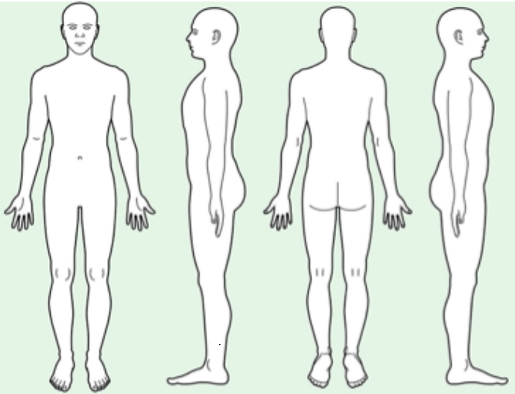

Mark and describe any injuries

**Outcome (note if RIDDOR reportable)**

**Action taken to prevent re-occurrence (please specify)**

MFRS/falls care plan updated?: Yes No N/A

Environmental risk updated?: Yes No N/A

Assessed by:

Date: