Reflective Practice

Reflective practice is a key part of any role within the care sector, as it is through reflective practice that we develop our skills, knowledge, and practice.
Reflective Practice is one form of Continuous Professional Learning (CPL) which is a requirement of registration with the SSSC and adherence with the SSSC Code of Practice. Continuous professional learning (CPL) - Scottish Social Services Council (sssc.uk.com)
Writing your reflections on learning and practice down can therefore demonstrate CPL, but in addition they can also be used as:
- Evidence for qualifications including SVQ* and PDA*
- Evidence for SSSC Open Badges*
- A discussion tool for supervision
- Part of your organisation’s Personal Development Planning or appraisal process.
- An informative piece of evaluation of training where classroom learning can be demonstrated and applied to practice*.
Pixabay
(*please ensure that no identifiable information of either staff, resident or client is provided to protect confidentiality*)
To help you formulate and structure your reflection of how you have applied your learning into practice, there is a form overleaf which you should complete within 3 months of undertaking any training. Alternative formats can be requested through LCA.
On the Day of Training complete:
Name of Training: |  | Date training undertaken:
Location of Training: |  | Training delivered by:
What were your key points of learning today?
How do you think you are going to apply this learning to practice?
Within 3 months of completing of training reflect on:
A situation when you have used your new skill – give a description of what happened:
How your training informed you on how to deal with the situation:
What worked particularly well?
Is there anything you will do differently next time you are faced with a similar situation?
Is there any additional or further training and development required to support you?
Date Reflection Completed |  | Your Name:

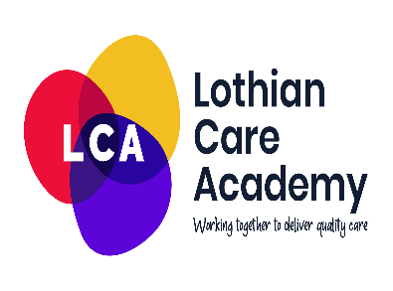
Once you have completed this document keep it safe along with your certificate from the training course, this will help you build a portfolio of learning and demonstrate your own professional development.
As identified earlier this information also provides valuable information about how training delivered impacts on practice and care given, therefore we would really appreciate you sharing your reflection with the LCA – please send a copy (or picture of the document) to LCA mailbox : loth.careacademy@nhslothian.scot.nhs.uk

