Correct toilet position


Step one |  | Step two
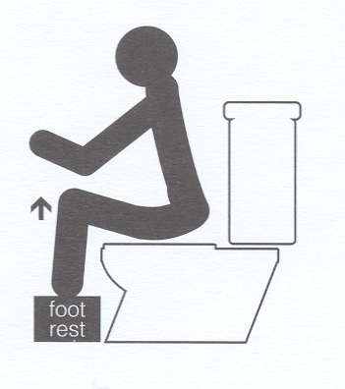 |  | 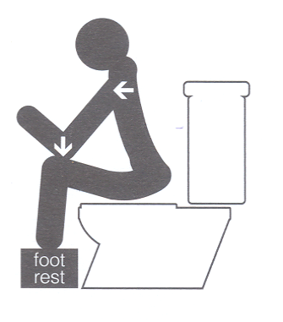
Knees higher than hips |  | Lean forwards and put elbows  on your knees
Step three |  | Correct position
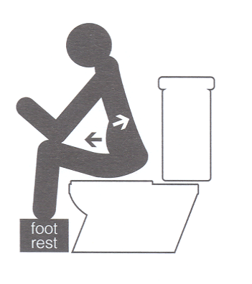 |  | 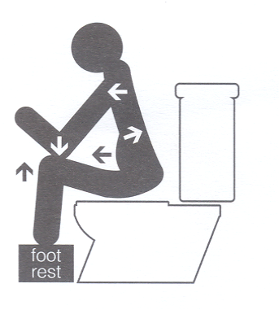
Bulge out your abdomen  Straighten your spine |  | Knees higher than hips  Lean forwards and put elbows  on your knees  Bulge out your abdomen  Straighten your spine

