
Bowel assessment chart

Name CHI:

Please complete in full each time bowels move. It is particularly important to document stool type and amount passed.

Bristol Stool Chart

Type 1 | Type 2 | Type 3 | Type 4 | Type 5 | Type 6 | Type 7
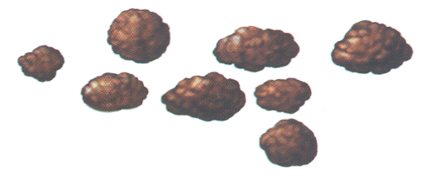 | 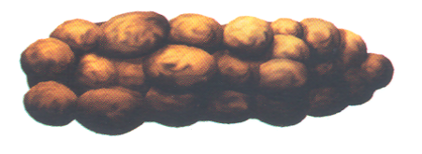 | 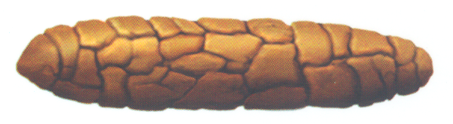 | 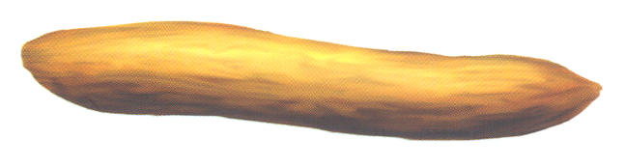 | 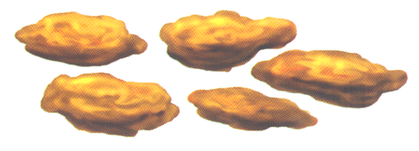 | 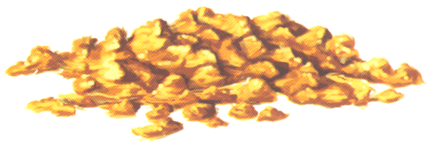 | 
Separate hard lumps, like nuts (hard to pass) | Sausage-shaped but lumpy | Like a sausage but with cracks on its surface | Like a sausage or snake, smooth and soft | Soft blobs with clear-cut edges (passed easily) | Fluffy pieces with ragged edges, a mushy stool | Watery, no solid pieces  Entirely liquid

Date | Time | Type  (1-7) | Amount  (small, medium, large) | Comments
e.g.  01/01/99 | 0900 | 2 | medium | Sat for 15 minutes, straining

Bristol Stool Chart

Type 1 | Type 2 | Type 3 | Type 4 | Type 5 | Type 6 | Type 7
Separate hard lumps, like nuts (hard to pass) | Sausage-shaped but lumpy | Like a sausage but with cracks on its surface | Like a sausage or snake, smooth and soft | Soft blobs with clear-cut edges (passed easily) | Fluffy pieces with ragged edges, a mushy stool | Watery, no solid pieces  Entirely liquid

Date | Time | Type  (1-7) | Amount  (small, medium, large) | Comments
e.g.  01/01/99 | 0900 | 2 | medium | Sat for 15 minutes, straining

